

# PROJECT REPORT ON

Under Supervision- Santu Purkait Director.

Netcamp Solutions Pvt. Ltd.

9331090003

[santu@netcamp.in](mailto:santu@netcamp.in) [www.netcamp.in](http://www.netcamp.in/)

# ANDROID

***SUBMITTED BY***

PAVAN SINGH

United College of Engineering And Research , Allahabad

*Acknowledgement*

I have taken efforts in this project. However, it would not have been possible without the kind support and help of many individuals and organizations. I would like to extend my sincere thanks to all of them.

I am highly indebted to Netcamp Solutions Pvt. Ltd. For their guidance and constant supervision as well as for providing necessary information regarding the project and also for their support in completing the project.

I would like to express my gratitude toward Mr. Santu Purkait, Director: Netcamp Solutions Pvt. Ltd. For their kind co-operation and encouragement which help me in completion of this project.

I would like to express my special gratitude and thanks to organization persons for giving me such attention and time.

My thanks and appreciations also go to my colleagues in developing the project and people who have willingly helped me out with their abilities.

Name : Pavan Singh

Netcamp ID :

College : United College of Engineering And Research , Allahabad

Date : 05 / 10 / 2022

Signature :

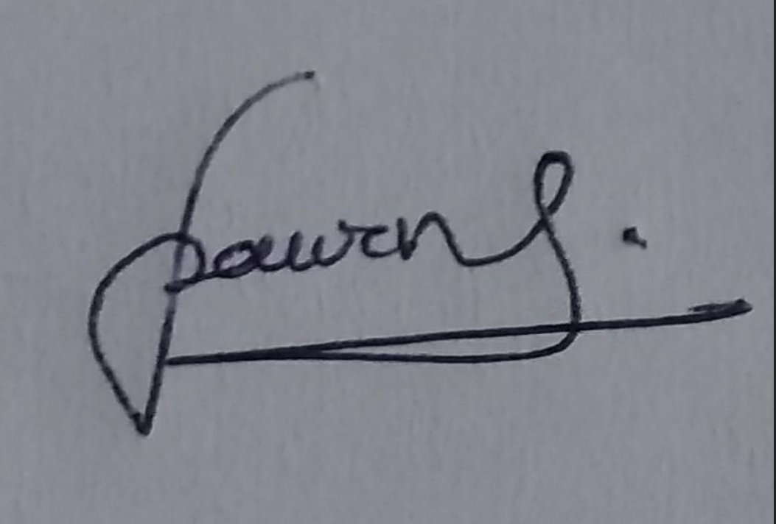

*Netcamp Solutions Private Limited*



***Certificate***

*This is to certify that,* ***Pavan Singh****, a student of program,* ***Android with Java Program*** *has successfully completed a project on Android Developement under the guidance of* ***Mr. Santu Purkait*** *(* ***Netcamp Solutions Private Limited.)***

***INDEX :***

|  |  |  |
| --- | --- | --- |
| **Serial NO.** | **Component** |  |
| 01 | Home Java Code ( MainActivity.java ) |  |
| 02 | Home xml snap with code ( activity_main.xml ) |  |
| 03 | Login With Mobile NO. ( second.java ) |  |
| 04 | Login with Email & pass ( activity_signin.xml ) |  |
| 05 | Login with Email & pass ( signin.java ) |  |
| 06 | Login with Email & pass ( activity_signin.xml ) |  |
| 07 | Home 2 game & tools section ( all.java ) |  |
| 08 | Home 2 game & tools section ( activity_all.xml ) |  |
| 09 | Profile java code ( third.java ) |  |
| 10 | Profile xml code ( activity_third.xml ) |  |
| 11 | List of Games ( games.java ) |  |
| 12 | List of Games Screen ( activity_games.xml ) |  |
| 13 | Math Game java code ( four.java ) |  |
| 14 | Math Game xml code ( activity_four.xml ) |  |
| 15 | Addition part of game ( fourone.java ) |  |
| 16 | Addition part of game ( activity_fourone.xml ) |  |
| 17 | Substraction part of game ( fourtwo.java ) |  |
| 18 | Substraction part of game screen ( activity_fourtwo.xml ) |  |
| 19 | Multiplication part of game ( fourthree.java ) |  |
| 20 | Multiplication part of game ( activity_fourthree.xml ) |  |
| 21 | Math Game Result Page ( result.java ) |  |
| 22 | Math Game Result Page Screen ( activity_result.xml ) |  |
| 23 | Tic Tac Toe add player java code ( AddPlayers.java ) |  |
| 24 | Tic Tac Toe add player Screen ( activity_AddPlayers.xml ) |  |
| 25 | Tic Tac Toe Main ( tictactoe.java ) |  |
| 26 | Tic Tac Toe Main screen ( activity_tictactoe.xml ) |  |
| 27 | Supporting java file for game ( winDialog.java ) |  |
| 28 | Supporting xml file for game ( win_dialog_layoutr.xml ) |  |
| 29 | Quiz Question 1 ( quiz.java ) |  |
| 30 | Quiz Question 1 screen ( activity_quiz.xml ) |  |
| 31 | Quiz Question 2 ( quiz2.java ) |  |
| 32 | Quiz Question 2 screen ( actvity_quiz2.xml ) |  |
| 33 | Quiz Question 3 ( quiz3.java ) |  |
| 34 | Quiz Question 3 screen ( activity_quiz3.xml ) |  |
| 35 | Quiz Question 4 ( quiz4.java ) |  |
| 36 | Quiz Question 4 screen ( actvity_quiz4.xml ) |  |
| 37 | Quiz Question 5 ( quiz5.java ) |  |
| 38 | Quiz Question 5 screen ( activity_quiz5.xml ) |  |
| 39 | Quiz Question 6 ( quiz6.java ) |  |
| 40 | Quiz Question 6 screen ( actvity_quiz6.xml ) |  |
| 41 | Quiz Question 7 ( quiz7.java ) |  |
| 42 | Quiz Question 7 screen ( activity_quiz7.xml ) |  |
| 43 | Quiz Question 8 ( quiz8.java ) |  |
| 44 | Quiz Question 8 screen ( actvity_quiz8.xml ) |  |
| 45 | Quiz Question 9 ( quiz9.java ) |  |
| 46 | Quiz Question 9 screen ( activity_quiz9.xml ) |  |
| 47 | Quiz Question 10 ( quiz10.java ) |  |
| 48 | Quiz Question 10 screen ( actvity_quiz10.xml ) |  |
| 49 | Quiz Result Page ( quizResult.java ) |  |
| 50 | Quiz result page screen ( actvity_quiz_result.xml ) |  |
| 51 | Tools section ( tools.java ) |  |
| 52 | Tools section screen ( activity_tools.xml ) |  |
| 53 | Bluetooth ( bluethoot.java ) |  |
| 54 | Bluetooth Screen ( activity_bluethoot.xml ) |  |
| 55 | Torch ( torch.java ) |  |
| 56 | Torch screen ( activity_torch.xml ) |  |
| 57 | Calculator ( cal.java ) |  |
| 58 | Calculator Screen ( actvity_cal.xml ) |  |
| 59 | Vibrator ( vibrate.java ) |  |
| 60 | Vibrator Screen ( activity_vibrate.xml ) |  |
| 61 | Text to Speech ( tts.java ) |  |
| 62 | Text to speech screen ( activity_tts.xml ) |  |
| 63 | MP 3 media player ( media.java ) |  |
| 64 | MP3 media player screen ( activity_media.xml ) |  |
| 65 | Camera ( camera.java ) |  |
| 66 | Camera Interface ( activity_camera.xml ) |  |
| 67 | Photo Camera ( photo.java ) |  |
| 68 | Photo camera xml ( activity_photo.xml ) |  |
| 69 | Video camera ( video.java ) |  |
| 70 | Video camera xml ( activity_video.xml ) |  |
| 71 | Wifi ( wifi.java ) |  |
| 72 | Wifi screen ( activity_wifi.xml ) |  |
| 73 | Danger zone ( danger.java ) |  |
| 74 | Danger zone screen ( activity_danger.xml ) |  |
| 75 | Supporting java class for realtime database ( Users.java ) |  |
| 76 | Screenshots from google firebase |  |
| 77 | Manifest file ( AndroidManifest.xml ) |  |
|  |  |  |

**MainActivity.java**

package com.example.app60;  
  
import androidx.annotation.NonNull;  
import androidx.appcompat.app.AppCompatActivity;  
  
import android.content.Intent;  
import android.os.Bundle;  
import android.util.Patterns;  
import android.view.View;  
import android.widget.Button;  
import android.widget.EditText;  
import android.widget.TextView;  
import android.widget.Toast;  
  
import com.google.android.gms.tasks.OnCompleteListener;  
import com.google.android.gms.tasks.OnFailureListener;  
import com.google.android.gms.tasks.Task;  
import com.google.firebase.auth.AuthResult;  
import com.google.firebase.auth.FirebaseAuth;  
import com.hbb20.CountryCodePicker;  
  
public class MainActivity extends AppCompatActivity {  
  
 EditText e1;  
 private EditText e2 , e3 ;  
 CountryCodePicker ccp;  
 Button b1 , b2;  
 private Button b3;  
 private TextView t1;  
 private FirebaseAuth firebaseAuth;  
 @Override  
 protected void onCreate(Bundle savedInstanceState) {  
 super.onCreate(savedInstanceState);  
 setContentView(R.layout.*activity_main*);  
 getSupportActionBar().setTitle("🏡 Home");  
 e1=(EditText) findViewById(R.id.*editText*);  
 e2=(EditText) findViewById(R.id.*editText2*);  
 e3=(EditText) findViewById(R.id.*editText3*);  
 ccp=(CountryCodePicker) findViewById(R.id.*ccp*);  
 ccp.registerCarrierNumberEditText(e1);  
 b1=(Button)findViewById(R.id.*button*);  
 b2=(Button)findViewById(R.id.*button5*);  
 b3=(Button)findViewById(R.id.*button16*);  
 t1=(TextView)findViewById(R.id.*textView10*);  
 firebaseAuth = FirebaseAuth.*getInstance*();  
 b2.setOnClickListener(new View.OnClickListener() {  
 @Override  
 public void onClick(View view) {  
 Intent i = new Intent( MainActivity.this , all.class);  
 startActivity(i);  
 //finish();  
 }  
 });  
 b1.setOnClickListener(new View.OnClickListener() {  
 @Override  
 public void onClick(View view) {  
 Intent i = new Intent( MainActivity.this , second.class);  
 i.putExtra("mobile",ccp.getFullNumberWithPlus().trim());  
 startActivity(i);  
 finish();  
 }  
 });  
 t1.setOnClickListener(new View.OnClickListener() {  
 @Override  
 public void onClick(View view) {  
 Intent intent = new Intent(MainActivity.this , signin.class);  
 startActivity(intent);  
 finish();  
 }  
 });  
 b3.setOnClickListener(new View.OnClickListener() {  
 @Override  
 public void onClick(View view) {  
 createuser();  
 }  
 });  
 }  
 private void createuser(){  
  
 String email = e2.getText().toString();  
 String pass = e3.getText().toString();  
  
 if(!email.isEmpty() && Patterns.*EMAIL_ADDRESS*.matcher(email).matches()){  
 if(!pass.isEmpty())  
 {  
 firebaseAuth.createUserWithEmailAndPassword(email,pass).addOnCompleteListener(new OnCompleteListener<AuthResult>() {  
 @Override  
 public void onComplete(@NonNull Task<AuthResult> task) {  
 Toast.*makeText*(MainActivity.this, "Registered Successfully !!", Toast.*LENGTH_SHORT*).show();  
 Intent intent = new Intent( MainActivity.this , signin.class);  
 startActivity(intent);  
 finish();  
 }  
 }).addOnFailureListener(new OnFailureListener() {  
 @Override  
 public void onFailure(@NonNull Exception e) {  
 Toast.*makeText*(MainActivity.this, "Registration Error !!", Toast.*LENGTH_SHORT*).show();  
 }  
 });  
 }else {  
 e3.setError("Empty Space is Not Allowd !");  
 }  
 }else if (email.isEmpty()){  
 e2.setError("Empty Space is Not Allowed !");  
 }else{  
 e2.setError("Please Enter Correct Email");  
 }  
  
 }  
}

**activity_main.xml**

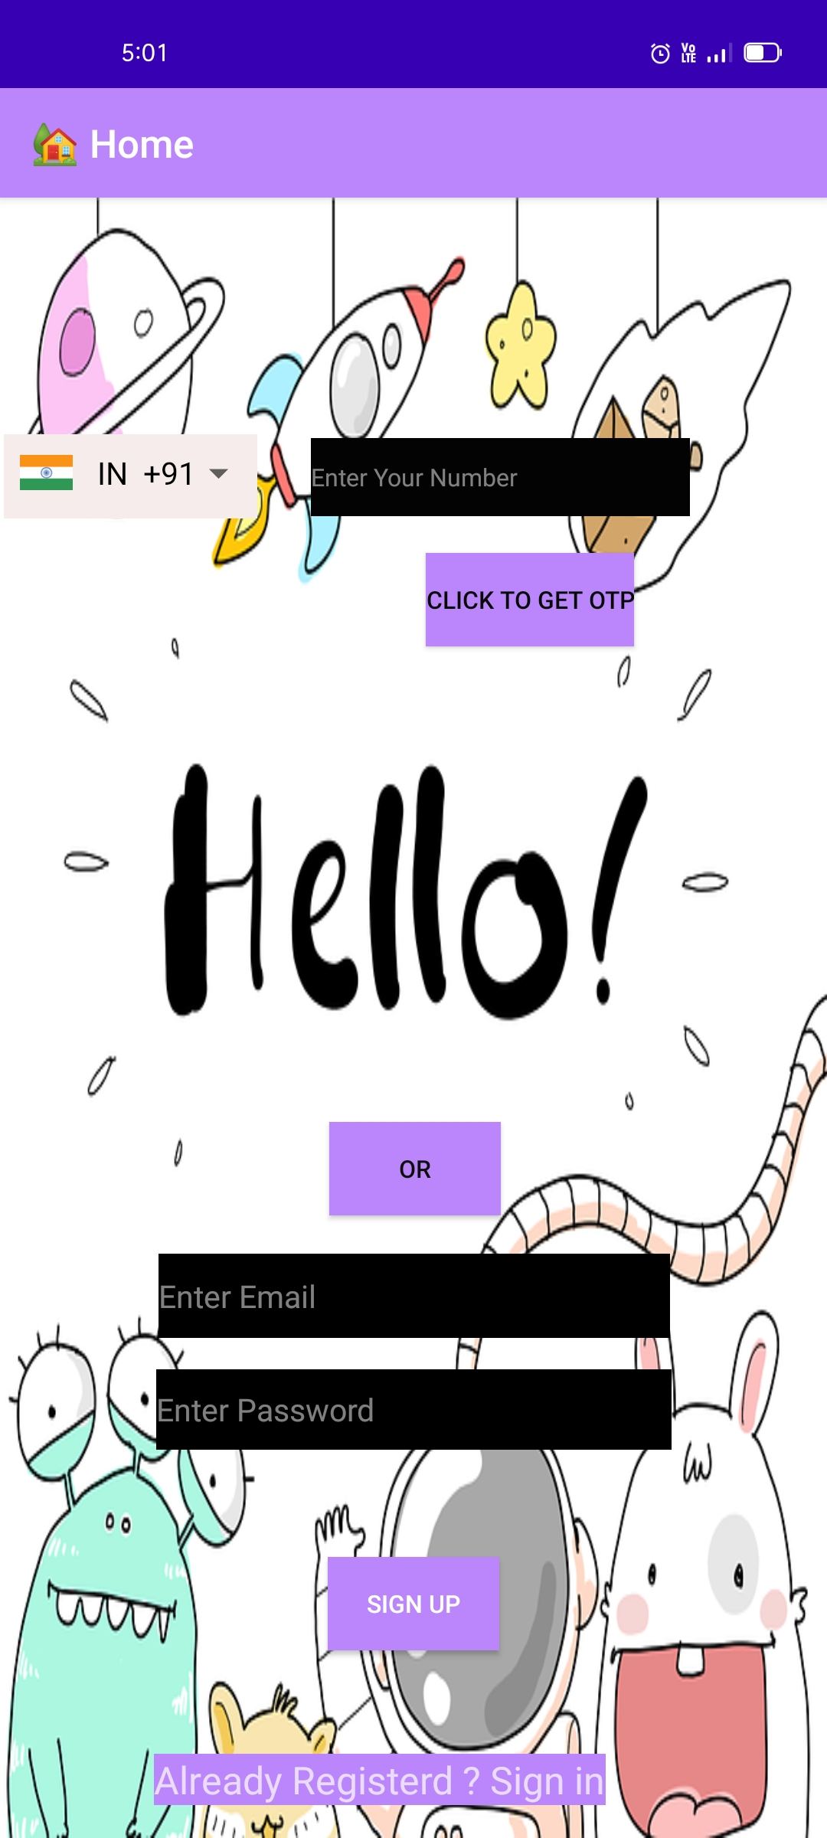

<?xml version="1.0" encoding="utf-8"?>

<RelativeLayout xmlns:android="http://schemas.android.com/apk/res/android"

xmlns:app="http://schemas.android.com/apk/res-auto"

xmlns:tools="http://schemas.android.com/tools"

android:layout_width="match_parent"

android:layout_height="match_parent"

android:background="@drawable/h"

tools:context=".MainActivity">

<com.hbb20.CountryCodePicker

android:id="@+id/ccp"

android:layout_width="wrap_content"

android:layout_height="43dp"

android:layout_alignParentStart="true"

android:layout_alignParentTop="true"

android:layout_marginStart="2dp"

android:layout_marginTop="121dp"

android:background="#F6ECEC" />

<EditText

android:id="@+id/editText"

android:layout_width="194dp"

android:layout_height="40dp"

android:layout_alignParentTop="true"

android:layout_alignParentEnd="true"

android:layout_marginTop="123dp"

android:layout_marginEnd="70dp"

android:background="@color/purple_200"

android:backgroundTint="#040303"

android:ems="10"

android:hint="Enter Your Number"

android:inputType="textPersonName"

android:textAppearance="@style/TextAppearance.AppCompat.Body1" />

<Button

android:id="@+id/button"

android:layout_width="wrap_content"

android:layout_height="wrap_content"

android:layout_alignParentStart="true"

android:layout_alignParentBottom="true"

android:layout_marginStart="218dp"

android:layout_marginBottom="610dp"

android:background="@color/purple_200"

android:text="click to get otp"

android:textColor="#070707" />

<Button

android:id="@+id/button5"

android:layout_width="wrap_content"

android:layout_height="wrap_content"

android:layout_alignParentEnd="true"

android:layout_alignParentBottom="true"

android:layout_centerHorizontal="true"

android:layout_marginEnd="167dp"

android:layout_marginBottom="319dp"

android:background="@color/purple_200"

android:text="OR"

android:textColor="#0E0D0D" />

<EditText

android:id="@+id/editText2"

android:layout_width="262dp"

android:layout_height="43dp"

android:layout_alignParentStart="true"

android:layout_alignParentBottom="true"

android:layout_marginStart="81dp"

android:layout_marginBottom="256dp"

android:background="@color/black"

android:ems="10"

android:hint="Enter Email"

android:inputType="textPersonName" />

<EditText

android:id="@+id/editText3"

android:layout_width="264dp"

android:layout_height="41dp"

android:layout_alignParentStart="true"

android:layout_alignParentBottom="true"

android:layout_centerHorizontal="true"

android:layout_marginStart="80dp"

android:layout_marginBottom="199dp"

android:background="@color/black"

android:ems="10"

android:hint="Enter Password"

android:inputType="textPersonName" />

<TextView

android:id="@+id/textView10"

android:layout_width="wrap_content"

android:layout_height="wrap_content"

android:layout_alignParentStart="true"

android:layout_alignParentBottom="true"

android:layout_centerHorizontal="true"

android:layout_marginStart="79dp"

android:layout_marginBottom="17dp"

android:background="@color/purple_200"

android:text="Already Registerd ? Sign in"

android:textSize="22sp" />

<Button

android:id="@+id/button16"

android:layout_width="wrap_content"

android:layout_height="wrap_content"

android:layout_alignParentBottom="true"

android:layout_centerHorizontal="true"

android:layout_marginBottom="96dp"

android:background="@color/purple_200"

android:text="SIGN UP" />

</RelativeLayout>

**second.java**

package com.example.app60;  
  
import androidx.annotation.NonNull;  
import androidx.appcompat.app.AppCompatActivity;  
  
import android.content.Intent;  
import android.os.Bundle;  
import android.view.View;  
import android.widget.Button;  
import android.widget.EditText;  
import android.widget.Toast;  
  
import com.google.android.gms.tasks.OnCompleteListener;  
import com.google.android.gms.tasks.Task;  
import com.google.firebase.FirebaseException;  
import com.google.firebase.auth.AuthResult;  
import com.google.firebase.auth.FirebaseAuth;  
import com.google.firebase.auth.PhoneAuthCredential;  
import com.google.firebase.auth.PhoneAuthProvider;  
import android.os.Bundle;  
import android.view.MenuItem;  
import androidx.annotation.NonNull;  
import androidx.appcompat.app.ActionBar;  
import androidx.appcompat.app.AppCompatActivity;  
  
  
import java.util.concurrent.TimeUnit;  
  
public class second extends AppCompatActivity {  
  
 EditText e1;  
 Button b1;  
 FirebaseAuth firebaseAuth;  
 String phone;  
 String otp;  
  
 @Override  
 protected void onCreate(Bundle savedInstanceState) {  
 super.onCreate(savedInstanceState);  
 setContentView(R.layout.*activity_second*);  
 ActionBar actionBar = getSupportActionBar();  
 actionBar.setDisplayHomeAsUpEnabled(true);  
 getSupportActionBar().setTitle("OTP Verification");  
 phone=getIntent().getStringExtra("mobile").toString();  
 e1=(EditText) findViewById(R.id.*editText2*);  
 b1=(Button) findViewById(R.id.*button2*);  
 firebaseAuth=FirebaseAuth.*getInstance*();  
 genotp();  
 b1.setOnClickListener(new View.OnClickListener() {  
 @Override  
 public void onClick(View view) {  
 String s1 = e1.getText().toString();  
 if(s1.isEmpty())  
 {  
 e1.setError("fill otp");  
 return;  
 }  
 else  
 {  
 if(s1.length()!=6)  
 {  
 e1.setError("wrong number");  
 return;  
 }  
 else  
 {  
 PhoneAuthCredential credential = PhoneAuthProvider.*getCredential*(otp,s1);  
 signInWithPhoneAuthCredential(credential);  
  
 }  
 }  
 }  
 });  
  
 }  
  
 private void genotp()  
 {  
 PhoneAuthProvider.*getInstance*().verifyPhoneNumber(  
 phone,  
 60,  
 TimeUnit.*SECONDS*,  
 this, new PhoneAuthProvider.OnVerificationStateChangedCallbacks() {  
 @Override  
 public void onCodeSent(@NonNull String s, @NonNull PhoneAuthProvider.ForceResendingToken forceResendingToken) {  
 super.onCodeSent(s, forceResendingToken);  
 otp=s;  
 }  
  
 @Override  
 public void onVerificationCompleted(@NonNull PhoneAuthCredential phoneAuthCredential) {  
  
 PhoneAuthCredential PhoneAuthCredential = null;  
 signInWithPhoneAuthCredential(PhoneAuthCredential);  
  
 }  
  
 @Override  
 public void onVerificationFailed(@NonNull FirebaseException e) {  
  
 Toast.*makeText*(second.this, "Wrong OTP", Toast.*LENGTH_SHORT*).show();  
  
 }  
 }  
 );  
 }  
  
 private void signInWithPhoneAuthCredential (PhoneAuthCredential credential)  
 {  
 firebaseAuth.signInWithCredential(credential).addOnCompleteListener(new OnCompleteListener<AuthResult>() {  
 @Override  
 public void onComplete(@NonNull Task<AuthResult> task) {  
 if(task.isSuccessful())  
 {  
 Toast.*makeText*(second.this, "Login Successful !!", Toast.*LENGTH_SHORT*).show();  
 Intent i = new Intent(second.this , all.class);  
 startActivity(i);  
 finish();  
 }  
 else  
 {  
 Toast.*makeText*(second.this, "Wrong OTP !", Toast.*LENGTH_SHORT*).show();  
 }  
 }  
 }  
 );  
 }  
  
 @Override  
 public boolean onOptionsItemSelected(@NonNull MenuItem item) {  
 switch (item.getItemId()) {  
 case android.R.id.*home*:  
 this.finish();  
 return true;  
 }  
 return super.onOptionsItemSelected(item);  
 }  
}

**activity_second.xml**

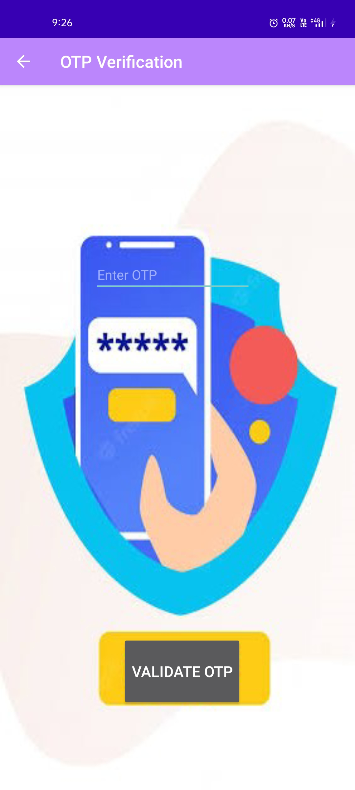

<?xml version="1.0" encoding="utf-8"?><RelativeLayout xmlns:android="http://schemas.android.com/apk/res/android" xmlns:app="http://schemas.android.com/apk/res-auto" xmlns:tools="http://schemas.android.com/tools" android:layout_width="match_parent" android:background="@drawable/otp" android:layout_height="match_parent" tools:context=".second"> <EditText android:id="@+id/editText2" android:layout_width="wrap_content" android:layout_height="wrap_content" android:layout_alignParentTop="true" android:layout_alignParentEnd="true" android:layout_centerHorizontal="true" android:layout_marginTop="205dp" android:layout_marginEnd="123dp" android:ems="10" android:hint="Enter OTP " android:inputType="textPersonName" android:textColor="#191818" /> <Button android:id="@+id/button2" android:layout_width="wrap_content" android:layout_height="85dp" android:layout_alignParentStart="true" android:layout_alignParentBottom="true" android:layout_centerHorizontal="true" android:layout_marginStart="145dp" android:layout_marginBottom="99dp" android:text="Validate OTP" android:textSize="20sp" /></RelativeLayout>

**signin.java**

package com.example.app60;import androidx.annotation.NonNull;import androidx.appcompat.app.AppCompatActivity;import android.content.Intent;import android.os.Bundle;import android.util.Patterns;import android.view.View;import android.widget.Button;import android.widget.EditText;import android.widget.TextView;import android.widget.Toast;import com.google.android.gms.tasks.OnCompleteListener;import com.google.android.gms.tasks.OnFailureListener;import com.google.android.gms.tasks.OnSuccessListener;import com.google.android.gms.tasks.Task;import com.google.firebase.auth.AuthResult;import com.google.firebase.auth.FirebaseAuth;import android.os.Bundle;import android.view.MenuItem;import androidx.annotation.NonNull;import androidx.appcompat.app.ActionBar;import androidx.appcompat.app.AppCompatActivity;public class signin extends AppCompatActivity { private EditText e2 , e3 ; private Button b3; private TextView t1; private FirebaseAuth firebaseAuth; @Override protected void onCreate(Bundle savedInstanceState) { super.onCreate(savedInstanceState); setContentView(R.layout.*activity_signin*); ActionBar actionBar = getSupportActionBar(); actionBar.setDisplayHomeAsUpEnabled(true); getSupportActionBar().setTitle("Login"); e2=(EditText)findViewById(R.id.*editText2*); e3=(EditText)findViewById(R.id.*editText3*); firebaseAuth=FirebaseAuth.*getInstance*(); b3=(Button) findViewById(R.id.*button15*); t1=(TextView) findViewById(R.id.*textView10*); t1.setOnClickListener(new View.OnClickListener() { @Override public void onClick(View view) { Intent intent = new Intent(signin.this , MainActivity.class); startActivity(intent); //finish(); } }); b3.setOnClickListener(new View.OnClickListener() { @Override public void onClick(View view) { loginuser(); } }); } private void loginuser(){ String email = e2.getText().toString(); String pass = e3.getText().toString(); if(!email.isEmpty() && Patterns.*EMAIL_ADDRESS*.matcher(email).matches()){ if(!pass.isEmpty()) { firebaseAuth.signInWithEmailAndPassword(email , pass).addOnSuccessListener(new OnSuccessListener<AuthResult>() { @Override public void onSuccess(AuthResult authResult) { Toast.*makeText*(signin.this, "Login Successfully !!", Toast.*LENGTH_SHORT*).show(); Intent intent = new Intent(signin.this , all.class); startActivity(intent); finish(); } }).addOnFailureListener(new OnFailureListener() { @Override public void onFailure(@NonNull Exception e) { Toast.*makeText*(signin.this, "Login Failed !!", Toast.*LENGTH_SHORT*).show(); } }); }else { e3.setError("Empty Space is Not Allowd !"); } }else if (email.isEmpty()){ e2.setError("Empty Space is Not Allowed !"); }else{ e2.setError("Please Enter Correct Email"); } } @Override public boolean onOptionsItemSelected(@NonNull MenuItem item) { switch (item.getItemId()) { case android.R.id.*home*: this.finish(); return true; } return super.onOptionsItemSelected(item); }}

**activity_signin.xml**

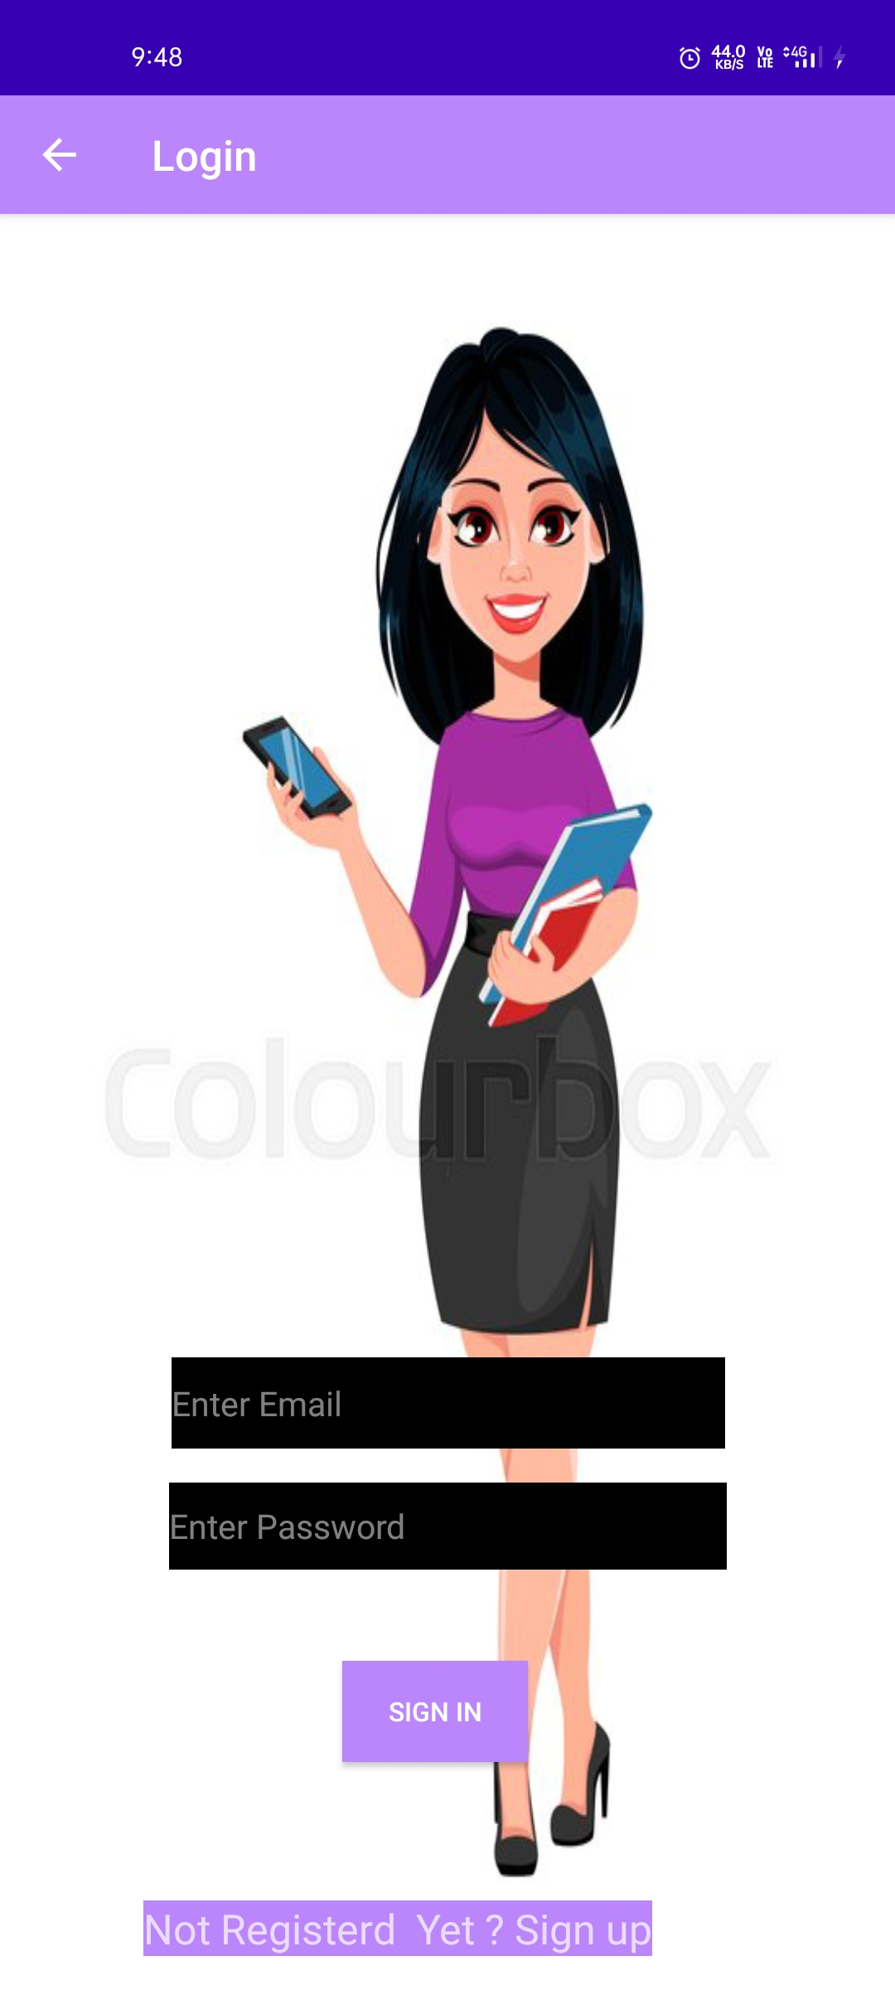

<?xml version="1.0" encoding="utf-8"?><RelativeLayout xmlns:android="http://schemas.android.com/apk/res/android" xmlns:app="http://schemas.android.com/apk/res-auto" xmlns:tools="http://schemas.android.com/tools" android:layout_width="match_parent" android:layout_height="match_parent" android:background="@drawable/login" tools:context=".signin"> <EditText android:id="@+id/editText2" android:layout_width="262dp" android:layout_height="43dp" android:layout_alignParentStart="true" android:layout_alignParentBottom="true" android:layout_marginStart="81dp" android:layout_marginBottom="256dp" android:background="@color/black" android:ems="10" android:hint="Enter Email" android:inputType="textPersonName" /> <EditText android:id="@+id/editText3" android:layout_width="264dp" android:layout_height="41dp" android:layout_alignParentStart="true" android:layout_alignParentBottom="true" android:layout_centerHorizontal="true" android:layout_marginStart="80dp" android:layout_marginBottom="199dp" android:background="@color/black" android:ems="10" android:hint="Enter Password" android:inputType="textPersonName" /> <TextView android:id="@+id/textView10" android:layout_width="wrap_content" android:layout_height="wrap_content" android:layout_alignParentStart="true" android:layout_alignParentBottom="true" android:layout_centerHorizontal="true" android:layout_marginStart="68dp" android:layout_marginBottom="16dp" android:background="@color/purple_200" android:text="Not Registerd Yet ? Sign up" android:textSize="22sp" /> <Button android:id="@+id/button15" android:layout_width="wrap_content" android:layout_height="wrap_content" android:layout_alignParentStart="true" android:layout_alignParentBottom="true" android:layout_centerHorizontal="true" android:layout_marginStart="162dp" android:layout_marginBottom="108dp" android:background="@color/purple_200" android:text="Sign In" /></RelativeLayout>

**all.java**

package com.example.app60;import androidx.appcompat.app.AppCompatActivity;import android.content.Intent;import android.os.Bundle;import android.view.View;import android.widget.ImageButton;import android.view.MenuItem;import androidx.annotation.NonNull;import androidx.appcompat.app.ActionBar;public class all extends AppCompatActivity { ImageButton ib1,ib2,ib3; @Override protected void onCreate(Bundle savedInstanceState) { super.onCreate(savedInstanceState); setContentView(R.layout.*activity_all*); getSupportActionBar().setTitle("🏡 Home"); ActionBar actionBar = getSupportActionBar(); actionBar.setDisplayHomeAsUpEnabled(true); ib1 = (ImageButton) findViewById(R.id.*imageButton26*); ib2 = (ImageButton) findViewById(R.id.*imageButton3*); ib3 = (ImageButton) findViewById(R.id.*imageButton29*); ib1.setOnClickListener(new View.OnClickListener() { @Override public void onClick(View view) { Intent i = new Intent( all.this , games.class); startActivity(i); //finish(); } }); ib2.setOnClickListener(new View.OnClickListener() { @Override public void onClick(View view) { Intent i = new Intent( all.this , tools.class); startActivity(i); //finish(); } }); ib3.setOnClickListener(new View.OnClickListener() { @Override public void onClick(View view) { Intent intent = new Intent(all.this,third.class); startActivity(intent); //finish(); } }); } @Override public boolean onOptionsItemSelected(@NonNull MenuItem item) { switch (item.getItemId()) { case android.R.id.*home*: this.finish(); return true; } return super.onOptionsItemSelected(item); }}

**activity_all.xml**

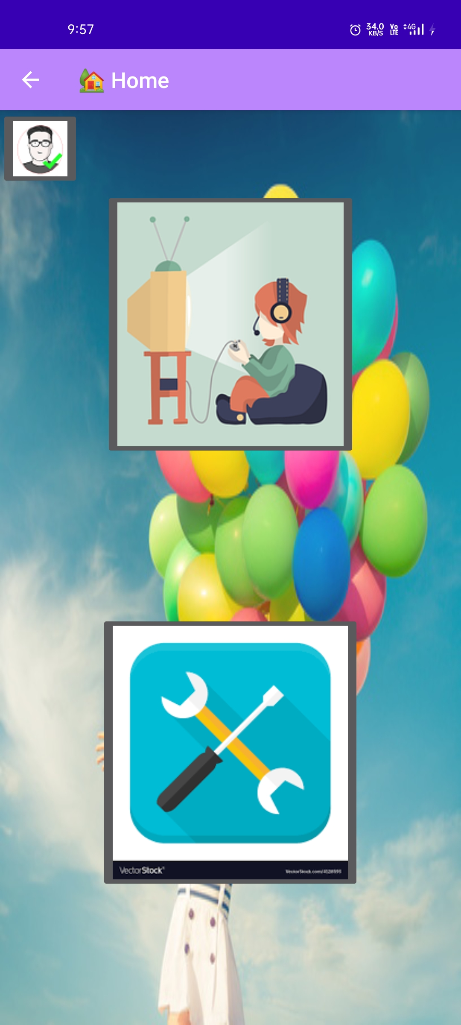

<?xml version="1.0" encoding="utf-8"?><RelativeLayout xmlns:android="http://schemas.android.com/apk/res/android" xmlns:app="http://schemas.android.com/apk/res-auto" xmlns:tools="http://schemas.android.com/tools" android:layout_width="match_parent" android:layout_height="match_parent" android:background="@drawable/b1" tools:context=".all"> <ImageButton android:id="@+id/imageButton26" android:layout_width="wrap_content" android:layout_height="wrap_content" android:layout_alignParentTop="true" android:layout_centerHorizontal="true" android:layout_marginTop="75dp" app:srcCompat="@drawable/g" tools:layout_editor_absoluteX="78dp" tools:layout_editor_absoluteY="97dp" /> <ImageButton android:id="@+id/imageButton3" android:layout_width="wrap_content" android:layout_height="wrap_content" android:layout_alignParentBottom="true" android:layout_centerHorizontal="true" android:layout_marginBottom="124dp" app:layout_constraintEnd_toEndOf="parent" app:layout_constraintHorizontal_bias="0.456" app:layout_constraintStart_toStartOf="parent" app:srcCompat="@drawable/tt" tools:layout_editor_absoluteY="379dp" /> <ImageButton android:id="@+id/imageButton29" android:layout_width="wrap_content" android:layout_height="wrap_content" android:layout_alignParentStart="true" android:layout_alignParentTop="true" app:srcCompat="@drawable/pro" /></RelativeLayout>

**third.java**

package com.example.app60;import androidx.appcompat.app.AppCompatActivity;import android.content.Intent;import android.os.Bundle;import android.view.View;import android.widget.Button;import android.widget.EditText;import android.widget.Toast;import android.os.Bundle;import android.view.MenuItem;import androidx.annotation.NonNull;import androidx.appcompat.app.ActionBar;import androidx.appcompat.app.AppCompatActivity;import com.google.firebase.auth.FirebaseAuth;import com.google.firebase.database.DatabaseReference;import com.google.firebase.database.FirebaseDatabase;public class third extends AppCompatActivity { Button b1,b2; FirebaseAuth firebaseAuth; EditText e1,e2,e3; FirebaseDatabase firebaseDatabase; DatabaseReference databaseReference; @Override protected void onCreate(Bundle savedInstanceState) { super.onCreate(savedInstanceState); setContentView(R.layout.*activity_third*); ActionBar actionBar = getSupportActionBar(); actionBar.setDisplayHomeAsUpEnabled(true); getSupportActionBar().setTitle("Profile"); b1=(Button) findViewById(R.id.*button4*); b2=(Button) findViewById(R.id.*button3*); e1=(EditText)findViewById(R.id.*editText3*); e2=(EditText)findViewById(R.id.*editText4*); e3=(EditText)findViewById(R.id.*editText5*); firebaseDatabase = FirebaseDatabase.*getInstance*(); firebaseAuth=FirebaseAuth.*getInstance*(); b1.setOnClickListener(new View.OnClickListener() { @Override public void onClick(View view) { firebaseAuth.signOut(); Intent i = new Intent(getApplicationContext() , MainActivity.class); i.addFlags(Intent.*FLAG_ACTIVITY_CLEAR_TOP*); startActivity(i); } }); b2.setOnClickListener(new View.OnClickListener() { @Override public void onClick(View view) { databaseReference = firebaseDatabase.getReference("Users"); String s1 = e1.getText().toString(); String s2 = e2.getText().toString(); String s3 = e3.getText().toString(); if(s3.length()!=10) { Toast.*makeText*(third.this, "Invalid Entry !!", Toast.*LENGTH_SHORT*).show(); } else { Users users = new Users(s1,s2,s3); databaseReference.child(s3).setValue(users); Toast.*makeText*(third.this, "updated", Toast.*LENGTH_SHORT*).show(); } } }); } @Override public boolean onOptionsItemSelected(@NonNull MenuItem item) { switch (item.getItemId()) { case android.R.id.*home*: this.finish(); return true; } return super.onOptionsItemSelected(item); }}

**activity_third.xml**

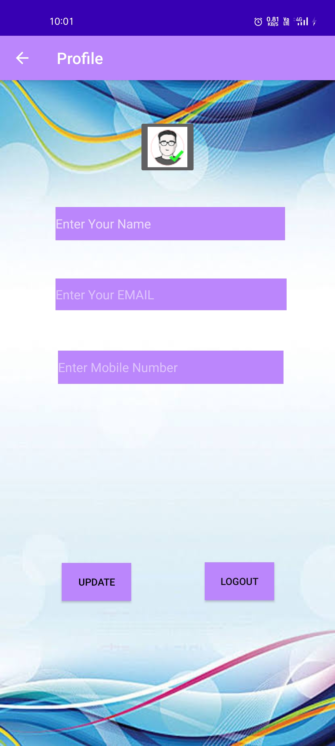

<?xml version="1.0" encoding="utf-8"?><RelativeLayout xmlns:android="http://schemas.android.com/apk/res/android" xmlns:app="http://schemas.android.com/apk/res-auto" xmlns:tools="http://schemas.android.com/tools" android:layout_width="match_parent" android:layout_height="match_parent" android:background="@drawable/profile" tools:context=".third"> <EditText android:id="@+id/editText3" android:layout_width="292dp" android:layout_height="40dp" android:layout_alignParentTop="true" android:layout_alignParentEnd="true" android:layout_centerHorizontal="true" android:layout_marginTop="250dp" android:layout_marginEnd="61dp" android:background="@color/purple_200" android:ems="10" android:hint="Enter Your EMAIL" android:inputType="textPersonName" /> <EditText android:id="@+id/editText4" android:layout_width="290dp" android:layout_height="42dp" android:layout_alignParentTop="true" android:layout_alignParentEnd="true" android:layout_marginTop="160dp" android:layout_marginEnd="63dp" android:background="@color/purple_200" android:ems="10" android:hint="Enter Your Name" android:inputType="textPersonName" /> <EditText android:id="@+id/editText5" android:layout_width="285dp" android:layout_height="42dp" android:layout_alignParentTop="true" android:layout_alignParentEnd="true" android:layout_centerInParent="true" android:layout_marginTop="341dp" android:layout_marginEnd="65dp" android:background="@color/purple_200" android:ems="10" android:hint="Enter Mobile Number" android:inputType="textPersonName" /> <Button android:id="@+id/button3" android:layout_width="wrap_content" android:layout_height="wrap_content" android:layout_alignParentStart="true" android:layout_alignParentBottom="true" android:layout_marginStart="78dp" android:layout_marginBottom="183dp" android:background="@color/purple_200" android:text="UPDATE" android:textColor="#000000" /> <Button android:id="@+id/button4" android:layout_width="wrap_content" android:layout_height="wrap_content" android:layout_alignParentEnd="true" android:layout_alignParentBottom="true" android:layout_marginEnd="77dp" android:layout_marginBottom="184dp" android:background="@color/purple_200" android:text="LogOut" android:textColor="#0E0E0E" /> <ImageButton android:id="@+id/imageButton30" android:layout_width="wrap_content" android:layout_height="wrap_content" android:layout_alignParentTop="true" android:layout_centerHorizontal="true" android:layout_marginTop="49dp" app:srcCompat="@drawable/pro" /></RelativeLayout>

**games.java**

package com.example.app60;import androidx.appcompat.app.AppCompatActivity;import android.content.Intent;import android.os.Bundle;import android.view.View;import android.widget.ImageButton;import android.os.Bundle;import android.view.MenuItem;import androidx.annotation.NonNull;import androidx.appcompat.app.ActionBar;import androidx.appcompat.app.AppCompatActivity;public class games extends AppCompatActivity { ImageButton ib1,ib2,ib3; @Override protected void onCreate(Bundle savedInstanceState) { super.onCreate(savedInstanceState); setContentView(R.layout.*activity_games*); getSupportActionBar().setTitle("Games"); ActionBar actionBar = getSupportActionBar(); actionBar.setDisplayHomeAsUpEnabled(true); ib1 = (ImageButton) findViewById(R.id.*imageButton2*); ib2 = (ImageButton) findViewById(R.id.*imageButton4*); ib3 = (ImageButton) findViewById(R.id.*imageButton28*); ib1.setOnClickListener(new View.OnClickListener() { @Override public void onClick(View view) { Intent i = new Intent(games.this , four.class); startActivity(i); //finish(); } }); ib2.setOnClickListener(new View.OnClickListener() { @Override public void onClick(View view) { Intent i1 = new Intent(games.this , AddPlayers.class); startActivity(i1); //finish(); } }); ib3.setOnClickListener(new View.OnClickListener() { @Override public void onClick(View view) { Intent intent = new Intent(games.this , quiz.class); startActivity(intent); //finish(); } }); } @Override public boolean onOptionsItemSelected(@NonNull MenuItem item) { switch (item.getItemId()) { case android.R.id.*home*: this.finish(); return true; } return super.onOptionsItemSelected(item); }}

**activity_games.xml**

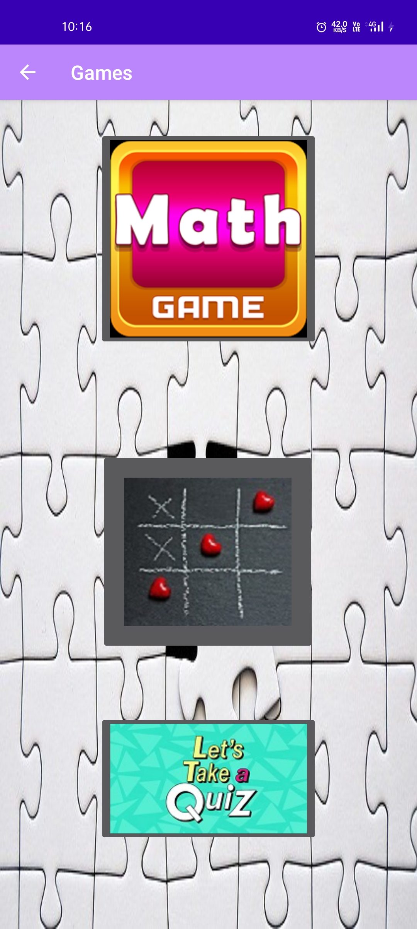

<?xml version="1.0" encoding="utf-8"?><RelativeLayout xmlns:android="http://schemas.android.com/apk/res/android" xmlns:app="http://schemas.android.com/apk/res-auto" xmlns:tools="http://schemas.android.com/tools" android:layout_width="match_parent" android:layout_height="match_parent" android:background="@drawable/p" tools:context=".games"> <ImageButton android:id="@+id/imageButton2" android:layout_width="wrap_content" android:layout_height="wrap_content" android:layout_alignParentTop="true" android:layout_centerHorizontal="true" android:layout_marginTop="31dp" app:layout_constraintEnd_toEndOf="parent" app:layout_constraintStart_toStartOf="parent" app:srcCompat="@drawable/m1" tools:layout_editor_absoluteY="3dp" /> <ImageButton android:id="@+id/imageButton4" android:layout_width="218dp" android:layout_height="202dp" android:layout_alignParentStart="true" android:layout_alignParentBottom="true" android:layout_centerInParent="true" android:layout_marginStart="102dp" android:layout_marginBottom="281dp" app:layout_constraintEnd_toEndOf="parent" app:layout_constraintStart_toStartOf="parent" app:srcCompat="@drawable/ti" tools:layout_editor_absoluteY="250dp" /> <ImageButton android:id="@+id/imageButton28" android:layout_width="wrap_content" android:layout_height="wrap_content" android:layout_alignParentBottom="true" android:layout_centerHorizontal="true" android:layout_marginBottom="87dp" app:srcCompat="@drawable/quiz" /></RelativeLayout>

**four.java**

package com.example.app60;import androidx.appcompat.app.AppCompatActivity;import android.content.Intent;import android.os.Bundle;import android.view.View;import android.widget.Button;import android.os.Bundle;import android.view.MenuItem;import androidx.annotation.NonNull;import androidx.appcompat.app.ActionBar;import androidx.appcompat.app.AppCompatActivity;public class four extends AppCompatActivity { Button b1,b2,b3; @Override protected void onCreate(Bundle savedInstanceState) { super.onCreate(savedInstanceState); setContentView(R.layout.*activity_four*); getSupportActionBar().setTitle("Math Game ?"); ActionBar actionBar = getSupportActionBar(); actionBar.setDisplayHomeAsUpEnabled(true); b1=(Button) findViewById(R.id.*button6*); b2=(Button) findViewById(R.id.*button7*); b3=(Button) findViewById(R.id.*button8*); b1.setOnClickListener(new View.OnClickListener() { @Override public void onClick(View view) { Intent i = new Intent( four.this , fourone.class); startActivity(i); // finish(); } }); b2.setOnClickListener(new View.OnClickListener() { @Override public void onClick(View view) { Intent i2 = new Intent(four.this ,fourtwo.class); startActivity(i2); // finish(); } }); b3.setOnClickListener(new View.OnClickListener() { @Override public void onClick(View view) { Intent i3 = new Intent(four.this ,fourthree.class); startActivity(i3); // finish(); } }); } @Override public boolean onOptionsItemSelected(@NonNull MenuItem item) { switch (item.getItemId()) { case android.R.id.*home*: this.finish(); return true; } return super.onOptionsItemSelected(item); }}

**activity_four.xml**

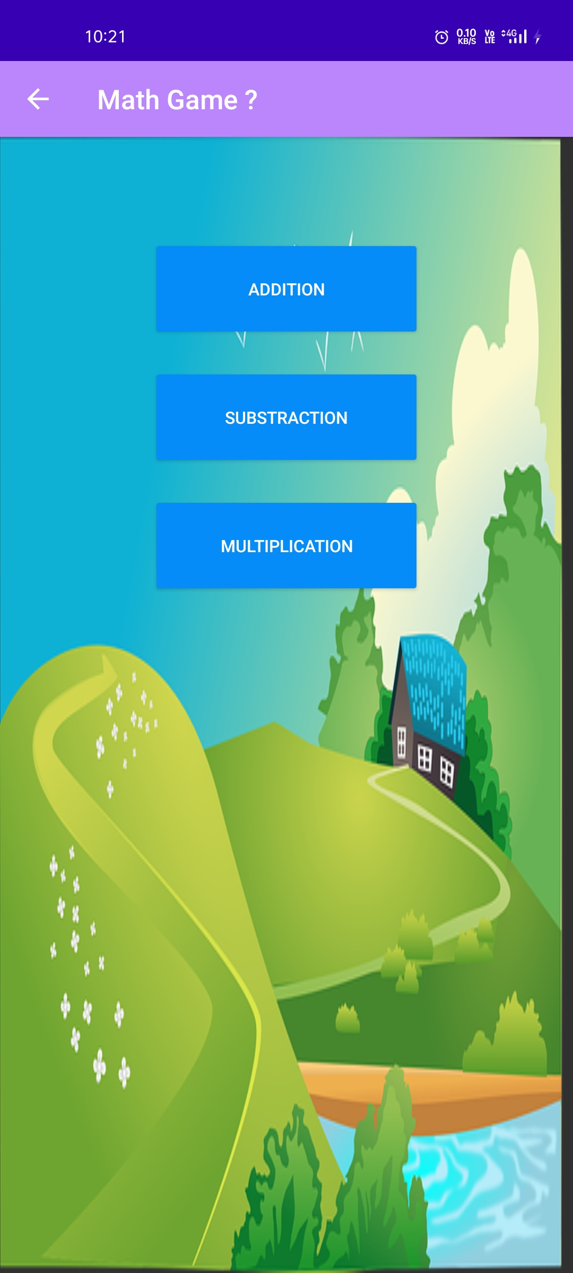

<?xml version="1.0" encoding="utf-8"?><LinearLayout xmlns:android="http://schemas.android.com/apk/res/android" xmlns:app="http://schemas.android.com/apk/res-auto" xmlns:tools="http://schemas.android.com/tools" android:layout_width="match_parent" android:layout_height="match_parent" android:background="@drawable/a" android:gravity="center_horizontal" android:orientation="vertical" tools:context=".four"> <androidx.constraintlayout.widget.Guideline android:id="@+id/guideline2" android:layout_width="wrap_content" android:layout_height="wrap_content" android:orientation="vertical" app:layout_constraintGuide_begin="20dp" /> <Button android:id="@+id/button6" android:layout_width="200dp" android:layout_height="75dp" android:layout_marginTop="75dp" android:backgroundTint="#058CF8" android:text="ADDITION" /> <Button android:id="@+id/button7" android:layout_width="200dp" android:layout_height="75dp" android:layout_marginTop="20dp" android:backgroundTint="#058CF8" android:text="SUBSTRACTION" /> <Button android:id="@+id/button8" android:layout_width="200dp" android:layout_height="75dp" android:layout_marginTop="20dp" android:backgroundTint="#058CF8" android:text="MULTIPLICATION" /></LinearLayout>

**fourone.java**

package com.example.app60;import androidx.appcompat.app.AppCompatActivity;import android.content.Intent;import android.os.Bundle;import android.os.CountDownTimer;import android.view.View;import android.widget.Button;import android.widget.EditText;import android.widget.TextView;import android.widget.Toast;import android.os.Bundle;import android.view.MenuItem;import androidx.annotation.NonNull;import androidx.appcompat.app.ActionBar;import androidx.appcompat.app.AppCompatActivity;import java.util.Locale;import java.util.Random;public class fourone extends AppCompatActivity { TextView t1,t2,t3,t4; EditText e1; Button b1,b2,b3,b4; Random random = new Random(); int number1 , number2; int ans; int rans; int score = 0; int life = 3; CountDownTimer timer; private static final long *START_TIMER* = 10000; Boolean run; long time_left = *START_TIMER*; @Override protected void onCreate(Bundle savedInstanceState) { super.onCreate(savedInstanceState); setContentView(R.layout.*activity_fourone*); getSupportActionBar().setTitle("Math Game ?"); ActionBar actionBar = getSupportActionBar(); actionBar.setDisplayHomeAsUpEnabled(true); t1=(TextView) findViewById(R.id.*textView2*); //score t2=(TextView) findViewById(R.id.*textView4*); //life t3=(TextView) findViewById(R.id.*textView6*); //time t4=(TextView) findViewById(R.id.*textView7*); //question e1=(EditText)findViewById(R.id.*editText6*); //answer b1=(Button) findViewById(R.id.*button9*); //ok b2=(Button) findViewById(R.id.*button10*); //next question b3=(Button) findViewById(R.id.*button11*); b4=(Button) findViewById(R.id.*button12*); game(); b1.setOnClickListener(new View.OnClickListener() { @Override public void onClick(View view) { ans = Integer.*valueOf*(e1.getText().toString()); pauseTimer(); if(ans == rans) { score = score + 10; t1.setText(""+score); t4.setText("Congratulations , Your answer is True ."); } else { life = life - 1; t2.setText(""+life); t4.setText("Sorry , Your Answer is wrong ."); } if(life <= 0) { Toast.*makeText*(fourone.this, "GAME OVER", Toast.*LENGTH_SHORT*).show(); Intent intent1 = new Intent(fourone.this , result.class); intent1.putExtra("score",score); startActivity(intent1); finish(); } } }); b2.setOnClickListener(new View.OnClickListener() { @Override public void onClick(View view) { e1.setText(""); game(); resetTimer(); } }); b3.setOnClickListener(new View.OnClickListener() { @Override public void onClick(View view) { Intent i1 = new Intent(fourone.this , result.class); startActivity(i1); finish(); } }); b4.setOnClickListener(new View.OnClickListener() { @Override public void onClick(View view) { Intent i2 = new Intent(fourone.this , four.class); startActivity(i2); finish(); } }); } public void game() { number1 = random.nextInt(100); number2 = random.nextInt(100); rans = number1 + number2; t4.setText(number1 + " + " + number2); startTimer(); } public void startTimer() { timer = new CountDownTimer(time_left,1000) { @Override public void onTick(long l) { time_left = l; updateText(); } @Override public void onFinish() { run = false; pauseTimer(); resetTimer(); updateText(); life = life - 1 ; t2.setText(""+life); t4.setText("Sorry ! Time is up !"); } }.start(); run = true; } public void updateText() { int seconds = (int)(time_left / 1000) % 60; String s1 = String.*format*(Locale.*getDefault*(),"%02d",seconds); t3.setText(s1); } public void pauseTimer() { timer.cancel(); run = false; } public void resetTimer() { time_left = *START_TIMER*; updateText(); } @Override public boolean onOptionsItemSelected(@NonNull MenuItem item) { switch (item.getItemId()) { case android.R.id.*home*: this.finish(); return true; } return super.onOptionsItemSelected(item); }}

**activity_fourone.xml**

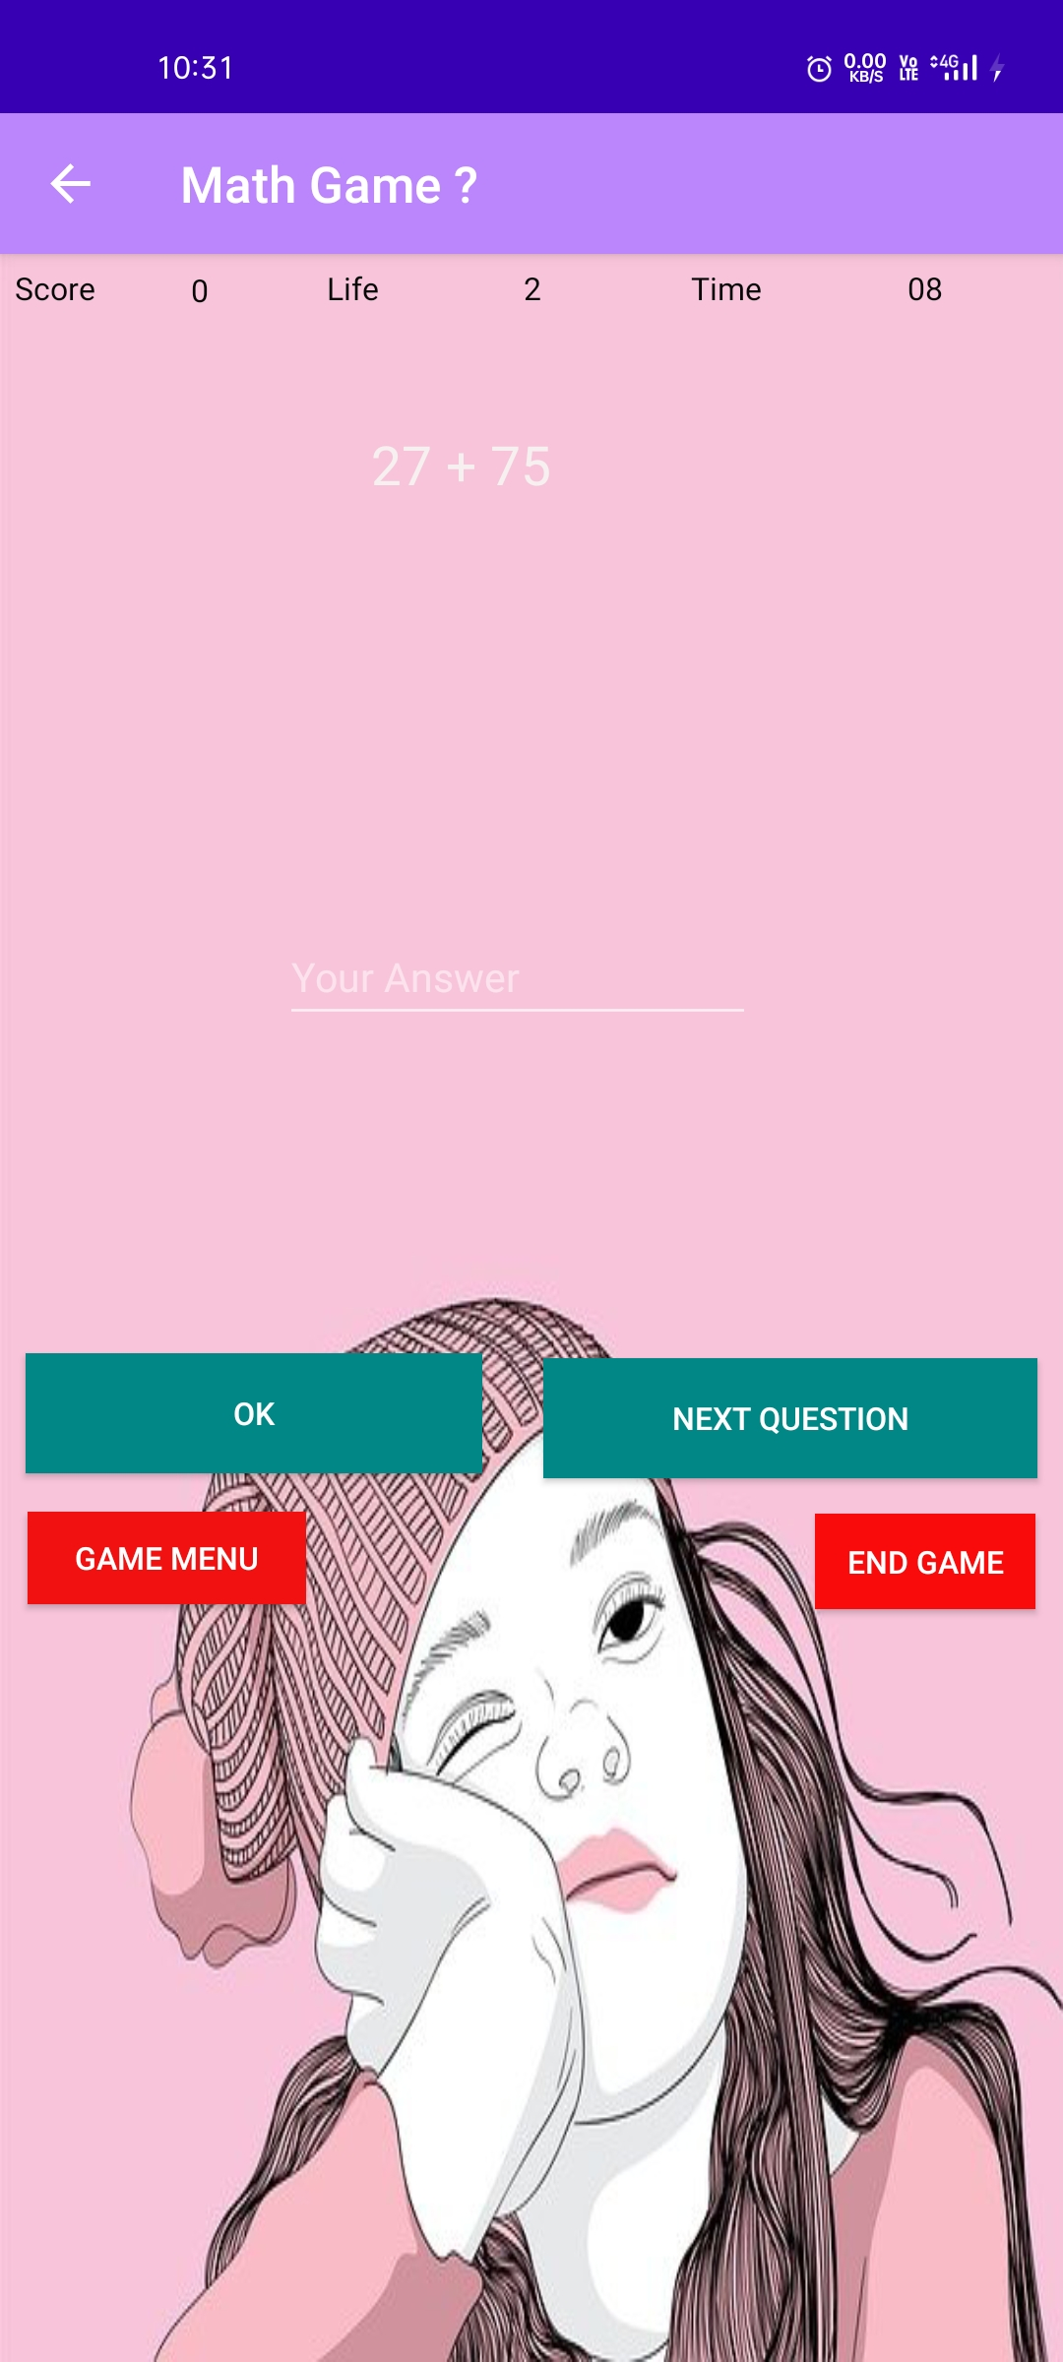

<?xml version="1.0" encoding="utf-8"?><RelativeLayout xmlns:android="http://schemas.android.com/apk/res/android" xmlns:app="http://schemas.android.com/apk/res-auto" xmlns:tools="http://schemas.android.com/tools" android:layout_width="match_parent" android:layout_height="match_parent" android:orientation="vertical" android:background="@drawable/b" tools:context=".fourone"> <TextView android:id="@+id/textView" android:layout_width="wrap_content" android:layout_height="wrap_content" android:layout_alignParentStart="true" android:layout_alignParentTop="true" android:layout_marginStart="6dp" android:layout_marginTop="5dp" android:text="Score" android:textColor="#070707" /> <TextView android:id="@+id/textView2" android:layout_width="wrap_content" android:layout_height="wrap_content" android:layout_alignParentStart="true" android:layout_alignParentTop="true" android:layout_marginStart="76dp" android:layout_marginTop="6dp" android:text="0" android:textColor="#070707" /> <TextView android:id="@+id/textView4" android:layout_width="wrap_content" android:layout_height="wrap_content" android:layout_alignParentTop="true" android:layout_alignParentEnd="true" android:layout_centerHorizontal="true" android:layout_marginTop="5dp" android:layout_marginEnd="208dp" android:text="3" android:textColor="#070707" /> <TextView android:id="@+id/textView3" android:layout_width="wrap_content" android:layout_height="wrap_content" android:layout_alignParentStart="true" android:layout_alignParentTop="true" android:layout_marginStart="130dp" android:layout_marginTop="5dp" android:text="Life" android:textColor="#070707" /> <TextView android:id="@+id/textView5" android:layout_width="wrap_content" android:layout_height="wrap_content" android:layout_alignParentTop="true" android:layout_alignParentEnd="true" android:layout_marginTop="5dp" android:layout_marginEnd="120dp" android:text="Time" android:textColor="#070707" /> <TextView android:id="@+id/textView6" android:layout_width="wrap_content" android:layout_height="wrap_content" android:layout_alignParentTop="true" android:layout_alignParentEnd="true" android:layout_marginTop="5dp" android:layout_marginEnd="48dp" android:text="60" android:textColor="#070707" /> <TextView android:id="@+id/textView7" android:layout_width="180dp" android:layout_height="176dp" android:layout_alignParentStart="true" android:layout_alignParentTop="true" android:layout_centerHorizontal="true" android:layout_marginStart="148dp" android:layout_marginTop="69dp" android:text="TextView" android:textColor="#F6F0F0" android:textSize="24sp" /> <EditText android:id="@+id/editText6" android:layout_width="wrap_content" android:layout_height="wrap_content" android:layout_alignParentStart="true" android:layout_alignParentTop="true" android:layout_centerHorizontal="true" android:layout_marginStart="112dp" android:layout_marginTop="267dp" android:ems="10" android:hint="Your Answer" android:inputType="textPersonName" /> <Button android:id="@+id/button9" android:layout_width="182dp" android:layout_height="wrap_content" android:layout_alignParentStart="true" android:layout_alignParentBottom="true" android:layout_marginStart="10dp" android:layout_marginBottom="354dp" android:background="@color/teal_700" android:text="OK" /> <Button android:id="@+id/button10" android:layout_width="197dp" android:layout_height="wrap_content" android:layout_alignParentEnd="true" android:layout_alignParentBottom="true" android:layout_centerVertical="true" android:layout_marginEnd="10dp" android:layout_marginBottom="352dp" android:background="@color/teal_700" android:text="Next Question" /> <Button android:id="@+id/button11" android:layout_width="wrap_content" android:layout_height="38dp" android:layout_alignParentEnd="true" android:layout_alignParentBottom="true" android:layout_marginEnd="11dp" android:layout_marginBottom="300dp" android:background="#FA0B0B" android:text="End Game" /> <Button android:id="@+id/button12" android:layout_width="111dp" android:layout_height="37dp" android:layout_alignParentStart="true" android:layout_alignParentBottom="true" android:layout_marginStart="11dp" android:layout_marginBottom="302dp" android:background="#F11111" android:text="GAME MENU" /></RelativeLayout>

**fourtwo.java**

package com.example.app60;import androidx.annotation.NonNull;import androidx.appcompat.app.AppCompatActivity;import android.content.Intent;import android.os.Bundle;import android.os.CountDownTimer;import android.view.MenuItem;import android.view.View;import android.widget.Button;import android.widget.EditText;import android.widget.TextView;import android.widget.Toast;import java.util.Locale;import java.util.Random;import android.os.Bundle;import android.view.MenuItem;import androidx.annotation.NonNull;import androidx.appcompat.app.ActionBar;import androidx.appcompat.app.AppCompatActivity;public class fourtwo extends AppCompatActivity { TextView t1,t2,t3,t4; EditText e1; Button b1,b2,b3,b4; Random random = new Random(); int number1 , number2; int ans; int rans; int score = 0; int life = 3; CountDownTimer timer; private static final long *START_TIMER* = 30000; Boolean run; long time_left = *START_TIMER*; @Override protected void onCreate(Bundle savedInstanceState) { super.onCreate(savedInstanceState); setContentView(R.layout.*activity_fourone*); getSupportActionBar().setTitle("Math Game ?"); ActionBar actionBar = getSupportActionBar(); actionBar.setDisplayHomeAsUpEnabled(true); t1=(TextView) findViewById(R.id.*textView2*); //score t2=(TextView) findViewById(R.id.*textView4*); //life t3=(TextView) findViewById(R.id.*textView6*); //time t4=(TextView) findViewById(R.id.*textView7*); //question e1=(EditText)findViewById(R.id.*editText6*); //answer b1=(Button) findViewById(R.id.*button9*); //ok b2=(Button) findViewById(R.id.*button10*); //next question b3=(Button) findViewById(R.id.*button11*); b4=(Button) findViewById(R.id.*button12*); game(); b1.setOnClickListener(new View.OnClickListener() { @Override public void onClick(View view) { ans = Integer.*valueOf*(e1.getText().toString()); pauseTimer(); if(ans == rans) { score = score + 10; t1.setText(""+score); t4.setText("Congratulations , Your answer is True ."); } else { life = life - 1; t2.setText(""+life); t4.setText("Sorry , Your Answer is wrong ."); } if(life <= 0) { Toast.*makeText*(fourtwo.this, "GAME OVER", Toast.*LENGTH_SHORT*).show(); Intent intent = new Intent(fourtwo.this , result.class); intent.putExtra("score",score); startActivity(intent); finish(); } } }); b2.setOnClickListener(new View.OnClickListener() { @Override public void onClick(View view) { e1.setText(""); game(); resetTimer(); } }); b3.setOnClickListener(new View.OnClickListener() { @Override public void onClick(View view) { Intent i1 = new Intent(fourtwo.this , result.class); startActivity(i1); finish(); } }); b4.setOnClickListener(new View.OnClickListener() { @Override public void onClick(View view) { Intent i2 = new Intent(fourtwo.this , four.class); startActivity(i2); finish(); } }); } public void game() { number1 = random.nextInt(100); number2 = random.nextInt(100); rans = number1 - number2; t4.setText(number1 + " - " + number2); startTimer(); } public void startTimer() { timer = new CountDownTimer(time_left,1000) { @Override public void onTick(long l) { time_left = l; updateText(); } @Override public void onFinish() { run = false; pauseTimer(); resetTimer(); updateText(); life = life - 1 ; t2.setText(""+life); t4.setText("Sorry ! Time is up !"); } }.start(); run = true; } public void updateText() { int seconds = (int)(time_left / 1000) % 60; String s1 = String.*format*(Locale.*getDefault*(),"%02d",seconds); t3.setText(s1); } public void pauseTimer() { timer.cancel(); run = false; } public void resetTimer() { time_left = *START_TIMER*; updateText(); } @Override public boolean onOptionsItemSelected(@NonNull MenuItem item) { switch (item.getItemId()) { case android.R.id.*home*: this.finish(); return true; } return super.onOptionsItemSelected(item); }}

**activity_fourtwo.xml**

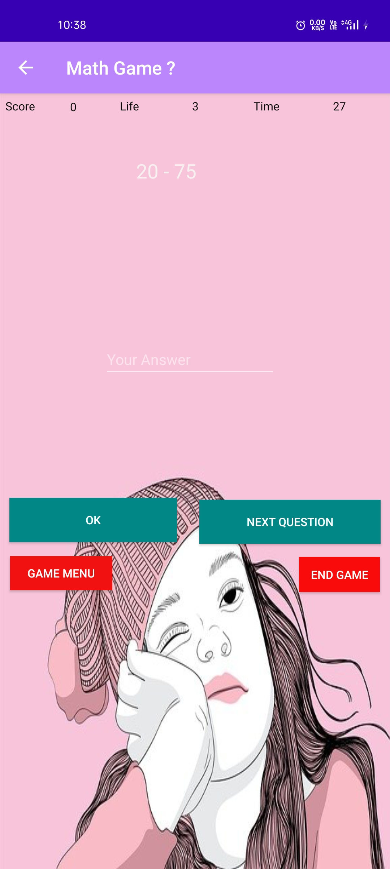

<?xml version="1.0" encoding="utf-8"?><RelativeLayout xmlns:android="http://schemas.android.com/apk/res/android" xmlns:app="http://schemas.android.com/apk/res-auto" xmlns:tools="http://schemas.android.com/tools" android:layout_width="match_parent" android:layout_height="match_parent" android:orientation="vertical" android:background="@drawable/b" tools:context=".fourtwo"> <TextView android:id="@+id/textView" android:layout_width="wrap_content" android:layout_height="wrap_content" android:layout_alignParentStart="true" android:layout_alignParentTop="true" android:layout_marginStart="6dp" android:layout_marginTop="5dp" android:text="Score" android:textColor="#070707" /> <TextView android:id="@+id/textView2" android:layout_width="wrap_content" android:layout_height="wrap_content" android:layout_alignParentStart="true" android:layout_alignParentTop="true" android:layout_marginStart="76dp" android:layout_marginTop="6dp" android:text="0" android:textColor="#070707" /> <TextView android:id="@+id/textView4" android:layout_width="wrap_content" android:layout_height="wrap_content" android:layout_alignParentTop="true" android:layout_alignParentEnd="true" android:layout_centerHorizontal="true" android:layout_marginTop="5dp" android:layout_marginEnd="208dp" android:text="3" android:textColor="#070707" /> <TextView android:id="@+id/textView3" android:layout_width="wrap_content" android:layout_height="wrap_content" android:layout_alignParentStart="true" android:layout_alignParentTop="true" android:layout_marginStart="130dp" android:layout_marginTop="5dp" android:text="Life" android:textColor="#070707" /> <TextView android:id="@+id/textView5" android:layout_width="wrap_content" android:layout_height="wrap_content" android:layout_alignParentTop="true" android:layout_alignParentEnd="true" android:layout_marginTop="5dp" android:layout_marginEnd="120dp" android:text="Time" android:textColor="#070707" /> <TextView android:id="@+id/textView6" android:layout_width="wrap_content" android:layout_height="wrap_content" android:layout_alignParentTop="true" android:layout_alignParentEnd="true" android:layout_marginTop="5dp" android:layout_marginEnd="48dp" android:text="60" android:textColor="#070707" /> <TextView android:id="@+id/textView7" android:layout_width="180dp" android:layout_height="176dp" android:layout_alignParentStart="true" android:layout_alignParentTop="true" android:layout_centerHorizontal="true" android:layout_marginStart="148dp" android:layout_marginTop="69dp" android:text="TextView" android:textColor="#F6F0F0" android:textSize="24sp" /> <EditText android:id="@+id/editText6" android:layout_width="wrap_content" android:layout_height="wrap_content" android:layout_alignParentStart="true" android:layout_alignParentTop="true" android:layout_centerHorizontal="true" android:layout_marginStart="112dp" android:layout_marginTop="267dp" android:ems="10" android:hint="Your Answer" android:inputType="textPersonName" /> <Button android:id="@+id/button9" android:layout_width="182dp" android:layout_height="wrap_content" android:layout_alignParentStart="true" android:layout_alignParentBottom="true" android:layout_marginStart="10dp" android:layout_marginBottom="354dp" android:background="@color/teal_700" android:text="OK" /> <Button android:id="@+id/button10" android:layout_width="197dp" android:layout_height="wrap_content" android:layout_alignParentEnd="true" android:layout_alignParentBottom="true" android:layout_centerVertical="true" android:layout_marginEnd="10dp" android:layout_marginBottom="352dp" android:background="@color/teal_700" android:text="Next Question" /> <Button android:id="@+id/button11" android:layout_width="wrap_content" android:layout_height="38dp" android:layout_alignParentEnd="true" android:layout_alignParentBottom="true" android:layout_marginEnd="11dp" android:layout_marginBottom="300dp" android:background="#FA0B0B" android:text="End Game" /> <Button android:id="@+id/button12" android:layout_width="111dp" android:layout_height="37dp" android:layout_alignParentStart="true" android:layout_alignParentBottom="true" android:layout_marginStart="11dp" android:layout_marginBottom="302dp" android:background="#F11111" android:text="GAME MENU" /></RelativeLayout>

**fourthree.java**

package com.example.app60;  
  
import androidx.appcompat.app.AppCompatActivity;  
  
import android.content.Intent;  
import android.os.Bundle;  
import android.os.CountDownTimer;  
import android.view.View;  
import android.widget.Button;  
import android.widget.EditText;  
import android.widget.TextView;  
import android.widget.Toast;  
  
import java.util.Locale;  
import java.util.Random;  
import android.os.Bundle;  
import android.view.MenuItem;  
import androidx.annotation.NonNull;  
import androidx.appcompat.app.ActionBar;  
import androidx.appcompat.app.AppCompatActivity;  
  
public class fourthree extends AppCompatActivity {  
  
 TextView t1,t2,t3,t4;  
 EditText e1;  
 Button b1,b2,b3,b4;  
 Random random = new Random();  
  
 int number1 , number2;  
 int ans;  
 int rans;  
 int score = 0;  
 int life = 3;  
 CountDownTimer timer;  
 private static final long *START_TIMER* = 60000;  
 Boolean run;  
 long time_left = *START_TIMER*;  
  
 @Override  
 protected void onCreate(Bundle savedInstanceState) {  
 super.onCreate(savedInstanceState);  
 setContentView(R.layout.*activity_fourone*);  
 getSupportActionBar().setTitle("Math Game ?");  
 ActionBar actionBar = getSupportActionBar();  
 actionBar.setDisplayHomeAsUpEnabled(true);  
  
 t1=(TextView) findViewById(R.id.*textView2*); //score  
 t2=(TextView) findViewById(R.id.*textView4*); //life  
 t3=(TextView) findViewById(R.id.*textView6*); //time  
 t4=(TextView) findViewById(R.id.*textView7*); //question  
 e1=(EditText)findViewById(R.id.*editText6*); //answer  
 b1=(Button) findViewById(R.id.*button9*); //ok  
 b2=(Button) findViewById(R.id.*button10*); //next question  
 b3=(Button) findViewById(R.id.*button11*);  
 b4=(Button) findViewById(R.id.*button12*);  
  
 game();  
  
 b1.setOnClickListener(new View.OnClickListener() {  
 @Override  
 public void onClick(View view) {  
  
 ans = Integer.*valueOf*(e1.getText().toString());  
  
 pauseTimer();  
  
 if(ans == rans)  
 {  
 score = score + 10;  
 t1.setText(""+score);  
 t4.setText("Congratulations , Your answer is True .");  
 }  
 else  
 {  
  
 life = life - 1;  
 t2.setText(""+life);  
 t4.setText("Sorry , Your Answer is wrong .");  
 }  
  
 if(life <= 0)  
 {  
 Toast.*makeText*(fourthree.this, "GAME OVER", Toast.*LENGTH_SHORT*).show();  
 Intent intent = new Intent(fourthree.this , result.class);  
 intent.putExtra("score",score);  
 startActivity(intent);  
 finish();  
 }  
  
 }  
 });  
  
 b2.setOnClickListener(new View.OnClickListener() {  
 @Override  
 public void onClick(View view) {  
  
  
 e1.setText("");  
 game();  
 resetTimer();  
  
 }  
 });  
  
 b3.setOnClickListener(new View.OnClickListener() {  
 @Override  
 public void onClick(View view) {  
 Intent i1 = new Intent(fourthree.this , result.class);  
 startActivity(i1);  
 finish();  
 }  
 });  
 b4.setOnClickListener(new View.OnClickListener() {  
 @Override  
 public void onClick(View view) {  
 Intent i2 = new Intent(fourthree.this , four.class);  
 startActivity(i2);  
 finish();  
 }  
 });  
  
 }  
  
 public void game()  
 {  
 number1 = random.nextInt(100);  
 number2 = random.nextInt(100);  
  
 rans = number1 * number2;  
  
 t4.setText(number1 + " X " + number2);  
 startTimer();  
 }  
  
 public void startTimer()  
 {  
 timer = new CountDownTimer(time_left,1000) {  
 @Override  
 public void onTick(long l) {  
  
 time_left = l;  
 updateText();  
  
  
 }  
  
 @Override  
 public void onFinish() {  
  
 run = false;  
 pauseTimer();  
 resetTimer();  
 updateText();  
 life = life - 1 ;  
 t2.setText(""+life);  
 t4.setText("Sorry ! Time is up !");  
  
 }  
 }.start();  
 run = true;  
 }  
 public void updateText()  
 {  
 int seconds = (int)(time_left / 1000) % 60;  
 String s1 = String.*format*(Locale.*getDefault*(),"%02d",seconds);  
 t3.setText(s1);  
 }  
 public void pauseTimer()  
 {  
  
 timer.cancel();  
 run = false;  
 }  
 public void resetTimer()  
 {  
 time_left = *START_TIMER*;  
 updateText();  
 }  
  
 @Override  
 public boolean onOptionsItemSelected(@NonNull MenuItem item) {  
 switch (item.getItemId()) {  
 case android.R.id.*home*:  
 this.finish();  
 return true;  
 }  
 return super.onOptionsItemSelected(item);  
 }  
}

**activity_fourthree.xml**

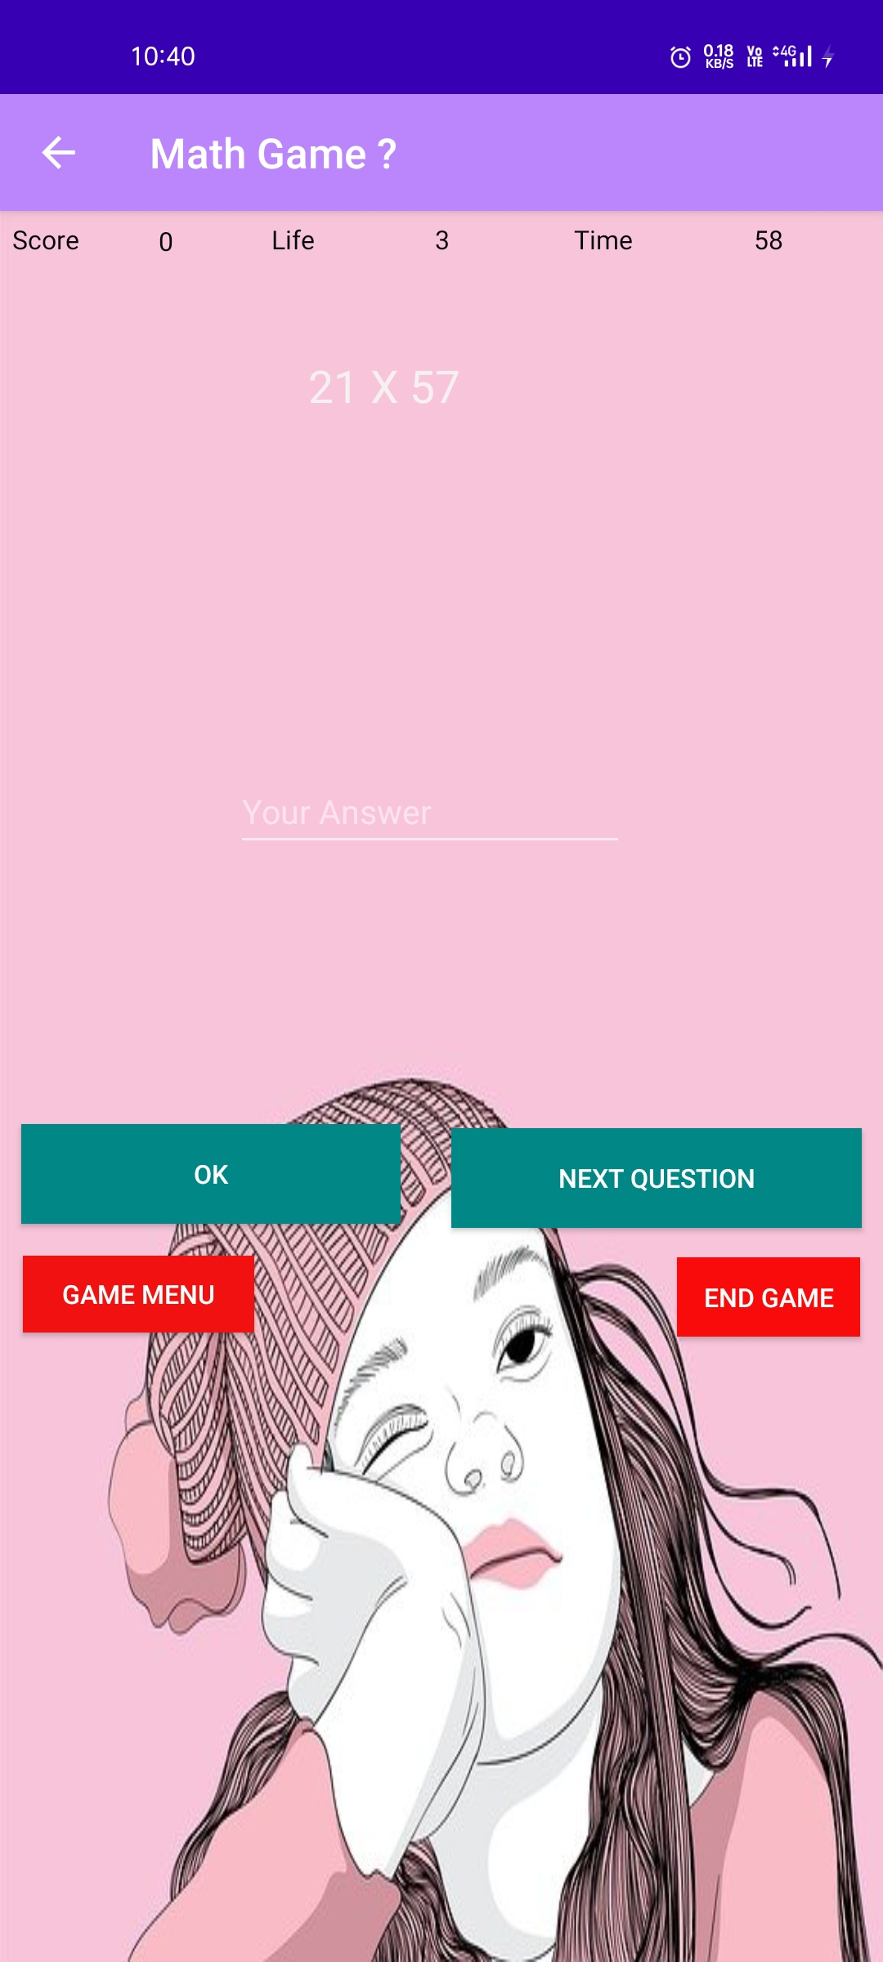

<?xml version="1.0" encoding="utf-8"?>  
<RelativeLayout xmlns:android="http://schemas.android.com/apk/res/android"  
 xmlns:app="http://schemas.android.com/apk/res-auto"  
 xmlns:tools="http://schemas.android.com/tools"  
 android:layout_width="match_parent"  
 android:layout_height="match_parent"  
 android:orientation="vertical"  
 android:background="@drawable/b"  
 tools:context=".fourthree">  
  
 <TextView  
 android:id="@+id/textView"  
 android:layout_width="wrap_content"  
 android:layout_height="wrap_content"  
 android:layout_alignParentStart="true"  
 android:layout_alignParentTop="true"  
 android:layout_marginStart="6dp"  
 android:layout_marginTop="5dp"  
 android:text="Score"  
 android:textColor="#070707" />  
  
 <TextView  
 android:id="@+id/textView2"  
 android:layout_width="wrap_content"  
 android:layout_height="wrap_content"  
 android:layout_alignParentStart="true"  
 android:layout_alignParentTop="true"  
 android:layout_marginStart="76dp"  
 android:layout_marginTop="6dp"  
 android:text="0"  
 android:textColor="#070707" />  
  
 <TextView  
 android:id="@+id/textView4"  
 android:layout_width="wrap_content"  
 android:layout_height="wrap_content"  
 android:layout_alignParentTop="true"  
 android:layout_alignParentEnd="true"  
 android:layout_centerHorizontal="true"  
 android:layout_marginTop="5dp"  
 android:layout_marginEnd="208dp"  
 android:text="3"  
 android:textColor="#070707" />  
  
 <TextView  
 android:id="@+id/textView3"  
 android:layout_width="wrap_content"  
 android:layout_height="wrap_content"  
 android:layout_alignParentStart="true"  
 android:layout_alignParentTop="true"  
 android:layout_marginStart="130dp"  
 android:layout_marginTop="5dp"  
 android:text="Life"  
 android:textColor="#070707" />  
  
 <TextView  
 android:id="@+id/textView5"  
 android:layout_width="wrap_content"  
 android:layout_height="wrap_content"  
 android:layout_alignParentTop="true"  
 android:layout_alignParentEnd="true"  
 android:layout_marginTop="5dp"  
 android:layout_marginEnd="120dp"  
 android:text="Time"  
 android:textColor="#070707" />  
  
 <TextView  
 android:id="@+id/textView6"  
 android:layout_width="wrap_content"  
 android:layout_height="wrap_content"  
 android:layout_alignParentTop="true"  
 android:layout_alignParentEnd="true"  
 android:layout_marginTop="5dp"  
 android:layout_marginEnd="48dp"  
 android:text="60"  
 android:textColor="#070707" />  
  
 <TextView  
 android:id="@+id/textView7"  
 android:layout_width="180dp"  
 android:layout_height="176dp"  
 android:layout_alignParentStart="true"  
 android:layout_alignParentTop="true"  
 android:layout_centerHorizontal="true"  
 android:layout_marginStart="148dp"  
 android:layout_marginTop="69dp"  
 android:text="TextView"  
 android:textColor="#F6F0F0"  
 android:textSize="24sp" />  
  
 <EditText  
 android:id="@+id/editText6"  
 android:layout_width="wrap_content"  
 android:layout_height="wrap_content"  
 android:layout_alignParentStart="true"  
 android:layout_alignParentTop="true"  
 android:layout_centerHorizontal="true"  
 android:layout_marginStart="112dp"  
 android:layout_marginTop="267dp"  
 android:ems="10"  
 android:hint="Your Answer"  
 android:inputType="textPersonName" />  
  
 <Button  
 android:id="@+id/button9"  
 android:layout_width="182dp"  
 android:layout_height="wrap_content"  
 android:layout_alignParentStart="true"  
 android:layout_alignParentBottom="true"  
 android:layout_marginStart="10dp"  
 android:layout_marginBottom="354dp"  
 android:background="@color/teal_700"  
 android:text="OK" />  
  
 <Button  
 android:id="@+id/button10"  
 android:layout_width="197dp"  
 android:layout_height="wrap_content"  
 android:layout_alignParentEnd="true"  
 android:layout_alignParentBottom="true"  
 android:layout_centerVertical="true"  
 android:layout_marginEnd="10dp"  
 android:layout_marginBottom="352dp"  
 android:background="@color/teal_700"  
 android:text="Next Question" />  
  
 <Button  
 android:id="@+id/button11"  
 android:layout_width="wrap_content"  
 android:layout_height="38dp"  
 android:layout_alignParentEnd="true"  
 android:layout_alignParentBottom="true"  
 android:layout_marginEnd="11dp"  
 android:layout_marginBottom="300dp"  
 android:background="#FA0B0B"  
 android:text="End Game" />  
  
 <Button  
 android:id="@+id/button12"  
 android:layout_width="111dp"  
 android:layout_height="37dp"  
 android:layout_alignParentStart="true"  
 android:layout_alignParentBottom="true"  
 android:layout_marginStart="11dp"  
 android:layout_marginBottom="302dp"  
 android:background="#F11111"  
 android:text="GAME MENU" />  
</RelativeLayout>

**result.java**

package com.example.app60;  
  
import androidx.appcompat.app.AppCompatActivity;  
  
import android.content.Intent;  
import android.os.Bundle;  
import android.view.View;  
import android.widget.Button;  
import android.widget.EditText;  
import android.widget.TextView;  
import android.os.Bundle;  
import android.view.MenuItem;  
import androidx.annotation.NonNull;  
import androidx.appcompat.app.ActionBar;  
import androidx.appcompat.app.AppCompatActivity;  
  
  
public class result extends AppCompatActivity {  
  
 TextView r;  
 Button b1 , b2;  
 int score = 0;  
 @Override  
 protected void onCreate(Bundle savedInstanceState) {  
 super.onCreate(savedInstanceState);  
 setContentView(R.layout.*activity_result*);  
 ActionBar actionBar = getSupportActionBar();  
 actionBar.setDisplayHomeAsUpEnabled(true);  
 getSupportActionBar().setTitle("Result");  
  
 r = (TextView) findViewById(R.id.*textView9*); // result  
 b1 = (Button) findViewById(R.id.*button13*); // playagain  
 b2 = (Button) findViewById(R.id.*button14*); // exit  
  
 Intent intent = getIntent();  
 score = intent.getIntExtra("score",0);  
 String sc = String.*valueOf*(score);  
 r.setText("score : "+sc);  
  
 b1.setOnClickListener(new View.OnClickListener() {  
 @Override  
 public void onClick(View view) {  
  
 Intent intent = new Intent(result.this , four.class);  
 startActivity(intent);  
 finish();  
  
 }  
 });  
 b2.setOnClickListener(new View.OnClickListener() {  
 @Override  
 public void onClick(View view) {  
  
 finish();  
  
  
 }  
 });  
  
 }  
 @Override  
 public boolean onOptionsItemSelected(@NonNull MenuItem item) {  
 switch (item.getItemId()) {  
 case android.R.id.*home*:  
 this.finish();  
 return true;  
 }  
 return super.onOptionsItemSelected(item);  
 }  
}

**activity_result.xml**

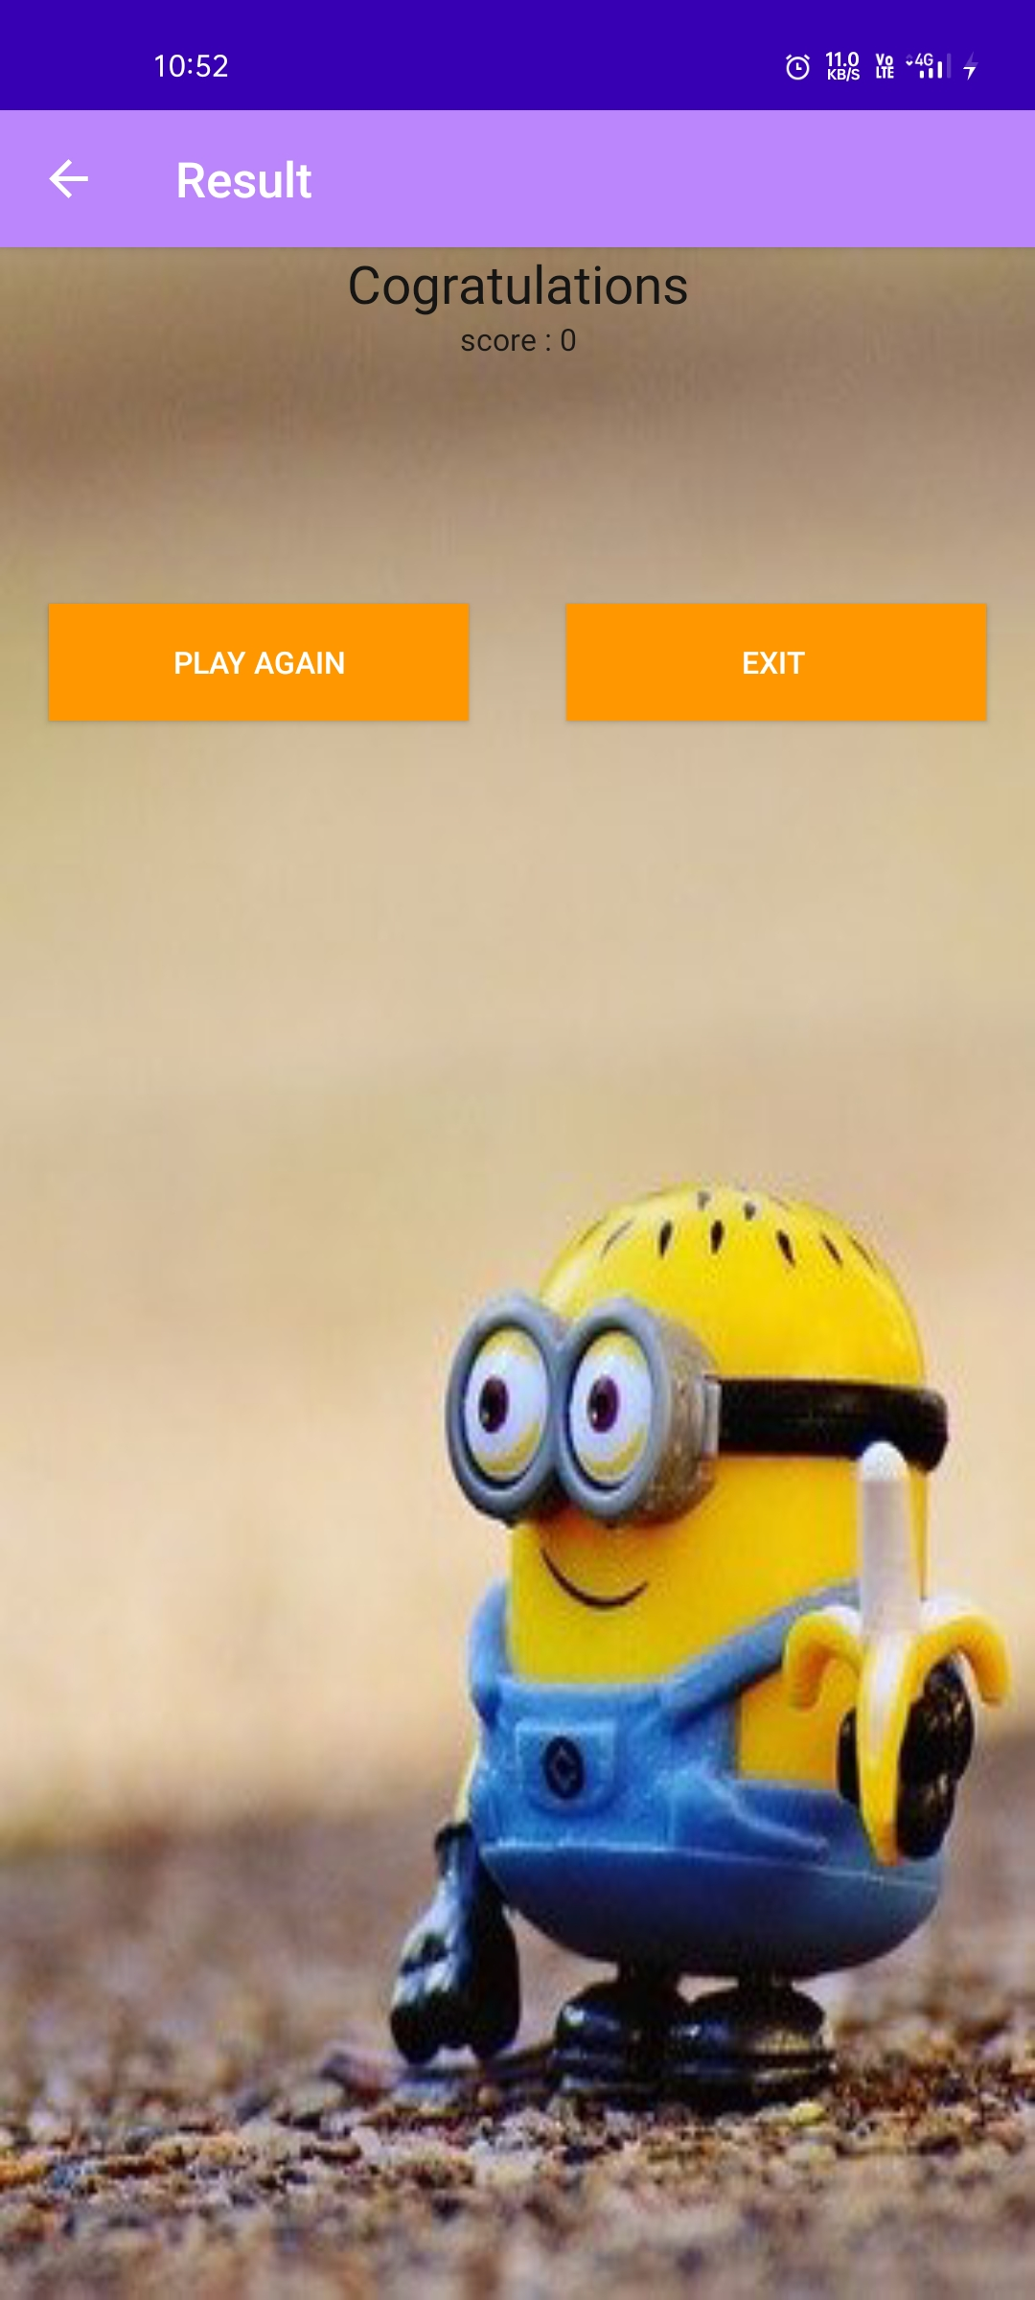

<?xml version="1.0" encoding="utf-8"?>  
<LinearLayout xmlns:android="http://schemas.android.com/apk/res/android"  
 xmlns:app="http://schemas.android.com/apk/res-auto"  
 xmlns:tools="http://schemas.android.com/tools"  
 android:layout_width="match_parent"  
 android:layout_height="match_parent"  
 android:background="@drawable/m"  
 android:gravity="center_horizontal"  
 android:orientation="vertical"  
  
 tools:context=".result">  
  
 <TextView  
 android:id="@+id/textView8"  
 android:layout_width="match_parent"  
 android:layout_height="wrap_content"  
 android:gravity="center_horizontal"  
 android:text="Cogratulations"  
 android:textColor="#151515"  
 android:textSize="24sp" />  
  
 <TextView  
 android:id="@+id/textView9"  
 android:layout_width="match_parent"  
 android:layout_height="wrap_content"  
 android:gravity="center_horizontal"  
 android:text="score 20"  
 android:textColor="#1B1818" />  
  
 <LinearLayout  
 android:layout_width="match_parent"  
 android:layout_height="match_parent"  
 android:orientation="horizontal">  
  
 <Button  
 android:id="@+id/button13"  
 android:layout_width="wrap_content"  
 android:layout_height="wrap_content"  
 android:layout_marginLeft="20dp"  
 android:layout_marginTop="100dp"  
 android:layout_marginRight="20dp"  
 android:layout_weight="1"  
 android:background="#FF9800"  
 android:text="PLAY AGAIN" />  
  
 <Button  
 android:id="@+id/button14"  
 android:layout_width="wrap_content"  
 android:layout_height="wrap_content"  
 android:layout_marginLeft="20dp"  
 android:layout_marginTop="100dp"  
 android:layout_marginRight="20dp"  
 android:layout_weight="1"  
 android:background="#FF9800"  
 android:text="EXIT " />  
 </LinearLayout>  
  
</LinearLayout>

**AddPlayers.java**

package com.example.app60;  
  
import androidx.appcompat.app.AppCompatActivity;  
  
import android.content.Intent;  
import android.os.Bundle;  
import android.view.View;  
import android.widget.Button;  
import android.widget.EditText;  
import android.widget.Toast;  
import android.os.Bundle;  
import android.view.MenuItem;  
import androidx.annotation.NonNull;  
import androidx.appcompat.app.ActionBar;  
import androidx.appcompat.app.AppCompatActivity;  
  
public class AddPlayers extends AppCompatActivity {  
  
 EditText playerOne,playerTwo;  
 Button startGameBtn;  
  
 @Override  
 protected void onCreate(Bundle savedInstanceState) {  
 super.onCreate(savedInstanceState);  
 setContentView(R.layout.*activity_add_players*);  
 ActionBar actionBar = getSupportActionBar();  
 actionBar.setDisplayHomeAsUpEnabled(true);  
 getSupportActionBar().setTitle("Add Player");  
  
 playerOne=(EditText) findViewById(R.id.*playerOneName*);  
 playerTwo=(EditText) findViewById(R.id.*playertwoName*);  
 startGameBtn=(Button) findViewById(R.id.*startGameBtn*);  
  
 startGameBtn.setOnClickListener(new View.OnClickListener() {  
 @Override  
 public void onClick(View view) {  
  
 String s1 = playerOne.getText().toString();  
 String s2 = playerTwo.getText().toString();  
  
 if(s1.isEmpty() || s2.isEmpty()){  
 Toast.*makeText*(AddPlayers.this, "Please Enter Player Name", Toast.*LENGTH_SHORT*).show();  
 }  
 else {  
 Intent intent = new Intent(AddPlayers.this , tictactoe.class);  
 intent.putExtra("playerOne",s1);  
 intent.putExtra("playerTwo",s2);  
 startActivity(intent);  
 //finish();  
 }  
 }  
 });  
  
 }  
 @Override  
 public boolean onOptionsItemSelected(@NonNull MenuItem item) {  
 switch (item.getItemId()) {  
 case android.R.id.*home*:  
 this.finish();  
 return true;  
 }  
 return super.onOptionsItemSelected(item);  
 }  
}

**activity_AddPlayers.xml**

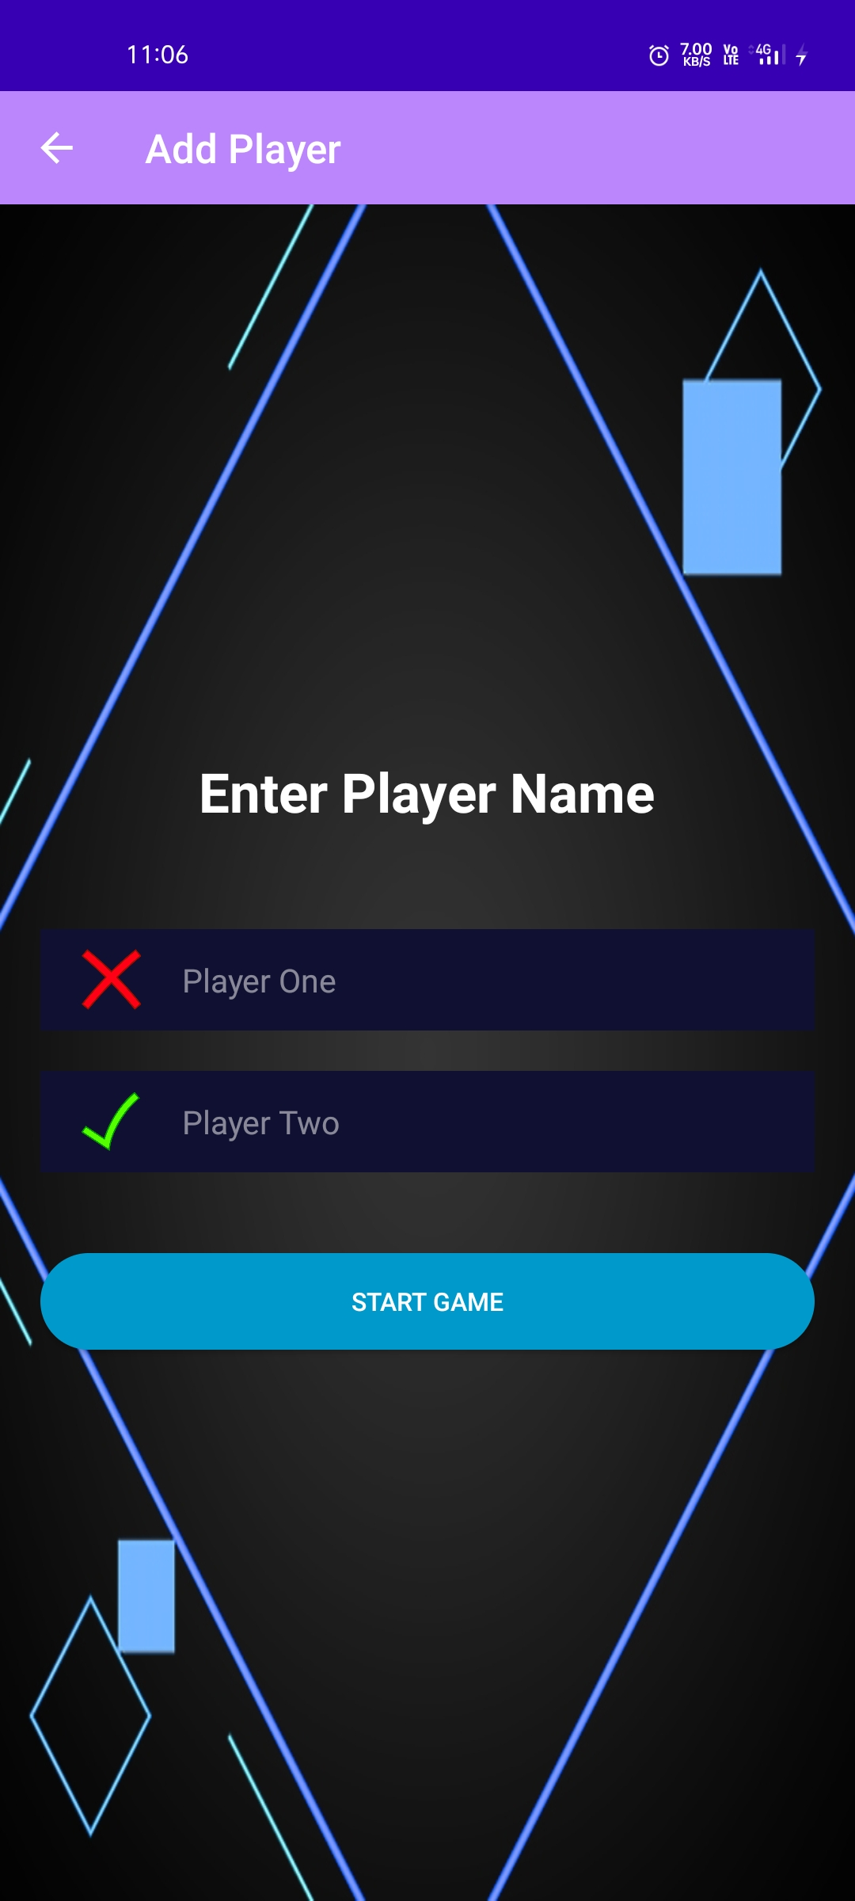

<?xml version="1.0" encoding="utf-8"?>  
<LinearLayout xmlns:android="http://schemas.android.com/apk/res/android"  
 xmlns:app="http://schemas.android.com/apk/res-auto"  
 xmlns:tools="http://schemas.android.com/tools"  
 android:layout_width="match_parent"  
 android:layout_height="match_parent"  
 android:orientation="vertical"  
 android:gravity="center"  
 android:background="@drawable/bluohohoh"  
 tools:context=".AddPlayers">  
  
 <TextView  
 android:layout_width="wrap_content"  
 android:layout_height="wrap_content"  
 android:textColor="#FFFFFF"  
 android:textSize="30sp"  
 android:text="Enter Player Name"  
 android:textStyle="bold"/>  
  
 <LinearLayout  
 android:gravity="center_vertical"  
 android:layout_width="match_parent"  
 android:layout_height="50dp"  
 android:layout_marginStart="20dp"  
 android:layout_marginEnd="20dp"  
 android:background="@color/dark_blue"  
 android:layout_marginTop="50dp"  
 android:orientation="horizontal">  
  
 <ImageView  
 android:layout_marginStart="20dp"  
 android:layout_width="30dp"  
 android:layout_height="30dp"  
 android:src="@drawable/tic2"  
 android:adjustViewBounds="true"/>  
 <EditText  
 android:inputType="text"  
 android:maxLines="1"  
 android:id="@+id/playerOneName"  
 android:layout_width="match_parent"  
 android:layout_height="50dp"  
 android:layout_marginStart="20dp"  
 android:layout_marginEnd="20dp"  
 android:hint="Player One"  
 android:textColorHint="@color/light_white"  
 android:background="@color/dark_blue"  
 android:textColor="#FFFFFF"/>  
 </LinearLayout>  
  
 <LinearLayout  
 android:gravity="center_vertical"  
 android:layout_width="match_parent"  
 android:layout_height="50dp"  
 android:layout_marginStart="20dp"  
 android:layout_marginEnd="20dp"  
 android:background="@color/dark_blue"  
 android:layout_marginTop="20dp"  
 android:orientation="horizontal">  
  
 <ImageView  
 android:layout_marginStart="20dp"  
 android:layout_width="30dp"  
 android:layout_height="30dp"  
 android:src="@drawable/tic1"  
 android:adjustViewBounds="true"/>  
 <EditText  
 android:inputType="text"  
 android:maxLines="1"  
 android:id="@+id/playertwoName"  
 android:layout_width="match_parent"  
 android:layout_height="50dp"  
 android:layout_marginStart="20dp"  
 android:layout_marginEnd="20dp"  
 android:hint="Player Two"  
 android:textColorHint="@color/light_white"  
 android:background="@color/dark_blue"  
 android:textColor="#FFFFFF"/>  
 </LinearLayout>  
  
 <androidx.appcompat.widget.AppCompatButton  
 android:id="@+id/startGameBtn"  
 android:layout_width="match_parent"  
 android:layout_height="wrap_content"  
 android:layout_marginEnd="20dp"  
 android:layout_marginStart="20dp"  
 android:layout_marginTop="40dp"  
 android:text="Start Game"  
 android:textColor="#FFFFFF"  
 android:background="@drawable/round_back_blue1000"/>  
  
  
  
  
  
</LinearLayout>

**tictactoe.java**

package com.example.app60;  
  
import androidx.appcompat.app.AppCompatActivity;  
  
import android.os.Bundle;  
import android.os.Bundle;  
import android.view.MenuItem;  
import android.view.View;  
import android.widget.ImageView;  
import android.widget.LinearLayout;  
import android.widget.TextView;  
  
import androidx.annotation.NonNull;  
import androidx.appcompat.app.ActionBar;  
import androidx.appcompat.app.AppCompatActivity;  
  
import java.util.ArrayList;  
import java.util.List;  
  
  
public class tictactoe extends AppCompatActivity {  
  
 TextView playerOneName , playerTwoName ;  
 LinearLayout playerOneLayout , playerTwoLayout ;  
 ImageView image1 , image2 , image3 , image4 , image5 , image6 , image7 , image8 , image9 ;  
 final List<int[]> combinationsList = new ArrayList<>();  
 int [] boxPositions = {0,0,0,0,0,0,0,0,0};  
 int playerTurn = 1;  
 int TotalSelectedBoxes = 1;  
 @Override  
 protected void onCreate(Bundle savedInstanceState) {  
 super.onCreate(savedInstanceState);  
 setContentView(R.layout.*activity_tictactoe*);  
 ActionBar actionBar = getSupportActionBar();  
 actionBar.setDisplayHomeAsUpEnabled(true);  
 getSupportActionBar().setTitle("Tic Tac Toe");  
  
 playerOneName = (TextView) findViewById(R.id.*playerOneName*);  
 playerTwoName = (TextView) findViewById(R.id.*playertwoName*);  
 playerOneLayout = (LinearLayout) findViewById(R.id.*playerOneLaytout*);  
 playerTwoLayout = (LinearLayout) findViewById(R.id.*playerTwoLayout*);  
  
 image1 = (ImageView) findViewById(R.id.*image1*);  
 image2 = (ImageView) findViewById(R.id.*image2*);  
 image3 = (ImageView) findViewById(R.id.*image3*);  
 image4 = (ImageView) findViewById(R.id.*image4*);  
 image5 = (ImageView) findViewById(R.id.*image5*);  
 image6 = (ImageView) findViewById(R.id.*image6*);  
 image7 = (ImageView) findViewById(R.id.*image7*);  
 image8 = (ImageView) findViewById(R.id.*image8*);  
 image9 = (ImageView) findViewById(R.id.*image9*);  
  
  
 combinationsList.add(new int[]{0,1,2});  
 combinationsList.add(new int[]{3,4,5});  
 combinationsList.add(new int[]{6,7,8});  
 combinationsList.add(new int[]{0,3,6});  
 combinationsList.add(new int[]{1,4,7});  
 combinationsList.add(new int[]{2,5,8});  
 combinationsList.add(new int[]{2,4,6});  
 combinationsList.add(new int[]{0,4,8});  
  
 String getPlayerOneName = getIntent().getStringExtra("playerOne");  
 String getPlayerTwoName = getIntent().getStringExtra("playerTwo");  
  
 playerOneName.setText(getPlayerOneName);  
 playerTwoName.setText(getPlayerTwoName);  
  
  
  
 image1.setOnClickListener(new View.OnClickListener() {  
 @Override  
 public void onClick(View view) {  
 if(isBoxSelectable(0)){  
  
 performAction((ImageView)view , 0);  
 }  
 }  
 });  
  
 image2.setOnClickListener(new View.OnClickListener() {  
 @Override  
 public void onClick(View view) {  
 if(isBoxSelectable(1)){  
  
 performAction((ImageView)view , 1);  
 }  
 }  
 });  
  
 image3.setOnClickListener(new View.OnClickListener() {  
 @Override  
 public void onClick(View view) {  
 if(isBoxSelectable(2)){  
  
 performAction((ImageView)view , 2);  
 }  
 }  
 });  
  
 image4.setOnClickListener(new View.OnClickListener() {  
 @Override  
 public void onClick(View view) {  
 if(isBoxSelectable(3)){  
  
 performAction((ImageView)view , 3);  
 }  
 }  
 });  
  
 image5.setOnClickListener(new View.OnClickListener() {  
 @Override  
 public void onClick(View view) {  
 if(isBoxSelectable(4)){  
 performAction((ImageView)view , 4);  
  
 }  
 }  
 });  
  
 image6.setOnClickListener(new View.OnClickListener() {  
 @Override  
 public void onClick(View view) {  
 if(isBoxSelectable(5)){  
 performAction((ImageView)view , 5);  
  
 }  
 }  
 });  
  
 image7.setOnClickListener(new View.OnClickListener() {  
 @Override  
 public void onClick(View view) {  
 if(isBoxSelectable(6)){  
 performAction((ImageView)view , 6);  
  
 }  
 }  
 });  
  
 image8.setOnClickListener(new View.OnClickListener() {  
 @Override  
 public void onClick(View view) {  
 if(isBoxSelectable(7)){  
  
 performAction((ImageView)view , 7);  
 }  
 }  
 });  
  
 image9.setOnClickListener(new View.OnClickListener() {  
 @Override  
 public void onClick(View view) {  
 if(isBoxSelectable(8)){  
  
 performAction((ImageView)view , 8);  
  
 }  
 }  
 });  
  
 }  
  
 @Override  
 public boolean onOptionsItemSelected(@NonNull MenuItem item) {  
 switch (item.getItemId()) {  
 case android.R.id.*home*:  
 this.finish();  
 return true;  
 }  
 return super.onOptionsItemSelected(item);  
 }  
 boolean isBoxSelectable(int boxPosition){  
 boolean response = false;  
 if(boxPositions[boxPosition] == 0){  
 response = true ;  
 }  
 return response;  
 }  
 private void performAction (ImageView imageView , int selectedBoxPosition){  
  
 boxPositions[selectedBoxPosition] = playerTurn;  
 if(playerTurn == 1 ){  
 imageView.setImageResource(R.drawable.*tic2*);  
  
 if(checkPlayerWin()){  
  
 winDialog winDialog = new winDialog(tictactoe.this , playerOneName.getText().toString() + "Has Won The Match" , tictactoe.this);  
 winDialog.setCancelable(false);  
 winDialog.show();  
 }  
 else if(TotalSelectedBoxes == 9){  
 winDialog winDialog = new winDialog(tictactoe.this , "It is Draw !" , tictactoe.this);  
 winDialog.setCancelable(false);  
 winDialog.show();  
 }  
 else {  
 changePlayerTurn(2);  
 TotalSelectedBoxes++;  
 }  
 }  
 else{  
 imageView.setImageResource(R.drawable.*tic1*);  
 if(checkPlayerWin()){  
 winDialog winDialog = new winDialog(tictactoe.this , playerTwoName.getText().toString() + "Has Won The Match" , tictactoe.this);  
 winDialog.setCancelable(false);  
 winDialog.show();  
  
 }  
 else if(selectedBoxPosition == 9){  
 winDialog winDialog = new winDialog(tictactoe.this , "It is Draw !" , tictactoe.this);  
 winDialog.setCancelable(false);  
 winDialog.show();  
 }  
 else {  
  
 changePlayerTurn(1);  
 TotalSelectedBoxes++;  
 }  
 }  
  
 }  
 private void changePlayerTurn (int currentPlayerTurn){  
 playerTurn = currentPlayerTurn;  
 if(playerTurn == 1){  
 playerOneLayout.setBackgroundResource(R.drawable.*round_black_blue_border*);  
 playerTwoLayout.setBackgroundResource(R.drawable.*round_back_dark_blue*);  
 }  
 else{  
 playerOneLayout.setBackgroundResource(R.drawable.*round_back_dark_blue*);  
 playerTwoLayout.setBackgroundResource(R.drawable.*round_black_blue_border*);  
 }  
 }  
 private boolean checkPlayerWin(){  
 boolean response = false ;  
 for(int i=0 ; i<combinationsList.size() ; i++){  
 int[] combination = combinationsList.get(i);  
  
 if(boxPositions[combination[0]] == playerTurn && boxPositions[combination[1]] == playerTurn && boxPositions[combination[2]] == playerTurn ) {  
 response = true;  
 }  
 }  
 return response;  
 }  
 public void restartTheMatch(){  
 boxPositions = new int[] {0,0,0,0,0,0,0,0,0};  
 playerTurn = 1;  
 TotalSelectedBoxes = 1;  
 image1.setImageResource(R.drawable.*transparent*);  
 image2.setImageResource(R.drawable.*transparent*);  
 image3.setImageResource(R.drawable.*transparent*);  
 image4.setImageResource(R.drawable.*transparent*);  
 image5.setImageResource(R.drawable.*transparent*);  
 image6.setImageResource(R.drawable.*transparent*);  
 image7.setImageResource(R.drawable.*transparent*);  
 image8.setImageResource(R.drawable.*transparent*);  
 image9.setImageResource(R.drawable.*transparent*);  
  
 }  
}

**activity_tictactoe.xml**

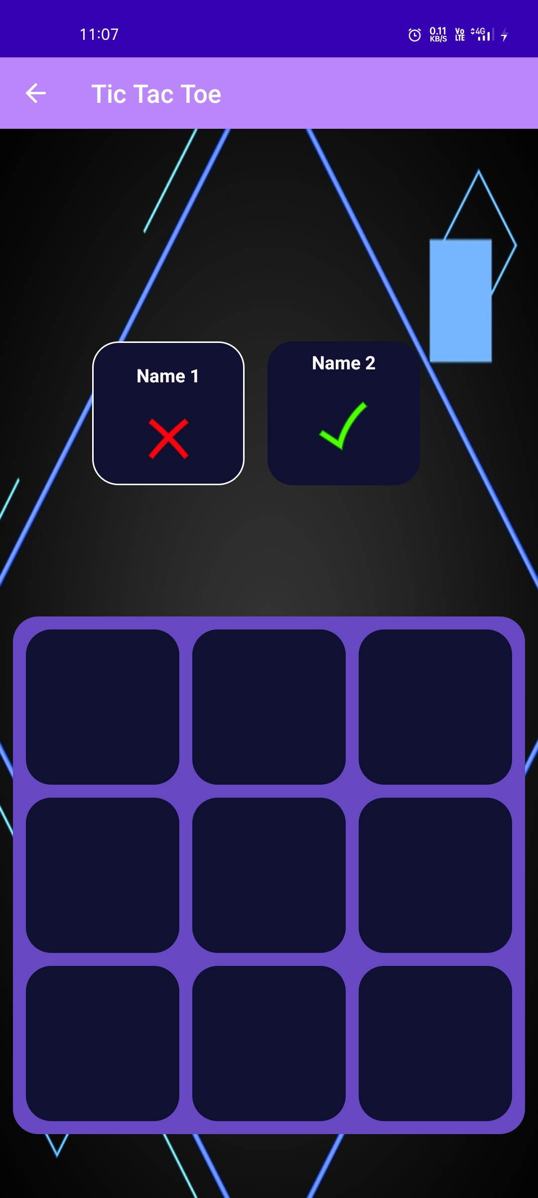

<?xml version="1.0" encoding="utf-8"?>  
<RelativeLayout xmlns:android="http://schemas.android.com/apk/res/android"  
 xmlns:app="http://schemas.android.com/apk/res-auto"  
 xmlns:tools="http://schemas.android.com/tools"  
 android:layout_width="match_parent"  
 android:layout_height="match_parent"  
 android:background="@drawable/bluohohoh"  
 tools:context=".tictactoe">  
  
 <LinearLayout  
 android:layout_above="@+id/container"  
 android:layout_alignParentTop="true"  
 android:layout_width="wrap_content"  
 android:layout_height="wrap_content"  
 android:gravity="center"  
 android:orientation="horizontal">  
  
 </LinearLayout>  
  
 <LinearLayout  
 android:id="@+id/playerTwoLayout"  
 android:layout_width="120dp"  
 android:layout_height="113dp"  
 android:layout_alignParentEnd="true"  
 android:layout_alignParentBottom="true"  
 android:layout_marginEnd="93dp"  
 android:layout_marginBottom="560dp"  
 android:background="@drawable/round_back_dark_blue"  
 android:gravity="center"  
 android:orientation="vertical">  
  
 <TextView  
 android:maxLines="1"  
 android:id="@+id/playertwoName"  
 android:layout_width="match_parent"  
 android:layout_height="wrap_content"  
 android:gravity="center"  
 android:text="Player Two"  
 android:textColor="#FFFFFF"  
 android:textSize="16sp"  
 android:textStyle="bold" />  
  
 <ImageView  
  
 android:layout_width="40dp"  
 android:layout_height="40dp"  
 android:layout_marginTop="20dp"  
 android:layout_marginBottom="20dp"  
 android:src="@drawable/tic1" />  
 </LinearLayout>  
  
 <LinearLayout  
 android:id="@+id/playerOneLaytout"  
 android:layout_width="120dp"  
 android:layout_height="113dp"  
 android:layout_alignParentEnd="true"  
 android:layout_alignParentBottom="true"  
 android:layout_marginEnd="231dp"  
 android:layout_marginBottom="560dp"  
 android:background="@drawable/round_black_blue_border"  
 android:gravity="center"  
 android:orientation="vertical">  
  
 <TextView  
 android:maxLines="1"  
 android:id="@+id/playerOneName"  
 android:layout_width="match_parent"  
 android:layout_height="wrap_content"  
 android:layout_marginTop="20dp"  
 android:gravity="center"  
 android:text="Player One"  
 android:textColor="#FFFFFF"  
 android:textSize="16sp"  
 android:textStyle="bold" />  
  
 <ImageView  
 android:layout_width="32dp"  
 android:layout_height="40dp"  
 android:layout_gravity="center"  
 android:layout_marginTop="20dp"  
 android:layout_marginBottom="20dp"  
 android:src="@drawable/tic2" />  
 </LinearLayout>  
  
  
 <LinearLayout  
 android:id="@+id/container"  
 android:layout_width="match_parent"  
 android:layout_height="wrap_content"  
 android:layout_alignParentBottom="true"  
 android:layout_marginStart="10dp"  
 android:layout_marginEnd="10dp"  
 android:orientation="vertical"  
 android:background="@drawable/round_back_purple"  
 android:layout_marginBottom="50dp">  
  
 <LinearLayout  
 android:layout_width="match_parent"  
 android:layout_height="wrap_content"  
 android:orientation="horizontal"  
 android:weightSum="3">  
  
 <ImageView  
 android:id="@+id/image1"  
 android:layout_marginTop="10dp"  
 android:layout_marginEnd="5dp"  
 android:layout_marginStart="10dp"  
 android:layout_width="0dp"  
 android:layout_height="wrap_content"  
 android:layout_weight="1"  
 android:adjustViewBounds="true"  
 android:padding="20dp"  
 android:src="@drawable/transparent"  
 android:background="@drawable/round_back_dark_blue"/>  
  
 <ImageView  
 android:id="@+id/image2"  
 android:layout_marginTop="10dp"  
 android:layout_marginEnd="5dp"  
 android:layout_marginStart="5dp"  
 android:layout_width="0dp"  
 android:layout_height="wrap_content"  
 android:layout_weight="1"  
 android:adjustViewBounds="true"  
 android:padding="20dp"  
 android:src="@drawable/transparent"  
 android:background="@drawable/round_back_dark_blue"/>  
  
 <ImageView  
 android:id="@+id/image3"  
 android:layout_marginTop="10dp"  
 android:layout_marginEnd="10dp"  
 android:layout_marginStart="5dp"  
 android:layout_width="0dp"  
 android:layout_height="wrap_content"  
 android:layout_weight="1"  
 android:adjustViewBounds="true"  
 android:padding="20dp"  
 android:src="@drawable/transparent"  
 android:background="@drawable/round_back_dark_blue"/>  
  
  
 </LinearLayout>  
  
 <LinearLayout  
 android:layout_width="match_parent"  
 android:layout_height="wrap_content"  
 android:orientation="horizontal"  
 android:weightSum="3">  
  
 <ImageView  
 android:id="@+id/image4"  
 android:layout_marginTop="10dp"  
 android:layout_marginEnd="5dp"  
 android:layout_marginStart="10dp"  
 android:layout_width="0dp"  
 android:layout_height="wrap_content"  
 android:layout_weight="1"  
 android:adjustViewBounds="true"  
 android:padding="20dp"  
 android:src="@drawable/transparent"  
 android:background="@drawable/round_back_dark_blue"/>  
  
 <ImageView  
 android:id="@+id/image5"  
 android:layout_marginTop="10dp"  
 android:layout_marginEnd="5dp"  
 android:layout_marginStart="5dp"  
 android:layout_width="0dp"  
 android:layout_height="wrap_content"  
 android:layout_weight="1"  
 android:adjustViewBounds="true"  
 android:padding="20dp"  
 android:src="@drawable/transparent"  
 android:background="@drawable/round_back_dark_blue"/>  
  
 <ImageView  
 android:id="@+id/image6"  
 android:layout_marginTop="10dp"  
 android:layout_marginEnd="10dp"  
 android:layout_marginStart="5dp"  
 android:layout_width="0dp"  
 android:layout_height="wrap_content"  
 android:layout_weight="1"  
 android:adjustViewBounds="true"  
 android:padding="20dp"  
 android:src="@drawable/transparent"  
 android:background="@drawable/round_back_dark_blue"/>  
  
  
 </LinearLayout>  
  
 <LinearLayout  
 android:layout_marginBottom="10dp"  
 android:layout_width="match_parent"  
 android:layout_height="wrap_content"  
 android:orientation="horizontal"  
 android:weightSum="3">  
  
 <ImageView  
 android:id="@+id/image7"  
 android:layout_marginTop="10dp"  
 android:layout_marginEnd="5dp"  
 android:layout_marginStart="10dp"  
 android:layout_width="0dp"  
 android:layout_height="wrap_content"  
 android:layout_weight="1"  
 android:adjustViewBounds="true"  
 android:padding="20dp"  
 android:src="@drawable/transparent"  
 android:background="@drawable/round_back_dark_blue"/>  
  
 <ImageView  
 android:id="@+id/image8"  
 android:layout_marginTop="10dp"  
 android:layout_marginEnd="5dp"  
 android:layout_marginStart="5dp"  
 android:layout_width="0dp"  
 android:layout_height="wrap_content"  
 android:layout_weight="1"  
 android:adjustViewBounds="true"  
 android:padding="20dp"  
 android:src="@drawable/transparent"  
 android:background="@drawable/round_back_dark_blue"/>  
  
 <ImageView  
 android:id="@+id/image9"  
 android:layout_marginTop="10dp"  
 android:layout_marginEnd="10dp"  
 android:layout_marginStart="5dp"  
 android:layout_width="0dp"  
 android:layout_height="wrap_content"  
 android:layout_weight="1"  
 android:adjustViewBounds="true"  
 android:padding="20dp"  
 android:src="@drawable/transparent"  
 android:background="@drawable/round_back_dark_blue"/>  
  
  
 </LinearLayout>  
  
 </LinearLayout>  
  
</RelativeLayout>

**winDialog.java**

package com.example.app60;  
  
import android.app.Dialog;  
import android.content.Context;  
import android.os.Bundle;  
import android.view.View;  
import android.widget.Button;  
import android.widget.TextView;  
  
import androidx.annotation.NonNull;  
  
public class winDialog extends Dialog {  
  
 private final String message ;  
 private final tictactoe tictactoe;  
  
  
 public winDialog(@NonNull Context context , String message , tictactoe tictactoe) {  
 super(context);  
 this.message = message ;  
 this.tictactoe = tictactoe ;  
 }  
  
 @Override  
 protected void onCreate(Bundle savedInstanceState) {  
 super.onCreate(savedInstanceState);  
 setContentView(R.layout.*win_dialog_layoutr*);  
  
 TextView messageTxt = (TextView) findViewById(R.id.*messageTxt*);  
 Button startAgainBtn = (Button) findViewById(R.id.*startAgainBtn*);  
  
 messageTxt.setText(message);  
  
 startAgainBtn.setOnClickListener(new View.OnClickListener() {  
 @Override  
 public void onClick(View view) {  
  
 tictactoe.restartTheMatch();  
 dismiss();  
  
 }  
 });  
 }  
}

**win_dialog_layoutr.xml**



<?xml version="1.0" encoding="utf-8"?>  
<RelativeLayout xmlns:android="http://schemas.android.com/apk/res/android"  
 android:layout_width="match_parent"  
 android:layout_height="match_parent">  
  
 <LinearLayout  
 android:layout_width="match_parent"  
 android:layout_height="wrap_content"  
 android:background="@color/dark_blue"  
 android:orientation="vertical">  
  
 <TextView  
 android:id="@+id/messageTxt"  
 android:layout_width="wrap_content"  
 android:layout_height="wrap_content"  
 android:gravity="center"  
 android:layout_marginTop="20dp"  
 android:layout_marginEnd="20dp"  
 android:layout_marginStart="20dp"  
 android:text="Message Here"  
 android:textSize="18sp"  
 android:textColor="#FFFFFF"  
 android:textStyle="bold"/>  
   
 <androidx.appcompat.widget.AppCompatButton  
 android:id="@+id/startAgainBtn"  
 android:layout_width="match_parent"  
 android:layout_height="wrap_content"  
 android:layout_margin="20dp"  
 android:background="@drawable/round_back_blue1000"  
 android:textColor="#FFFFFF"  
 android:text="Start Again"  
 />  
  
  
 </LinearLayout>  
  
  
</RelativeLayout>

**quiz.java**

package com.example.app60;import androidx.appcompat.app.AppCompatActivity;import android.content.Intent;import android.os.Bundle;import android.os.Bundle;import android.view.MenuItem;import android.view.View;import android.widget.Button;import android.widget.RadioButton;import androidx.annotation.NonNull;import androidx.appcompat.app.ActionBar;import androidx.appcompat.app.AppCompatActivity;public class quiz extends AppCompatActivity { Button b1; RadioButton r1,r2,r3,r4; static int *score*=0; @Override protected void onCreate(Bundle savedInstanceState) { super.onCreate(savedInstanceState); setContentView(R.layout.*activity_quiz*); getSupportActionBar().setTitle("Quiz ?"); b1=(Button)findViewById(R.id.*button*); r1=(RadioButton)findViewById(R.id.*radioButton*); r2=(RadioButton)findViewById(R.id.*radioButton2*); r3=(RadioButton)findViewById(R.id.*radioButton3*); r4=(RadioButton)findViewById(R.id.*radioButton4*); b1.setOnClickListener(new View.OnClickListener() { @Override public void onClick(View view) { if(r3.isChecked()){ ++*score*; } else { --*score*; } Intent i1 = new Intent(quiz.this , quiz2.class); startActivity(i1); finish(); } }); }}

**activity_quiz.xml**

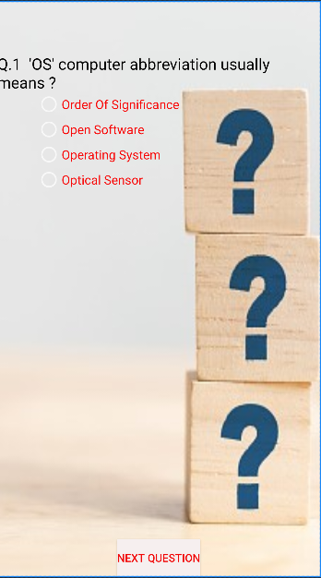

<?xml version="1.0" encoding="utf-8"?>  
<RelativeLayout xmlns:android="http://schemas.android.com/apk/res/android"  
 xmlns:app="http://schemas.android.com/apk/res-auto"  
 xmlns:tools="http://schemas.android.com/tools"  
 android:layout_width="match_parent"  
 android:layout_height="match_parent"  
 android:background="@drawable/quiz1"  
 tools:context=".quiz">  
  
 <TextView  
 android:id="@+id/textView"  
 android:layout_width="match_parent"  
 android:layout_height="wrap_content"  
 android:layout_alignParentStart="true"  
 android:layout_alignParentLeft="true"  
 android:layout_alignParentTop="true"  
 android:layout_marginStart="0dp"  
 android:layout_marginLeft="0dp"  
 android:layout_marginTop="65dp"  
 android:text="Q.1 'OS' computer abbreviation usually means ?"  
 android:textColor="#000000"  
 android:textSize="20sp" />  
  
 <Button  
 android:id="@+id/button"  
 android:layout_width="wrap_content"  
 android:layout_height="wrap_content"  
 android:layout_alignParentBottom="true"  
 android:layout_centerHorizontal="true"  
 android:background="#F6EFEF"  
 android:text="Next Question"  
 android:textColor="#F10808" />  
  
 <RadioGroup  
 android:layout_width="match_parent"  
 android:layout_height="match_parent"  
 android:layout_above="@+id/button"  
 android:layout_below="@+id/textView"  
 android:layout_alignEnd="@+id/textView"  
 android:layout_alignRight="@+id/textView"  
 android:layout_alignParentStart="true"  
 android:layout_alignParentLeft="true"  
 android:layout_marginStart="50dp"  
 android:layout_marginLeft="1dp"  
 android:layout_marginTop="-2dp"  
 android:layout_marginEnd="-1dp"  
 android:layout_marginRight="-1dp"  
 android:layout_marginBottom="20dp">  
  
 <RadioButton  
 android:id="@+id/radioButton"  
 android:layout_width="wrap_content"  
 android:layout_height="wrap_content"  
 android:checked="false"  
 android:text="Order Of Significance"  
 android:textColor="#F80909"  
 android:textSize="16sp" />  
  
 <RadioButton  
 android:id="@+id/radioButton2"  
 android:layout_width="wrap_content"  
 android:layout_height="wrap_content"  
 android:checked="false"  
 android:text="Open Software"  
 android:textColor="#F80909"  
 android:textSize="16sp" />  
  
 <RadioButton  
 android:id="@+id/radioButton3"  
 android:layout_width="wrap_content"  
 android:layout_height="wrap_content"  
 android:checked="false"  
 android:text="Operating System"  
 android:textColor="#F80909"  
 android:textSize="16sp" />  
  
 <RadioButton  
 android:id="@+id/radioButton4"  
 android:layout_width="wrap_content"  
 android:layout_height="wrap_content"  
 android:checked="false"  
 android:text="Optical Sensor"  
 android:textColor="#F80909"  
 android:textSize="16sp" />  
 </RadioGroup>  
  
</RelativeLayout>

**quiz2.java**

package com.example.app60;  
  
import androidx.appcompat.app.AppCompatActivity;  
  
import android.content.Intent;  
import android.os.Bundle;  
import android.os.Bundle;  
import android.view.MenuItem;  
import android.view.View;  
import android.widget.Button;  
import android.widget.RadioButton;  
  
import androidx.annotation.NonNull;  
import androidx.appcompat.app.ActionBar;  
import androidx.appcompat.app.AppCompatActivity;  
  
  
public class quiz2 extends AppCompatActivity {  
  
 Button b1;  
 RadioButton r1,r2,r3,r4;  
  
 @Override  
 protected void onCreate(Bundle savedInstanceState) {  
 super.onCreate(savedInstanceState);  
 setContentView(R.layout.*activity_quiz2*);  
 getSupportActionBar().setTitle("Quiz ?");  
  
 b1=(Button)findViewById(R.id.*button*);  
 r1=(RadioButton)findViewById(R.id.*radioButton*);  
 r2=(RadioButton)findViewById(R.id.*radioButton2*);  
 r3=(RadioButton)findViewById(R.id.*radioButton3*);  
 r4=(RadioButton)findViewById(R.id.*radioButton4*);  
 b1.setOnClickListener(new View.OnClickListener() {  
 @Override  
 public void onClick(View view) {  
 if(r2.isChecked()){  
 ++quiz.*score*;  
 }  
 else  
 {  
 --quiz.*score*;  
 }  
 Intent i1 = new Intent(quiz2.this , quiz3.class);  
 startActivity(i1);  
 finish();  
 }  
 });  
 }  
}

**activity_quiz2.xml**

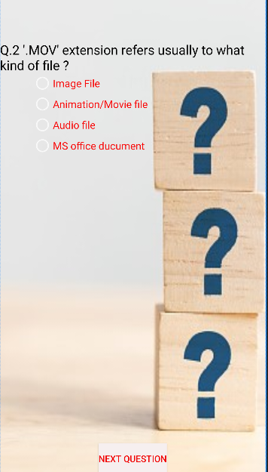

<?xml version="1.0" encoding="utf-8"?>  
<RelativeLayout xmlns:android="http://schemas.android.com/apk/res/android"  
 xmlns:app="http://schemas.android.com/apk/res-auto"  
 xmlns:tools="http://schemas.android.com/tools"  
 android:layout_width="match_parent"  
 android:layout_height="match_parent"  
 android:background="@drawable/quiz1"  
 tools:context=".quiz2">  
  
 <TextView  
 android:id="@+id/textView"  
 android:layout_width="match_parent"  
 android:layout_height="wrap_content"  
 android:layout_alignParentStart="true"  
 android:layout_alignParentLeft="true"  
 android:layout_alignParentTop="true"  
 android:layout_marginStart="0dp"  
 android:layout_marginLeft="0dp"  
 android:layout_marginTop="65dp"  
 android:text="Q.2 '.MOV' extension refers usually to what kind of file ?"  
 android:textColor="#000000"  
 android:textSize="20sp" />  
  
 <Button  
 android:id="@+id/button"  
 android:layout_width="wrap_content"  
 android:layout_height="wrap_content"  
 android:layout_alignParentBottom="true"  
 android:layout_centerHorizontal="true"  
 android:background="#F6EFEF"  
 android:text="Next Question"  
 android:textColor="#F10808" />  
  
 <RadioGroup  
 android:layout_width="match_parent"  
 android:layout_height="match_parent"  
 android:layout_above="@+id/button"  
 android:layout_below="@+id/textView"  
 android:layout_alignEnd="@+id/textView"  
 android:layout_alignRight="@+id/textView"  
 android:layout_alignParentStart="true"  
 android:layout_alignParentLeft="true"  
 android:layout_marginStart="50dp"  
 android:layout_marginLeft="1dp"  
 android:layout_marginTop="-2dp"  
 android:layout_marginEnd="-1dp"  
 android:layout_marginRight="-1dp"  
 android:layout_marginBottom="20dp">  
  
 <RadioButton  
 android:id="@+id/radioButton"  
 android:layout_width="wrap_content"  
 android:layout_height="wrap_content"  
 android:checked="false"  
 android:text="Image File "  
 android:textColor="#F80909"  
 android:textSize="16sp" />  
  
 <RadioButton  
 android:id="@+id/radioButton2"  
 android:layout_width="wrap_content"  
 android:layout_height="wrap_content"  
 android:checked="false"  
 android:text="Animation/Movie file"  
 android:textColor="#F80909"  
 android:textSize="16sp" />  
  
 <RadioButton  
 android:id="@+id/radioButton3"  
 android:layout_width="wrap_content"  
 android:layout_height="wrap_content"  
 android:checked="false"  
 android:text="Audio file"  
 android:textColor="#F80909"  
 android:textSize="16sp" />  
  
 <RadioButton  
 android:id="@+id/radioButton4"  
 android:layout_width="wrap_content"  
 android:layout_height="wrap_content"  
 android:checked="false"  
 android:text="MS office ducument"  
 android:textColor="#F80909"  
 android:textSize="16sp" />  
 </RadioGroup>  
  
</RelativeLayout>

**quiz3.java**

package com.example.app60;  
  
import androidx.appcompat.app.AppCompatActivity;  
  
import android.content.Intent;  
import android.os.Bundle;  
import android.os.Bundle;  
import android.view.MenuItem;  
import android.view.View;  
import android.widget.Button;  
import android.widget.RadioButton;  
  
import androidx.annotation.NonNull;  
import androidx.appcompat.app.ActionBar;  
import androidx.appcompat.app.AppCompatActivity;  
  
public class quiz3 extends AppCompatActivity {  
  
 Button b1;  
 RadioButton r1,r2,r3,r4;  
  
 @Override  
 protected void onCreate(Bundle savedInstanceState) {  
 super.onCreate(savedInstanceState);  
 setContentView(R.layout.*activity_quiz3*);  
 getSupportActionBar().setTitle("Quiz ?");  
  
 b1=(Button)findViewById(R.id.*button*);  
 r1=(RadioButton)findViewById(R.id.*radioButton*);  
 r2=(RadioButton)findViewById(R.id.*radioButton2*);  
 r3=(RadioButton)findViewById(R.id.*radioButton3*);  
 r4=(RadioButton)findViewById(R.id.*radioButton4*);  
 b1.setOnClickListener(new View.OnClickListener() {  
 @Override  
 public void onClick(View view) {  
 if(r3.isChecked()){  
 ++quiz.*score*;  
 }  
 else  
 {  
 --quiz.*score*;  
 }  
 Intent i1 = new Intent(quiz3.this , quiz4.class);  
 startActivity(i1);  
 finish();  
 }  
 });  
 }  
}

**activity_quiz3.xml**

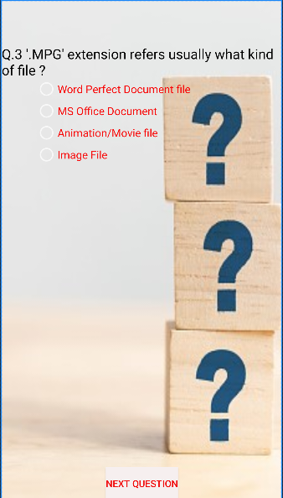

<?xml version="1.0" encoding="utf-8"?>  
<RelativeLayout xmlns:android="http://schemas.android.com/apk/res/android"  
 xmlns:app="http://schemas.android.com/apk/res-auto"  
 xmlns:tools="http://schemas.android.com/tools"  
 android:layout_width="match_parent"  
 android:layout_height="match_parent"  
 android:background="@drawable/quiz1"  
 tools:context=".quiz3">  
  
 <TextView  
 android:id="@+id/textView"  
 android:layout_width="match_parent"  
 android:layout_height="wrap_content"  
 android:layout_alignParentStart="true"  
 android:layout_alignParentLeft="true"  
 android:layout_alignParentTop="true"  
 android:layout_marginStart="0dp"  
 android:layout_marginLeft="0dp"  
 android:layout_marginTop="65dp"  
 android:text="Q.3 '.MPG' extension refers usually what kind of file ?"  
 android:textColor="#000000"  
 android:textSize="20sp" />  
  
 <Button  
 android:id="@+id/button"  
 android:layout_width="wrap_content"  
 android:layout_height="wrap_content"  
 android:layout_alignParentBottom="true"  
 android:layout_centerHorizontal="true"  
 android:background="#F6EFEF"  
 android:text="Next Question"  
 android:textColor="#F10808" />  
  
 <RadioGroup  
 android:layout_width="match_parent"  
 android:layout_height="match_parent"  
 android:layout_above="@+id/button"  
 android:layout_below="@+id/textView"  
 android:layout_alignEnd="@+id/textView"  
 android:layout_alignRight="@+id/textView"  
 android:layout_alignParentStart="true"  
 android:layout_alignParentLeft="true"  
 android:layout_marginStart="50dp"  
 android:layout_marginLeft="1dp"  
 android:layout_marginTop="-2dp"  
 android:layout_marginEnd="-1dp"  
 android:layout_marginRight="-1dp"  
 android:layout_marginBottom="20dp">  
  
 <RadioButton  
 android:id="@+id/radioButton"  
 android:layout_width="wrap_content"  
 android:layout_height="wrap_content"  
 android:checked="false"  
 android:text="Word Perfect Document file"  
 android:textColor="#F80909"  
 android:textSize="16sp" />  
  
 <RadioButton  
 android:id="@+id/radioButton2"  
 android:layout_width="wrap_content"  
 android:layout_height="wrap_content"  
 android:checked="false"  
 android:text="MS Office Document"  
 android:textColor="#F80909"  
 android:textSize="16sp" />  
  
 <RadioButton  
 android:id="@+id/radioButton3"  
 android:layout_width="wrap_content"  
 android:layout_height="wrap_content"  
 android:checked="false"  
 android:text="Animation/Movie file"  
 android:textColor="#F80909"  
 android:textSize="16sp" />  
  
 <RadioButton  
 android:id="@+id/radioButton4"  
 android:layout_width="wrap_content"  
 android:layout_height="wrap_content"  
 android:checked="false"  
 android:text="Image File"  
 android:textColor="#F80909"  
 android:textSize="16sp" />  
 </RadioGroup>  
  
</RelativeLayout>

**quiz4.java**

package com.example.app60;  
  
import androidx.appcompat.app.AppCompatActivity;  
  
import android.content.Intent;  
import android.os.Bundle;  
import android.os.Bundle;  
import android.view.MenuItem;  
import android.view.View;  
import android.widget.Button;  
import android.widget.RadioButton;  
  
import androidx.annotation.NonNull;  
import androidx.appcompat.app.ActionBar;  
import androidx.appcompat.app.AppCompatActivity;  
  
  
public class quiz4 extends AppCompatActivity {  
  
 Button b1;  
 RadioButton r1,r2,r3,r4;  
  
 @Override  
 protected void onCreate(Bundle savedInstanceState) {  
 super.onCreate(savedInstanceState);  
 setContentView(R.layout.*activity_quiz4*);  
 getSupportActionBar().setTitle("Quiz ?");  
  
 b1=(Button)findViewById(R.id.*button*);  
 r1=(RadioButton)findViewById(R.id.*radioButton*);  
 r2=(RadioButton)findViewById(R.id.*radioButton2*);  
 r3=(RadioButton)findViewById(R.id.*radioButton3*);  
 r4=(RadioButton)findViewById(R.id.*radioButton4*);  
 b1.setOnClickListener(new View.OnClickListener() {  
 @Override  
 public void onClick(View view) {  
 if(r2.isChecked()){  
 ++quiz.*score*;  
 }  
 else  
 {  
 --quiz.*score*;  
 }  
 Intent i1 = new Intent(quiz4.this , quiz5.class);  
 startActivity(i1);  
 finish();  
 }  
 });  
 }  
}

**activity_quiz4.xml**

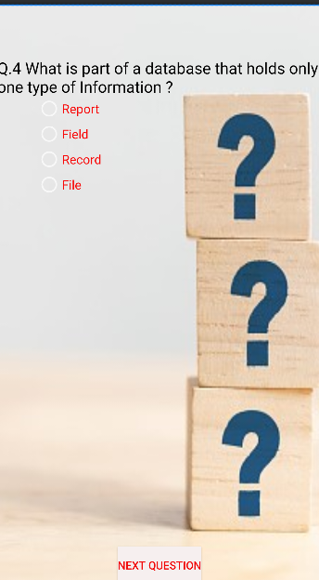

<?xml version="1.0" encoding="utf-8"?>  
<RelativeLayout xmlns:android="http://schemas.android.com/apk/res/android"  
 xmlns:app="http://schemas.android.com/apk/res-auto"  
 xmlns:tools="http://schemas.android.com/tools"  
 android:layout_width="match_parent"  
 android:layout_height="match_parent"  
 android:background="@drawable/quiz1"  
 tools:context=".quiz4">  
  
 <TextView  
 android:id="@+id/textView"  
 android:layout_width="match_parent"  
 android:layout_height="wrap_content"  
 android:layout_alignParentStart="true"  
 android:layout_alignParentLeft="true"  
 android:layout_alignParentTop="true"  
 android:layout_marginStart="0dp"  
 android:layout_marginLeft="0dp"  
 android:layout_marginTop="65dp"  
 android:text="Q.4 What is part of a database that holds only one type of Information ?"  
 android:textColor="#000000"  
 android:textSize="20sp" />  
  
 <Button  
 android:id="@+id/button"  
 android:layout_width="wrap_content"  
 android:layout_height="wrap_content"  
 android:layout_alignParentBottom="true"  
 android:layout_centerHorizontal="true"  
 android:background="#F6EFEF"  
 android:text="Next Question"  
 android:textColor="#F10808" />  
  
 <RadioGroup  
 android:layout_width="match_parent"  
 android:layout_height="match_parent"  
 android:layout_above="@+id/button"  
 android:layout_below="@+id/textView"  
 android:layout_alignEnd="@+id/textView"  
 android:layout_alignRight="@+id/textView"  
 android:layout_alignParentStart="true"  
 android:layout_alignParentLeft="true"  
 android:layout_marginStart="50dp"  
 android:layout_marginLeft="1dp"  
 android:layout_marginTop="-2dp"  
 android:layout_marginEnd="-1dp"  
 android:layout_marginRight="-1dp"  
 android:layout_marginBottom="20dp">  
  
 <RadioButton  
 android:id="@+id/radioButton"  
 android:layout_width="wrap_content"  
 android:layout_height="wrap_content"  
 android:checked="false"  
 android:text="Report"  
 android:textColor="#F80909"  
 android:textSize="16sp" />  
  
 <RadioButton  
 android:id="@+id/radioButton2"  
 android:layout_width="wrap_content"  
 android:layout_height="wrap_content"  
 android:checked="false"  
 android:text="Field"  
 android:textColor="#F80909"  
 android:textSize="16sp" />  
  
 <RadioButton  
 android:id="@+id/radioButton3"  
 android:layout_width="wrap_content"  
 android:layout_height="wrap_content"  
 android:checked="false"  
 android:text="Record"  
 android:textColor="#F80909"  
 android:textSize="16sp" />  
  
 <RadioButton  
 android:id="@+id/radioButton4"  
 android:layout_width="wrap_content"  
 android:layout_height="wrap_content"  
 android:checked="false"  
 android:text="File"  
 android:textColor="#F80909"  
 android:textSize="16sp" />  
 </RadioGroup>  
  
</RelativeLayout>

**quiz5.java**

package com.example.app60;  
  
import androidx.appcompat.app.AppCompatActivity;  
  
import android.content.Intent;  
import android.os.Bundle;  
import android.os.Bundle;  
import android.view.MenuItem;  
import android.view.View;  
import android.widget.Button;  
import android.widget.RadioButton;  
  
import androidx.annotation.NonNull;  
import androidx.appcompat.app.ActionBar;  
import androidx.appcompat.app.AppCompatActivity;  
  
  
public class quiz5 extends AppCompatActivity {  
  
 Button b1;  
 RadioButton r1,r2,r3,r4;  
  
 @Override  
 protected void onCreate(Bundle savedInstanceState) {  
 super.onCreate(savedInstanceState);  
 setContentView(R.layout.*activity_quiz5*);  
 getSupportActionBar().setTitle("Quiz ?");  
  
 b1=(Button)findViewById(R.id.*button*);  
 r1=(RadioButton)findViewById(R.id.*radioButton*);  
 r2=(RadioButton)findViewById(R.id.*radioButton2*);  
 r3=(RadioButton)findViewById(R.id.*radioButton3*);  
 r4=(RadioButton)findViewById(R.id.*radioButton4*);  
 b1.setOnClickListener(new View.OnClickListener() {  
 @Override  
 public void onClick(View view) {  
 if(r2.isChecked()){  
 ++quiz.*score*;  
 }  
 else  
 {  
 --quiz.*score*;  
 }  
 Intent i1 = new Intent(quiz5.this , quiz6.class);  
 startActivity(i1);  
 finish();  
 }  
 });  
 }  
}

**activity_quiz5.xml**

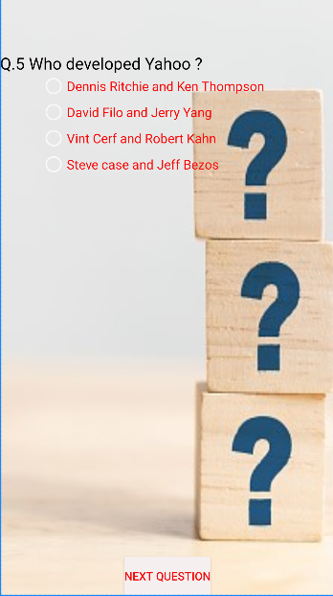

<?xml version="1.0" encoding="utf-8"?>  
<RelativeLayout xmlns:android="http://schemas.android.com/apk/res/android"  
 xmlns:app="http://schemas.android.com/apk/res-auto"  
 xmlns:tools="http://schemas.android.com/tools"  
 android:layout_width="match_parent"  
 android:layout_height="match_parent"  
 android:background="@drawable/quiz1"  
 tools:context=".quiz5">  
  
 <TextView  
 android:id="@+id/textView"  
 android:layout_width="match_parent"  
 android:layout_height="wrap_content"  
 android:layout_alignParentStart="true"  
 android:layout_alignParentLeft="true"  
 android:layout_alignParentTop="true"  
 android:layout_marginStart="0dp"  
 android:layout_marginLeft="0dp"  
 android:layout_marginTop="65dp"  
 android:text="Q.5 Who developed Yahoo ?"  
 android:textColor="#000000"  
 android:textSize="20sp" />  
  
 <Button  
 android:id="@+id/button"  
 android:layout_width="wrap_content"  
 android:layout_height="wrap_content"  
 android:layout_alignParentBottom="true"  
 android:layout_centerHorizontal="true"  
 android:background="#F6EFEF"  
 android:text="Next Question"  
 android:textColor="#F10808" />  
  
 <RadioGroup  
 android:layout_width="match_parent"  
 android:layout_height="match_parent"  
 android:layout_above="@+id/button"  
 android:layout_below="@+id/textView"  
 android:layout_alignEnd="@+id/textView"  
 android:layout_alignRight="@+id/textView"  
 android:layout_alignParentStart="true"  
 android:layout_alignParentLeft="true"  
 android:layout_marginStart="50dp"  
 android:layout_marginLeft="1dp"  
 android:layout_marginTop="-2dp"  
 android:layout_marginEnd="-1dp"  
 android:layout_marginRight="-1dp"  
 android:layout_marginBottom="20dp">  
  
 <RadioButton  
 android:id="@+id/radioButton"  
 android:layout_width="wrap_content"  
 android:layout_height="wrap_content"  
 android:checked="false"  
 android:text="Dennis Ritchie and Ken Thompson"  
 android:textColor="#F80909"  
 android:textSize="16sp" />  
  
 <RadioButton  
 android:id="@+id/radioButton2"  
 android:layout_width="wrap_content"  
 android:layout_height="wrap_content"  
 android:checked="false"  
 android:text="David Filo and Jerry Yang"  
 android:textColor="#F80909"  
 android:textSize="16sp" />  
  
 <RadioButton  
 android:id="@+id/radioButton3"  
 android:layout_width="wrap_content"  
 android:layout_height="wrap_content"  
 android:checked="false"  
 android:text="Vint Cerf and Robert Kahn"  
 android:textColor="#F80909"  
 android:textSize="16sp" />  
  
 <RadioButton  
 android:id="@+id/radioButton4"  
 android:layout_width="wrap_content"  
 android:layout_height="wrap_content"  
 android:checked="false"  
 android:text="Steve case and Jeff Bezos"  
 android:textColor="#F80909"  
 android:textSize="16sp" />  
 </RadioGroup>  
  
</RelativeLayout>

**quiz6.java**

package com.example.app60;  
  
import androidx.appcompat.app.AppCompatActivity;  
  
import android.content.Intent;  
import android.os.Bundle;  
import android.os.Bundle;  
import android.view.MenuItem;  
import android.view.View;  
import android.widget.Button;  
import android.widget.RadioButton;  
  
import androidx.annotation.NonNull;  
import androidx.appcompat.app.ActionBar;  
import androidx.appcompat.app.AppCompatActivity;  
  
  
public class quiz6 extends AppCompatActivity {  
  
 Button b1;  
 RadioButton r1,r2,r3,r4;  
  
 @Override  
 protected void onCreate(Bundle savedInstanceState) {  
 super.onCreate(savedInstanceState);  
 setContentView(R.layout.*activity_quiz6*);  
 getSupportActionBar().setTitle("Quiz ?");  
  
 b1=(Button)findViewById(R.id.*button*);  
 r1=(RadioButton)findViewById(R.id.*radioButton*);  
 r2=(RadioButton)findViewById(R.id.*radioButton2*);  
 r3=(RadioButton)findViewById(R.id.*radioButton3*);  
 r4=(RadioButton)findViewById(R.id.*radioButton4*);  
 b1.setOnClickListener(new View.OnClickListener() {  
 @Override  
 public void onClick(View view) {  
 if(r1.isChecked()){  
 ++quiz.*score*;  
 }  
 else  
 {  
 --quiz.*score*;  
 }  
 Intent i1 = new Intent(quiz6.this , quiz7.class);  
 startActivity(i1);  
 finish();  
 }  
 });  
 }  
}

**activity_quiz6.xml**

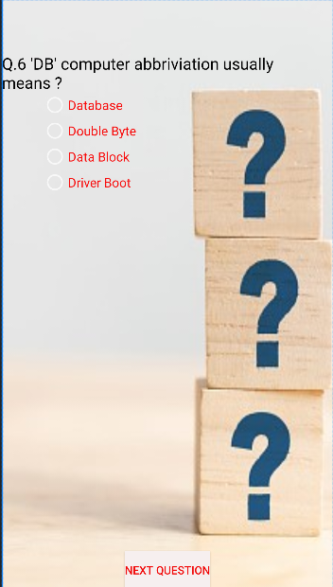

<?xml version="1.0" encoding="utf-8"?>  
<RelativeLayout xmlns:android="http://schemas.android.com/apk/res/android"  
 xmlns:app="http://schemas.android.com/apk/res-auto"  
 xmlns:tools="http://schemas.android.com/tools"  
 android:layout_width="match_parent"  
 android:layout_height="match_parent"  
 android:background="@drawable/quiz1"  
 tools:context=".quiz6">  
  
 <TextView  
 android:id="@+id/textView"  
 android:layout_width="match_parent"  
 android:layout_height="wrap_content"  
 android:layout_alignParentStart="true"  
 android:layout_alignParentLeft="true"  
 android:layout_alignParentTop="true"  
 android:layout_marginStart="0dp"  
 android:layout_marginLeft="0dp"  
 android:layout_marginTop="65dp"  
 android:text="Q.6 'DB' computer abbriviation usually means ?"  
 android:textColor="#000000"  
 android:textSize="20sp" />  
  
 <Button  
 android:id="@+id/button"  
 android:layout_width="wrap_content"  
 android:layout_height="wrap_content"  
 android:layout_alignParentBottom="true"  
 android:layout_centerHorizontal="true"  
 android:background="#F6EFEF"  
 android:text="Next Question"  
 android:textColor="#F10808" />  
  
 <RadioGroup  
 android:layout_width="match_parent"  
 android:layout_height="match_parent"  
 android:layout_above="@+id/button"  
 android:layout_below="@+id/textView"  
 android:layout_alignEnd="@+id/textView"  
 android:layout_alignRight="@+id/textView"  
 android:layout_alignParentStart="true"  
 android:layout_alignParentLeft="true"  
 android:layout_marginStart="50dp"  
 android:layout_marginLeft="1dp"  
 android:layout_marginTop="-2dp"  
 android:layout_marginEnd="-1dp"  
 android:layout_marginRight="-1dp"  
 android:layout_marginBottom="20dp">  
  
 <RadioButton  
 android:id="@+id/radioButton"  
 android:layout_width="wrap_content"  
 android:layout_height="wrap_content"  
 android:checked="false"  
 android:text="Database"  
 android:textColor="#F80909"  
 android:textSize="16sp" />  
  
 <RadioButton  
 android:id="@+id/radioButton2"  
 android:layout_width="wrap_content"  
 android:layout_height="wrap_content"  
 android:checked="false"  
 android:text="Double Byte"  
 android:textColor="#F80909"  
 android:textSize="16sp" />  
  
 <RadioButton  
 android:id="@+id/radioButton3"  
 android:layout_width="wrap_content"  
 android:layout_height="wrap_content"  
 android:checked="false"  
 android:text="Data Block"  
 android:textColor="#F80909"  
 android:textSize="16sp" />  
  
 <RadioButton  
 android:id="@+id/radioButton4"  
 android:layout_width="wrap_content"  
 android:layout_height="wrap_content"  
 android:checked="false"  
 android:text="Driver Boot"  
 android:textColor="#F80909"  
 android:textSize="16sp" />  
 </RadioGroup>  
  
</RelativeLayout>

**quiz7.java**

package com.example.app60;  
  
import androidx.appcompat.app.AppCompatActivity;  
  
import android.content.Intent;  
import android.os.Bundle;  
import android.os.Bundle;  
import android.view.MenuItem;  
import android.view.View;  
import android.widget.Button;  
import android.widget.RadioButton;  
  
import androidx.annotation.NonNull;  
import androidx.appcompat.app.ActionBar;  
import androidx.appcompat.app.AppCompatActivity;  
  
  
public class quiz7 extends AppCompatActivity {  
  
 Button b1;  
 RadioButton r1,r2,r3,r4;  
  
 @Override  
 protected void onCreate(Bundle savedInstanceState) {  
 super.onCreate(savedInstanceState);  
 setContentView(R.layout.*activity_quiz7*);  
 getSupportActionBar().setTitle("Quiz ?");  
  
 b1=(Button)findViewById(R.id.*button*);  
 r1=(RadioButton)findViewById(R.id.*radioButton*);  
 r2=(RadioButton)findViewById(R.id.*radioButton2*);  
 r3=(RadioButton)findViewById(R.id.*radioButton3*);  
 r4=(RadioButton)findViewById(R.id.*radioButton4*);  
 b1.setOnClickListener(new View.OnClickListener() {  
 @Override  
 public void onClick(View view) {  
 if(r2.isChecked()){  
 ++quiz.*score*;  
 }  
 else  
 {  
 --quiz.*score*;  
 }  
 Intent i1 = new Intent(quiz7.this , quiz8.class);  
 startActivity(i1);  
 finish();  
 }  
 });  
 }  
}

**activity_quiz7.xml**

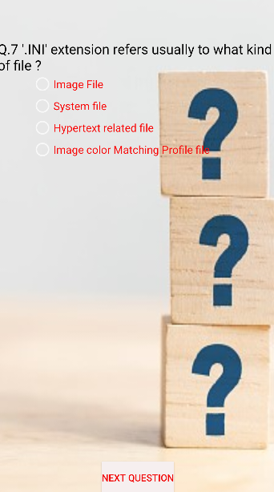

<?xml version="1.0" encoding="utf-8"?>  
<RelativeLayout xmlns:android="http://schemas.android.com/apk/res/android"  
 xmlns:app="http://schemas.android.com/apk/res-auto"  
 xmlns:tools="http://schemas.android.com/tools"  
 android:layout_width="match_parent"  
 android:layout_height="match_parent"  
 android:background="@drawable/quiz1"  
 tools:context=".quiz7">  
  
 <TextView  
 android:id="@+id/textView"  
 android:layout_width="match_parent"  
 android:layout_height="wrap_content"  
 android:layout_alignParentStart="true"  
 android:layout_alignParentLeft="true"  
 android:layout_alignParentTop="true"  
 android:layout_marginStart="0dp"  
 android:layout_marginLeft="0dp"  
 android:layout_marginTop="65dp"  
 android:text="Q.7 '.INI' extension refers usually to what kind of file ?"  
 android:textColor="#000000"  
 android:textSize="20sp" />  
  
 <Button  
 android:id="@+id/button"  
 android:layout_width="wrap_content"  
 android:layout_height="wrap_content"  
 android:layout_alignParentBottom="true"  
 android:layout_centerHorizontal="true"  
 android:background="#F6EFEF"  
 android:text="Next Question"  
 android:textColor="#F10808" />  
  
 <RadioGroup  
 android:layout_width="match_parent"  
 android:layout_height="match_parent"  
 android:layout_above="@+id/button"  
 android:layout_below="@+id/textView"  
 android:layout_alignEnd="@+id/textView"  
 android:layout_alignRight="@+id/textView"  
 android:layout_alignParentStart="true"  
 android:layout_alignParentLeft="true"  
 android:layout_marginStart="50dp"  
 android:layout_marginLeft="1dp"  
 android:layout_marginTop="-2dp"  
 android:layout_marginEnd="-1dp"  
 android:layout_marginRight="-1dp"  
 android:layout_marginBottom="20dp">  
  
 <RadioButton  
 android:id="@+id/radioButton"  
 android:layout_width="wrap_content"  
 android:layout_height="wrap_content"  
 android:checked="false"  
 android:text="Image File"  
 android:textColor="#F80909"  
 android:textSize="16sp" />  
  
 <RadioButton  
 android:id="@+id/radioButton2"  
 android:layout_width="wrap_content"  
 android:layout_height="wrap_content"  
 android:checked="false"  
 android:text="System file"  
 android:textColor="#F80909"  
 android:textSize="16sp" />  
  
 <RadioButton  
 android:id="@+id/radioButton3"  
 android:layout_width="wrap_content"  
 android:layout_height="wrap_content"  
 android:checked="false"  
 android:text="Hypertext related file"  
 android:textColor="#F80909"  
 android:textSize="16sp" />  
  
 <RadioButton  
 android:id="@+id/radioButton4"  
 android:layout_width="wrap_content"  
 android:layout_height="wrap_content"  
 android:checked="false"  
 android:text="Image color Matching Profile file"  
 android:textColor="#F80909"  
 android:textSize="16sp" />  
 </RadioGroup>  
  
</RelativeLayout>

**quiz8.java**

package com.example.app60;  
  
import androidx.appcompat.app.AppCompatActivity;  
  
import android.content.Intent;  
import android.os.Bundle;  
import android.os.Bundle;  
import android.view.MenuItem;  
import android.view.View;  
import android.widget.Button;  
import android.widget.RadioButton;  
  
import androidx.annotation.NonNull;  
import androidx.appcompat.app.ActionBar;  
import androidx.appcompat.app.AppCompatActivity;  
  
  
public class quiz8 extends AppCompatActivity {  
  
 Button b1;  
 RadioButton r1,r2,r3,r4;  
  
 @Override  
 protected void onCreate(Bundle savedInstanceState) {  
 super.onCreate(savedInstanceState);  
 setContentView(R.layout.*activity_quiz8*);  
 getSupportActionBar().setTitle("Quiz ?");  
  
 b1=(Button)findViewById(R.id.*button*);  
 r1=(RadioButton)findViewById(R.id.*radioButton*);  
 r2=(RadioButton)findViewById(R.id.*radioButton2*);  
 r3=(RadioButton)findViewById(R.id.*radioButton3*);  
 r4=(RadioButton)findViewById(R.id.*radioButton4*);  
 b1.setOnClickListener(new View.OnClickListener() {  
 @Override  
 public void onClick(View view) {  
 if(r3.isChecked()){  
 ++quiz.*score*;  
 }  
 else  
 {  
 --quiz.*score*;  
 }  
 Intent i1 = new Intent(quiz8.this , quiz9.class);  
 startActivity(i1);  
 finish();  
 }  
 });  
 }  
}

**activity_quiz8.xml**

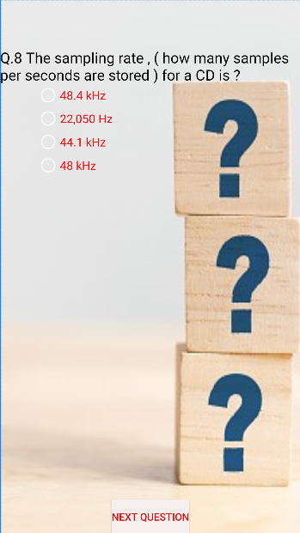

<?xml version="1.0" encoding="utf-8"?>  
<RelativeLayout xmlns:android="http://schemas.android.com/apk/res/android"  
 xmlns:app="http://schemas.android.com/apk/res-auto"  
 xmlns:tools="http://schemas.android.com/tools"  
 android:layout_width="match_parent"  
 android:layout_height="match_parent"  
 android:background="@drawable/quiz1"  
 tools:context=".quiz8">  
  
 <TextView  
 android:id="@+id/textView"  
 android:layout_width="match_parent"  
 android:layout_height="wrap_content"  
 android:layout_alignParentStart="true"  
 android:layout_alignParentLeft="true"  
 android:layout_alignParentTop="true"  
 android:layout_marginStart="0dp"  
 android:layout_marginLeft="0dp"  
 android:layout_marginTop="65dp"  
 android:text="Q.8 The sampling rate , ( how many samples per seconds are stored ) for a CD is ?"  
 android:textColor="#000000"  
 android:textSize="20sp" />  
  
 <Button  
 android:id="@+id/button"  
 android:layout_width="wrap_content"  
 android:layout_height="wrap_content"  
 android:layout_alignParentBottom="true"  
 android:layout_centerHorizontal="true"  
 android:background="#F6EFEF"  
 android:text="Next Question"  
 android:textColor="#F10808" />  
  
 <RadioGroup  
 android:layout_width="match_parent"  
 android:layout_height="match_parent"  
 android:layout_above="@+id/button"  
 android:layout_below="@+id/textView"  
 android:layout_alignEnd="@+id/textView"  
 android:layout_alignRight="@+id/textView"  
 android:layout_alignParentStart="true"  
 android:layout_alignParentLeft="true"  
 android:layout_marginStart="50dp"  
 android:layout_marginLeft="1dp"  
 android:layout_marginTop="-2dp"  
 android:layout_marginEnd="-1dp"  
 android:layout_marginRight="-1dp"  
 android:layout_marginBottom="20dp">  
  
 <RadioButton  
 android:id="@+id/radioButton"  
 android:layout_width="wrap_content"  
 android:layout_height="wrap_content"  
 android:checked="false"  
 android:text="48.4 kHz"  
 android:textColor="#F80909"  
 android:textSize="16sp" />  
  
 <RadioButton  
 android:id="@+id/radioButton2"  
 android:layout_width="wrap_content"  
 android:layout_height="wrap_content"  
 android:checked="false"  
 android:text="22,050 Hz"  
 android:textColor="#F80909"  
 android:textSize="16sp" />  
  
 <RadioButton  
 android:id="@+id/radioButton3"  
 android:layout_width="wrap_content"  
 android:layout_height="wrap_content"  
 android:checked="false"  
 android:text="44.1 kHz"  
 android:textColor="#F80909"  
 android:textSize="16sp" />  
  
 <RadioButton  
 android:id="@+id/radioButton4"  
 android:layout_width="wrap_content"  
 android:layout_height="wrap_content"  
 android:checked="false"  
 android:text="48 kHz"  
 android:textColor="#F80909"  
 android:textSize="16sp" />  
 </RadioGroup>  
  
</RelativeLayout>

**quiz9.java**

package com.example.app60;  
  
import androidx.appcompat.app.AppCompatActivity;  
  
import android.content.Intent;  
import android.os.Bundle;  
import android.os.Bundle;  
import android.view.MenuItem;  
import android.view.View;  
import android.widget.Button;  
import android.widget.RadioButton;  
  
import androidx.annotation.NonNull;  
import androidx.appcompat.app.ActionBar;  
import androidx.appcompat.app.AppCompatActivity;  
  
  
public class quiz9 extends AppCompatActivity {  
  
 Button b1;  
 RadioButton r1,r2,r3,r4;  
  
 @Override  
 protected void onCreate(Bundle savedInstanceState) {  
 super.onCreate(savedInstanceState);  
 setContentView(R.layout.*activity_quiz9*);  
 getSupportActionBar().setTitle("Quiz ?");  
  
 b1=(Button)findViewById(R.id.*button*);  
 r1=(RadioButton)findViewById(R.id.*radioButton*);  
 r2=(RadioButton)findViewById(R.id.*radioButton2*);  
 r3=(RadioButton)findViewById(R.id.*radioButton3*);  
 r4=(RadioButton)findViewById(R.id.*radioButton4*);  
 b1.setOnClickListener(new View.OnClickListener() {  
 @Override  
 public void onClick(View view) {  
 if(r3.isChecked()){  
 ++quiz.*score*;  
 }  
 else  
 {  
 --quiz.*score*;  
 }  
 Intent i1 = new Intent(quiz9.this , quiz10.class);  
 startActivity(i1);  
 finish();  
 }  
 });  
 }  
}

**activity_quiz9.xml**

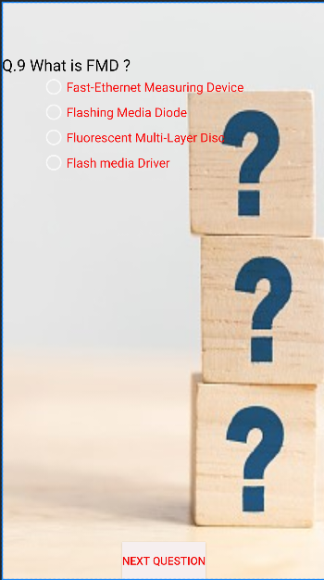

<?xml version="1.0" encoding="utf-8"?>  
<RelativeLayout xmlns:android="http://schemas.android.com/apk/res/android"  
 xmlns:app="http://schemas.android.com/apk/res-auto"  
 xmlns:tools="http://schemas.android.com/tools"  
 android:layout_width="match_parent"  
 android:layout_height="match_parent"  
 android:background="@drawable/quiz1"  
 tools:context=".quiz9">  
  
 <TextView  
 android:id="@+id/textView"  
 android:layout_width="match_parent"  
 android:layout_height="wrap_content"  
 android:layout_alignParentStart="true"  
 android:layout_alignParentLeft="true"  
 android:layout_alignParentTop="true"  
 android:layout_marginStart="0dp"  
 android:layout_marginLeft="0dp"  
 android:layout_marginTop="65dp"  
 android:text="Q.9 What is FMD ?"  
 android:textColor="#000000"  
 android:textSize="20sp" />  
  
 <Button  
 android:id="@+id/button"  
 android:layout_width="wrap_content"  
 android:layout_height="wrap_content"  
 android:layout_alignParentBottom="true"  
 android:layout_centerHorizontal="true"  
 android:background="#F6EFEF"  
 android:text="Next Question"  
 android:textColor="#F10808" />  
  
 <RadioGroup  
 android:layout_width="match_parent"  
 android:layout_height="match_parent"  
 android:layout_above="@+id/button"  
 android:layout_below="@+id/textView"  
 android:layout_alignEnd="@+id/textView"  
 android:layout_alignRight="@+id/textView"  
 android:layout_alignParentStart="true"  
 android:layout_alignParentLeft="true"  
 android:layout_marginStart="50dp"  
 android:layout_marginLeft="1dp"  
 android:layout_marginTop="-2dp"  
 android:layout_marginEnd="-1dp"  
 android:layout_marginRight="-1dp"  
 android:layout_marginBottom="20dp">  
  
 <RadioButton  
 android:id="@+id/radioButton"  
 android:layout_width="wrap_content"  
 android:layout_height="wrap_content"  
 android:checked="false"  
 android:text="Fast-Ethernet Measuring Device"  
 android:textColor="#F80909"  
 android:textSize="16sp" />  
  
 <RadioButton  
 android:id="@+id/radioButton2"  
 android:layout_width="wrap_content"  
 android:layout_height="wrap_content"  
 android:checked="false"  
 android:text="Flashing Media Diode"  
 android:textColor="#F80909"  
 android:textSize="16sp" />  
  
 <RadioButton  
 android:id="@+id/radioButton3"  
 android:layout_width="wrap_content"  
 android:layout_height="wrap_content"  
 android:checked="false"  
 android:text="Fluorescent Multi-Layer Disc"  
 android:textColor="#F80909"  
 android:textSize="16sp" />  
  
 <RadioButton  
 android:id="@+id/radioButton4"  
 android:layout_width="wrap_content"  
 android:layout_height="wrap_content"  
 android:checked="false"  
 android:text="Flash media Driver"  
 android:textColor="#F80909"  
 android:textSize="16sp" />  
 </RadioGroup>  
  
</RelativeLayout>

**quiz10.java**

package com.example.app60;  
  
import androidx.appcompat.app.AppCompatActivity;  
  
import android.content.Intent;  
import android.os.Bundle;  
import android.os.Bundle;  
import android.view.MenuItem;  
import android.view.View;  
import android.widget.Button;  
import android.widget.RadioButton;  
  
import androidx.annotation.NonNull;  
import androidx.appcompat.app.ActionBar;  
import androidx.appcompat.app.AppCompatActivity;  
  
  
public class quiz10 extends AppCompatActivity {  
  
 Button b1;  
 RadioButton r1,r2,r3,r4;  
  
 @Override  
 protected void onCreate(Bundle savedInstanceState) {  
 super.onCreate(savedInstanceState);  
 setContentView(R.layout.*activity_quiz10*);  
 getSupportActionBar().setTitle("Quiz ?");  
  
 b1=(Button)findViewById(R.id.*button*);  
 r1=(RadioButton)findViewById(R.id.*radioButton*);  
 r2=(RadioButton)findViewById(R.id.*radioButton2*);  
 r3=(RadioButton)findViewById(R.id.*radioButton3*);  
 r4=(RadioButton)findViewById(R.id.*radioButton4*);  
 b1.setOnClickListener(new View.OnClickListener() {  
 @Override  
 public void onClick(View view) {  
 if(r1.isChecked()){  
 ++quiz.*score*;  
 }  
 else  
 {  
 --quiz.*score*;  
 }  
 Intent i1 = new Intent(quiz10.this , quizResult.class);  
 startActivity(i1);  
 finish();  
 }  
 });  
 }  
}

**activity_quiz10.xml**

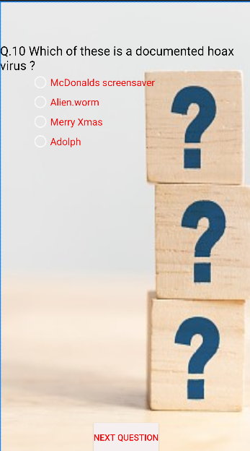

<?xml version="1.0" encoding="utf-8"?>  
<RelativeLayout xmlns:android="http://schemas.android.com/apk/res/android"  
 xmlns:app="http://schemas.android.com/apk/res-auto"  
 xmlns:tools="http://schemas.android.com/tools"  
 android:layout_width="match_parent"  
 android:layout_height="match_parent"  
 android:background="@drawable/quiz1"  
 tools:context=".quiz10">  
  
 <TextView  
 android:id="@+id/textView"  
 android:layout_width="match_parent"  
 android:layout_height="wrap_content"  
 android:layout_alignParentStart="true"  
 android:layout_alignParentLeft="true"  
 android:layout_alignParentTop="true"  
 android:layout_marginStart="0dp"  
 android:layout_marginLeft="0dp"  
 android:layout_marginTop="65dp"  
 android:text="Q.10 Which of these is a documented hoax virus ?"  
 android:textColor="#000000"  
 android:textSize="20sp" />  
  
 <Button  
 android:id="@+id/button"  
 android:layout_width="wrap_content"  
 android:layout_height="wrap_content"  
 android:layout_alignParentBottom="true"  
 android:layout_centerHorizontal="true"  
 android:background="#F6EFEF"  
 android:text="Next Question"  
 android:textColor="#F10808" />  
  
 <RadioGroup  
 android:layout_width="match_parent"  
 android:layout_height="match_parent"  
 android:layout_above="@+id/button"  
 android:layout_below="@+id/textView"  
 android:layout_alignEnd="@+id/textView"  
 android:layout_alignRight="@+id/textView"  
 android:layout_alignParentStart="true"  
 android:layout_alignParentLeft="true"  
 android:layout_marginStart="50dp"  
 android:layout_marginLeft="1dp"  
 android:layout_marginTop="-2dp"  
 android:layout_marginEnd="-1dp"  
 android:layout_marginRight="-1dp"  
 android:layout_marginBottom="20dp">  
  
 <RadioButton  
 android:id="@+id/radioButton"  
 android:layout_width="wrap_content"  
 android:layout_height="wrap_content"  
 android:checked="false"  
 android:text="McDonalds screensaver"  
 android:textColor="#F80909"  
 android:textSize="16sp" />  
  
 <RadioButton  
 android:id="@+id/radioButton2"  
 android:layout_width="wrap_content"  
 android:layout_height="wrap_content"  
 android:checked="false"  
 android:text="Alien.worm"  
 android:textColor="#F80909"  
 android:textSize="16sp" />  
  
 <RadioButton  
 android:id="@+id/radioButton3"  
 android:layout_width="wrap_content"  
 android:layout_height="wrap_content"  
 android:checked="false"  
 android:text="Merry Xmas"  
 android:textColor="#F80909"  
 android:textSize="16sp" />  
  
 <RadioButton  
 android:id="@+id/radioButton4"  
 android:layout_width="wrap_content"  
 android:layout_height="wrap_content"  
 android:checked="false"  
 android:text="Adolph"  
 android:textColor="#F80909"  
 android:textSize="16sp" />  
 </RadioGroup>  
  
</RelativeLayout>

**quizResult.java**

package com.example.app60;  
  
import androidx.appcompat.app.AppCompatActivity;  
  
import android.content.Intent;  
import android.os.Bundle;  
import android.view.View;  
import android.widget.Button;  
import android.widget.TextView;  
import android.os.Bundle;  
import android.view.MenuItem;  
import androidx.annotation.NonNull;  
import androidx.appcompat.app.ActionBar;  
import androidx.appcompat.app.AppCompatActivity;  
  
public class quizResult extends AppCompatActivity {  
  
 Button b;  
 TextView t;  
  
 @Override  
 protected void onCreate(Bundle savedInstanceState) {  
 super.onCreate(savedInstanceState);  
 setContentView(R.layout.*activity_quiz_result*);  
 ActionBar actionBar = getSupportActionBar();  
 actionBar.setDisplayHomeAsUpEnabled(true);  
 getSupportActionBar().setTitle("Quiz Result");  
  
 b=(Button)findViewById(R.id.*button2*);  
 t=(TextView)findViewById(R.id.*textView2*);  
  
 t.setText("the result is = "+quiz.*score*);  
 b.setOnClickListener(new View.OnClickListener() {  
 @Override  
 public void onClick(View view) {  
 Intent i1 = new Intent(quizResult.this , games.class);  
 startActivity(i1);  
 finish();  
 }  
 });  
 }  
 @Override  
 public boolean onOptionsItemSelected(@NonNull MenuItem item) {  
 switch (item.getItemId()) {  
 case android.R.id.*home*:  
 this.finish();  
 return true;  
 }  
 return super.onOptionsItemSelected(item);  
 }  
}

**actvity_quiz_result.xml**

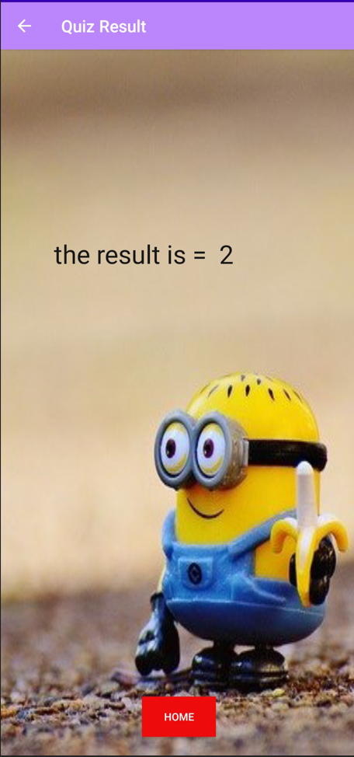

<?xml version="1.0" encoding="utf-8"?>  
<RelativeLayout xmlns:android="http://schemas.android.com/apk/res/android"  
 xmlns:app="http://schemas.android.com/apk/res-auto"  
 xmlns:tools="http://schemas.android.com/tools"  
 android:layout_width="match_parent"  
 android:layout_height="match_parent"  
 android:background="@drawable/m"  
 tools:context=".quizResult">  
  
 <TextView  
 android:id="@+id/textView2"  
 android:layout_width="match_parent"  
 android:layout_height="wrap_content"  
 android:layout_alignParentStart="true"  
 android:layout_alignParentLeft="true"  
 android:layout_alignParentTop="true"  
 android:layout_centerHorizontal="true"  
 android:layout_marginStart="63dp"  
 android:layout_marginLeft="63dp"  
 android:layout_marginTop="222dp"  
 android:text="New Text"  
 android:textColor="#171616"  
 android:textSize="34sp" />  
  
 <Button  
 android:id="@+id/button2"  
 android:layout_width="wrap_content"  
 android:layout_height="wrap_content"  
 android:layout_alignParentBottom="true"  
 android:layout_centerHorizontal="true"  
 android:layout_marginBottom="24dp"  
 android:background="#ED0B0B"  
 android:text="Home" />  
  
</RelativeLayout>

**tools.java**

package com.example.app60;  
  
import androidx.appcompat.app.AppCompatActivity;  
  
import android.content.Intent;  
import android.media.Image;  
import android.os.Bundle;  
import android.os.Bundle;  
import android.view.MenuItem;  
import android.view.View;  
import android.widget.ImageButton;  
  
import androidx.annotation.NonNull;  
import androidx.appcompat.app.ActionBar;  
import androidx.appcompat.app.AppCompatActivity;  
  
  
  
public class tools extends AppCompatActivity {  
  
 ImageButton ib1,ib2,ib3,ib4,ib5,ib6,ib7,ib8,ib9;  
  
 @Override  
 protected void onCreate(Bundle savedInstanceState) {  
 super.onCreate(savedInstanceState);  
 setContentView(R.layout.*activity_tools*);  
 ActionBar actionBar = getSupportActionBar();  
 actionBar.setDisplayHomeAsUpEnabled(true);  
 getSupportActionBar().setTitle("Tools");  
 ib1=(ImageButton) findViewById(R.id.*imageButton5*);  
 ib2=(ImageButton) findViewById(R.id.*imageButton6*);  
 ib3=(ImageButton) findViewById(R.id.*imageButton22*);  
 ib4=(ImageButton) findViewById(R.id.*imageButton23*);  
 ib5=(ImageButton) findViewById(R.id.*imageButton18*);  
 ib6=(ImageButton) findViewById(R.id.*imageButton20*);  
 ib7=(ImageButton) findViewById(R.id.*imageButton25*);  
 ib8=(ImageButton) findViewById(R.id.*imageButton*);  
 ib9=(ImageButton) findViewById(R.id.*imageButton27*);  
  
  
 ib1.setOnClickListener(new View.OnClickListener() {  
 @Override  
 public void onClick(View view) {  
 Intent i = new Intent(tools.this,cal.class);  
 startActivity(i);  
 //finish();  
 }  
 });  
  
 ib2.setOnClickListener(new View.OnClickListener() {  
 @Override  
 public void onClick(View view) {  
 Intent i = new Intent(tools.this,media.class);  
 startActivity(i);  
 //finish();  
 }  
 });  
 ib3.setOnClickListener(new View.OnClickListener() {  
 @Override  
 public void onClick(View view) {  
 Intent i = new Intent(tools.this,tts.class);  
 startActivity(i);  
 //finish();  
 }  
 });  
 ib4.setOnClickListener(new View.OnClickListener() {  
 @Override  
 public void onClick(View view) {  
 Intent i = new Intent(tools.this,wifi.class);  
 startActivity(i);  
 //finish();  
 }  
 });  
 ib5.setOnClickListener(new View.OnClickListener() {  
 @Override  
 public void onClick(View view) {  
 Intent i = new Intent(tools.this,bluethoot.class);  
 startActivity(i);  
 //finish();  
 }  
 });  
 ib6.setOnClickListener(new View.OnClickListener() {  
 @Override  
 public void onClick(View view) {  
 Intent intent = new Intent(tools.this , camera.class);  
 startActivity(intent);  
 //finish();  
 }  
 });  
 ib7.setOnClickListener(new View.OnClickListener() {  
 @Override  
 public void onClick(View view) {  
 Intent intent = new Intent(tools.this , torch.class);  
 startActivity(intent);  
 //finish();  
 }  
 });  
 ib8.setOnClickListener(new View.OnClickListener() {  
 @Override  
 public void onClick(View view) {  
 Intent intent = new Intent(tools.this , vibrate.class);  
 startActivity(intent);  
 //finish();  
 }  
 });  
 ib9.setOnClickListener(new View.OnClickListener() {  
 @Override  
 public void onClick(View view) {  
 Intent intent = new Intent(tools.this,danger.class);  
 startActivity(intent);  
 //finish();  
 }  
 });  
 }  
  
 @Override  
 public boolean onOptionsItemSelected(@NonNull MenuItem item) {  
 switch (item.getItemId()) {  
 case android.R.id.*home*:  
 this.finish();  
 return true;  
 }  
 return super.onOptionsItemSelected(item);  
 }  
}

**activity_tools.xml**

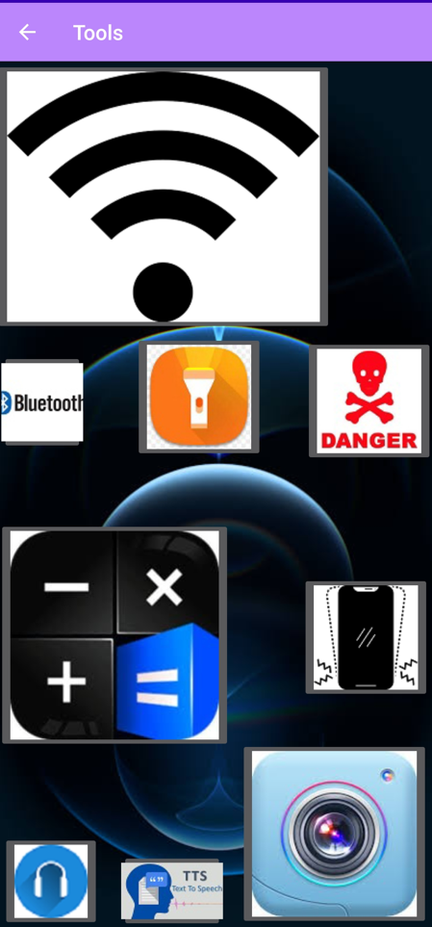

<?xml version="1.0" encoding="utf-8"?>  
<RelativeLayout xmlns:android="http://schemas.android.com/apk/res/android"  
 xmlns:app="http://schemas.android.com/apk/res-auto"  
 xmlns:tools="http://schemas.android.com/tools"  
 android:layout_width="match_parent"  
 android:layout_height="match_parent"  
 android:background="@drawable/wal"  
 tools:context=".tools">  
  
 <ImageButton  
 android:id="@+id/imageButton18"  
 android:layout_width="wrap_content"  
 android:layout_height="wrap_content"  
 android:layout_alignParentStart="true"  
 android:layout_alignParentEnd="true"  
 android:layout_alignParentBottom="true"  
 android:layout_marginStart="3dp"  
 android:layout_marginEnd="342dp"  
 android:layout_marginBottom="466dp"  
 app:srcCompat="@drawable/logo" />  
  
 <ImageButton  
 android:id="@+id/imageButton5"  
 android:layout_width="wrap_content"  
 android:layout_height="wrap_content"  
 android:layout_alignParentStart="true"  
 android:layout_alignParentBottom="true"  
 android:layout_centerVertical="true"  
 android:layout_marginStart="0dp"  
 android:layout_marginBottom="180dp"  
 app:layout_constraintEnd_toEndOf="parent"  
 app:layout_constraintHorizontal_bias="0.021"  
 app:layout_constraintStart_toStartOf="parent"  
 app:srcCompat="@drawable/cal"  
 tools:layout_editor_absoluteY="6dp" />  
  
 <ImageButton  
 android:id="@+id/imageButton22"  
 android:layout_width="85dp"  
 android:layout_height="wrap_content"  
 android:layout_alignParentStart="true"  
 android:layout_alignParentEnd="true"  
 android:layout_alignParentBottom="true"  
 android:layout_centerVertical="true"  
 android:layout_marginStart="118dp"  
 android:layout_marginTop="13dp"  
 android:layout_marginEnd="208dp"  
 android:layout_marginBottom="8dp"  
 app:srcCompat="@drawable/images" />  
  
 <ImageButton  
 android:id="@+id/imageButton23"  
 android:layout_width="wrap_content"  
 android:layout_height="wrap_content"  
 android:layout_marginStart="-3dp"  
 android:layout_marginBottom="4dp"  
 android:baselineAligned="false"  
 app:srcCompat="@drawable/black" />  
  
 <ImageButton  
 android:id="@+id/imageButton6"  
 android:layout_width="wrap_content"  
 android:layout_height="wrap_content"  
 android:layout_alignParentStart="true"  
 android:layout_alignParentBottom="true"  
 android:layout_marginStart="4dp"  
 android:layout_marginBottom="9dp"  
 app:srcCompat="@drawable/mpplayer" />  
  
 <ImageButton  
 android:id="@+id/imageButton20"  
 android:layout_width="wrap_content"  
 android:layout_height="wrap_content"  
 android:layout_alignParentEnd="true"  
 android:layout_alignParentBottom="true"  
 android:layout_marginEnd="10dp"  
 android:layout_marginBottom="10dp"  
 app:srcCompat="@drawable/camera" />  
  
 <ImageButton  
 android:id="@+id/imageButton25"  
 android:layout_width="wrap_content"  
 android:layout_height="wrap_content"  
 android:layout_alignParentTop="true"  
 android:layout_alignParentEnd="true"  
 android:layout_marginTop="262dp"  
 android:layout_marginEnd="169dp"  
 app:srcCompat="@drawable/torch" />  
  
 <ImageButton  
 android:id="@+id/imageButton"  
 android:layout_width="wrap_content"  
 android:layout_height="wrap_content"  
 android:layout_alignParentEnd="true"  
 android:layout_alignParentBottom="true"  
 android:layout_marginEnd="9dp"  
 android:layout_marginBottom="228dp"  
 app:srcCompat="@drawable/vibrate" />  
  
 <ImageButton  
 android:id="@+id/imageButton27"  
 android:layout_width="wrap_content"  
 android:layout_height="wrap_content"  
 android:layout_alignParentTop="true"  
 android:layout_alignParentEnd="true"  
 android:layout_centerVertical="true"  
 android:layout_marginTop="266dp"  
 android:layout_marginEnd="6dp"  
 app:srcCompat="@drawable/download" />  
  
</RelativeLayout>

**bluethoot.java**

package com.example.app60;  
  
import androidx.appcompat.app.AppCompatActivity;  
  
import android.bluetooth.BluetoothAdapter;  
import android.bluetooth.BluetoothDevice;  
import android.content.Intent;  
import android.os.Bundle;  
import android.view.View;  
import android.widget.ImageButton;  
import android.os.Bundle;  
import android.view.MenuItem;  
import androidx.annotation.NonNull;  
import androidx.appcompat.app.ActionBar;  
import androidx.appcompat.app.AppCompatActivity;  
  
public class bluethoot extends AppCompatActivity {  
  
 ImageButton lb;  
 BluetoothAdapter ba;  
 private boolean blue = false;  
 @Override  
 protected void onCreate(Bundle savedInstanceState) {  
 super.onCreate(savedInstanceState);  
 setContentView(R.layout.*activity_bluethoot*);  
  
 ActionBar actionBar = getSupportActionBar();  
 actionBar.setDisplayHomeAsUpEnabled(true);  
 getSupportActionBar().setTitle("Bluethooth");  
  
  
 lb=(ImageButton)findViewById(R.id.*imageButton19*);  
 ba=BluetoothAdapter.*getDefaultAdapter*();  
  
 lb.setOnClickListener(new View.OnClickListener() {  
 @Override  
 public void onClick(View view) {  
 if(blue == false)  
 {  
 ba.enable();  
 blue=true;  
 lb.setImageResource(R.drawable.*on*);  
 }  
 else  
 {  
 ba.disable();  
 blue=false;  
 lb.setImageResource(R.drawable.*off*);  
 }  
 }  
 });  
  
  
 }  
 @Override  
 public boolean onOptionsItemSelected(@NonNull MenuItem item) {  
 switch (item.getItemId()) {  
 case android.R.id.*home*:  
 this.finish();  
 return true;  
 }  
 return super.onOptionsItemSelected(item);  
 }  
}

**activity_bluethoot.xml**

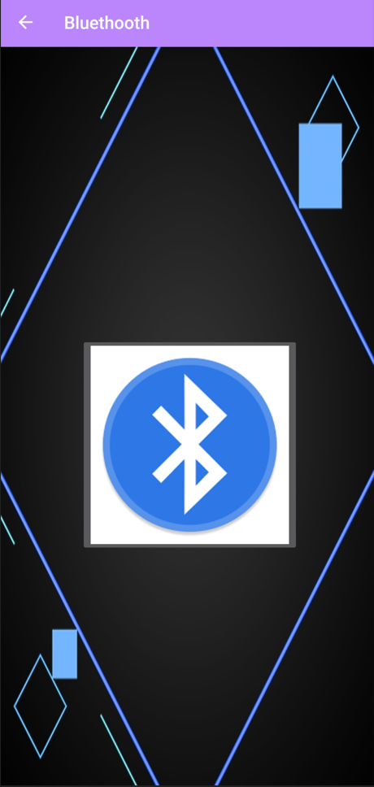

<?xml version="1.0" encoding="utf-8"?>  
<RelativeLayout xmlns:android="http://schemas.android.com/apk/res/android"  
 xmlns:app="http://schemas.android.com/apk/res-auto"  
 xmlns:tools="http://schemas.android.com/tools"  
 android:layout_width="match_parent"  
 android:layout_height="match_parent"  
 android:background="@drawable/bluohohoh"  
 tools:context=".bluethoot">  
  
 <ImageButton  
 android:id="@+id/imageButton19"  
 android:layout_width="wrap_content"  
 android:layout_height="wrap_content"  
 android:layout_alignParentStart="true"  
 android:layout_alignParentBottom="true"  
 android:layout_centerHorizontal="true"  
 android:layout_marginStart="90dp"  
 android:layout_marginBottom="266dp"  
 app:srcCompat="@drawable/off" />  
</RelativeLayout>

**torch.java**

package com.example.app60;import static com.example.app60.R.id.*imageButton26*;import androidx.appcompat.app.AppCompatActivity;import android.hardware.camera2.CameraAccessException;import android.hardware.camera2.CameraManager;import android.os.Bundle;import android.view.MenuItem;import android.view.View;import android.widget.ImageButton;import androidx.annotation.NonNull;import androidx.appcompat.app.ActionBar;public class torch extends AppCompatActivity { ImageButton b; private boolean blue = false; CameraManager cm; @Override protected void onCreate(Bundle savedInstanceState) { super.onCreate(savedInstanceState); setContentView(R.layout.*activity_torch*); ActionBar actionBar = getSupportActionBar(); actionBar.setDisplayHomeAsUpEnabled(true); getSupportActionBar().setTitle("Torch");  b=(ImageButton) findViewById(R.id.*imageButton26*); cm=(CameraManager)getSystemService(*CAMERA_SERVICE*); b.setOnClickListener(new View.OnClickListener() { @Override public void onClick(View view) { if(blue == false) { try{ String id = cm.getCameraIdList()[0]; cm.setTorchMode(id,true); blue = true; b.setImageResource(R.drawable.*dd*); } catch (CameraAccessException e){ } } else { try { String id = cm.getCameraIdList()[0]; cm.setTorchMode(id,false); blue = false; b.setImageResource(R.drawable.*cc*); } catch (CameraAccessException e){ } } } }); } @Override public boolean onOptionsItemSelected(@NonNull MenuItem item) { switch (item.getItemId()) { case android.R.id.*home*: this.finish(); return true; } return super.onOptionsItemSelected(item); }}

**activity_torch.xml**

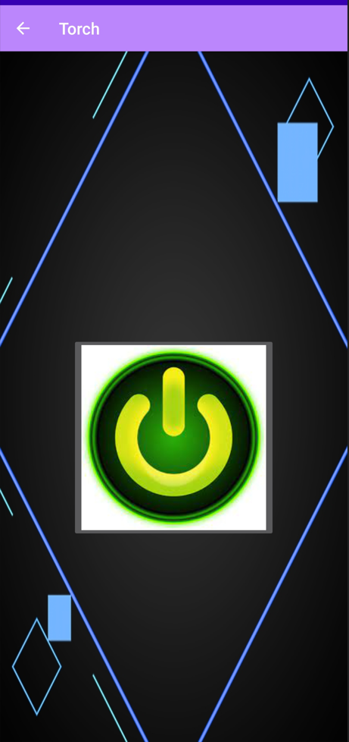

<?xml version="1.0" encoding="utf-8"?><RelativeLayout xmlns:android="http://schemas.android.com/apk/res/android" xmlns:app="http://schemas.android.com/apk/res-auto" xmlns:tools="http://schemas.android.com/tools" android:layout_width="match_parent" android:layout_height="match_parent" android:background="@drawable/bluohohoh" tools:context=".torch"> <ImageButton android:id="@+id/imageButton26" android:layout_width="wrap_content" android:layout_height="wrap_content" android:layout_alignParentBottom="true" android:layout_centerInParent="true" android:layout_marginBottom="248dp" app:srcCompat="@drawable/cc" /></RelativeLayout>

**cal.java**

package com.example.app60;import androidx.appcompat.app.AppCompatActivity;import android.os.Bundle;import android.os.Bundle;import android.view.MenuItem;import android.view.View;import android.widget.Button;import android.widget.EditText;import android.widget.TextView;import android.widget.Toast;import androidx.annotation.NonNull;import androidx.appcompat.app.ActionBar;import androidx.appcompat.app.AppCompatActivity;public class cal extends AppCompatActivity { EditText e1, e2; TextView t1; Button b1,b2,b3,b4; @Override protected void onCreate(Bundle savedInstanceState) { super.onCreate(savedInstanceState); setContentView(R.layout.*activity_cal*); ActionBar actionBar = getSupportActionBar(); actionBar.setDisplayHomeAsUpEnabled(true); getSupportActionBar().setTitle("Calculator"); e1 = (EditText) findViewById(R.id.*editText*); e2 = (EditText) findViewById(R.id.*editText2*); t1 = (TextView) findViewById(R.id.*textView*); b1 = (Button) findViewById(R.id.*button*); b2 = (Button)findViewById(R.id.*button2*); b3 = (Button)findViewById(R.id.*button3*); b4 = (Button)findViewById(R.id.*button4*); b1.setOnClickListener(new View.OnClickListener() { @Override public void onClick(View view) { String s1 = e1.getText().toString(); String s2 = e2.getText().toString(); Float i1 = Float.*parseFloat*(s1); Float i2 = Float.*parseFloat*(s2); Float i3 = i1 + i2; String s3 = Float.*toString*(i3); t1.setText(s3); Toast.*makeText*(cal.this, "The Result is = "+s3, Toast.*LENGTH_SHORT*).show(); } }); b2.setOnClickListener(new View.OnClickListener() { @Override public void onClick(View view) { String s1 = e1.getText().toString(); String s2 = e2.getText().toString(); Float i1 = Float.*parseFloat*(s1); Float i2 = Float.*parseFloat*(s2); Float i3 = i1 - i2; String s3 = Float.*toString*(i3); t1.setText(s3); Toast.*makeText*(cal.this, "The Result is = "+s3, Toast.*LENGTH_SHORT*).show(); } }); b3.setOnClickListener(new View.OnClickListener() { @Override public void onClick(View view) { String s1 = e1.getText().toString(); String s2 = e2.getText().toString(); Float i1 = Float.*parseFloat*(s1); Float i2 = Float.*parseFloat*(s2); Float i3 = i1 * i2; String s3 = Float.*toString*(i3); t1.setText(s3); Toast.*makeText*(cal.this, "The Result is = "+s3, Toast.*LENGTH_SHORT*).show(); } }); b4.setOnClickListener(new View.OnClickListener() { @Override public void onClick(View view) { String s1 = e1.getText().toString(); String s2 = e2.getText().toString(); Float i1 = Float.*parseFloat*(s1); Float i2 = Float.*parseFloat*(s2); Float i3 = i1 / i2; String s3 = Float.*toString*(i3); t1.setText(s3); Toast.*makeText*(cal.this, "The Result is = "+s3, Toast.*LENGTH_SHORT*).show(); } }); } @Override public boolean onOptionsItemSelected(@NonNull MenuItem item) { switch (item.getItemId()) { case android.R.id.*home*: this.finish(); return true; } return super.onOptionsItemSelected(item); }}

**activity_cal.xml**

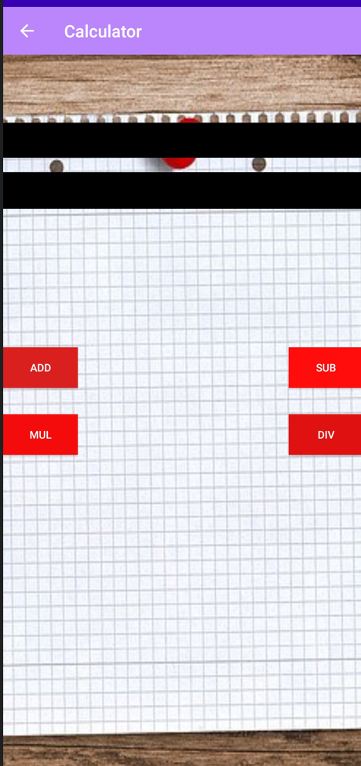

<?xml version="1.0" encoding="utf-8"?><RelativeLayout xmlns:android="http://schemas.android.com/apk/res/android" xmlns:app="http://schemas.android.com/apk/res-auto" xmlns:tools="http://schemas.android.com/tools" android:layout_width="match_parent" android:layout_height="match_parent" android:background="@drawable/calc" tools:context=".cal"> <EditText android:id="@+id/editText" android:layout_width="match_parent" android:layout_height="41dp" android:layout_alignParentStart="true" android:layout_alignParentLeft="true" android:layout_alignParentTop="true" android:layout_marginTop="80dp" android:background="@color/black" /> <EditText android:id="@+id/editText2" android:layout_width="match_parent" android:layout_height="43dp" android:layout_below="@+id/editText" android:layout_centerHorizontal="true" android:layout_marginTop="17dp" android:background="@color/black" /> <TextView android:id="@+id/textView" android:layout_width="wrap_content" android:layout_height="99dp" android:layout_below="@+id/editText2" android:layout_alignParentStart="true" android:layout_alignParentLeft="true" android:layout_alignParentEnd="true" android:layout_centerHorizontal="true" android:layout_marginStart="147dp" android:layout_marginLeft="147dp" android:layout_marginTop="31dp" android:layout_marginEnd="4dp" android:textColor="#0C0B0B" android:textSize="48sp" /> <Button android:id="@+id/button" android:layout_width="wrap_content" android:layout_height="wrap_content" android:layout_below="@+id/textView" android:layout_alignParentStart="true" android:layout_alignParentLeft="true" android:layout_marginTop="33dp" android:background="#DA1F1F" android:text="ADD" /> <Button android:id="@+id/button2" android:layout_width="wrap_content" android:layout_height="wrap_content" android:layout_alignEnd="@+id/editText2" android:layout_alignRight="@+id/editText2" android:layout_alignBottom="@+id/button" android:background="#FF0C0C" android:text="sub" /> <Button android:id="@+id/button3" android:layout_width="wrap_content" android:layout_height="wrap_content" android:layout_below="@+id/button" android:layout_alignParentStart="true" android:layout_alignParentLeft="true" android:layout_marginTop="31dp" android:background="#F40B0B" android:text="mul" /> <Button android:id="@+id/button4" android:layout_width="wrap_content" android:layout_height="wrap_content" android:layout_alignTop="@+id/button3" android:layout_alignEnd="@+id/button2" android:layout_alignRight="@+id/button2" android:background="#DF1111" android:text="div" /></RelativeLayout>

**vibrate.java**

package com.example.app60;import androidx.appcompat.app.AppCompatActivity;import android.os.Build;import android.os.Bundle;import android.os.Bundle;import android.os.Vibrator;import android.view.MenuItem;import android.view.View;import android.widget.Button;import android.widget.CompoundButton;import android.widget.Toast;import android.widget.ToggleButton;import androidx.annotation.NonNull;import androidx.appcompat.app.ActionBar;import androidx.appcompat.app.AppCompatActivity;public class vibrate extends AppCompatActivity { ToggleButton b1; Vibrator v1; @Override protected void onCreate(Bundle savedInstanceState) { super.onCreate(savedInstanceState); setContentView(R.layout.*activity_vibrate*); getSupportActionBar().setTitle("Vibrator"); ActionBar actionBar = getSupportActionBar(); actionBar.setDisplayHomeAsUpEnabled(true); b1=(ToggleButton) findViewById(R.id.*toggleButton*); v1=(Vibrator)getSystemService(*VIBRATOR_SERVICE*); b1.setOnCheckedChangeListener(new CompoundButton.OnCheckedChangeListener() { @Override public void onCheckedChanged(CompoundButton compoundButton, boolean b) { if(b){ v1.vibrate(10000); } else{ Toast.*makeText*(vibrate.this, "Wait For 10 Seconds", Toast.*LENGTH_SHORT*).show(); } } }); } @Override public boolean onOptionsItemSelected(@NonNull MenuItem item) { switch (item.getItemId()) { case android.R.id.*home*: this.finish(); return true; } return super.onOptionsItemSelected(item); }}

**activity_vibrate.xml**

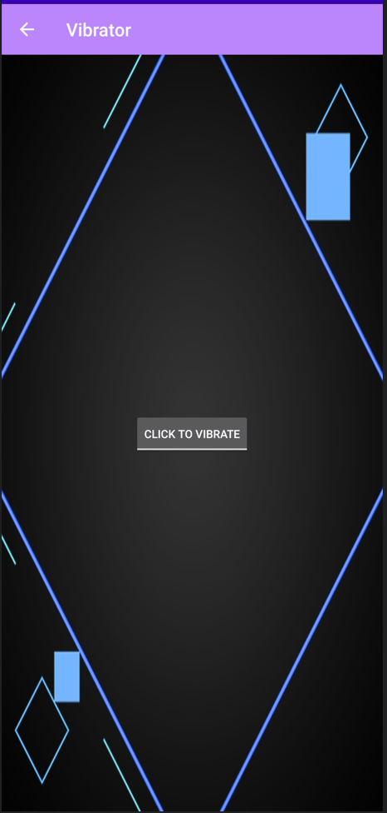

<?xml version="1.0" encoding="utf-8"?><RelativeLayout xmlns:android="http://schemas.android.com/apk/res/android" xmlns:app="http://schemas.android.com/apk/res-auto" xmlns:tools="http://schemas.android.com/tools" android:layout_width="match_parent" android:layout_height="match_parent" android:background="@drawable/bluohohoh" tools:context=".vibrate"> <ToggleButton android:id="@+id/toggleButton" android:layout_width="wrap_content" android:layout_height="wrap_content" android:layout_centerInParent="true" android:text="ToggleButton" android:textOff="Click To Vibrate" android:textOn="click to Off Vibration" app:layout_constraintEnd_toEndOf="parent" app:layout_constraintStart_toStartOf="parent" tools:layout_editor_absoluteY="308dp" /></RelativeLayout>

**tts.java**

package com.example.app60;import androidx.appcompat.app.AppCompatActivity;import android.os.Bundle;import android.os.Bundle;import android.speech.tts.TextToSpeech;import android.view.MenuItem;import android.view.View;import android.widget.Button;import android.widget.EditText;import android.widget.ImageButton;import androidx.annotation.NonNull;import androidx.appcompat.app.ActionBar;import androidx.appcompat.app.AppCompatActivity;import java.util.Locale;public class tts extends AppCompatActivity { EditText e1; ImageButton b1; TextToSpeech ts; @Override protected void onCreate(Bundle savedInstanceState) { super.onCreate(savedInstanceState); setContentView(R.layout.*activity_tts*); ActionBar actionBar = getSupportActionBar(); actionBar.setDisplayHomeAsUpEnabled(true); getSupportActionBar().setTitle("Text To Speech"); e1=(EditText)findViewById(R.id.*editText*); b1=(ImageButton) findViewById(R.id.*imageButton12*); ts = new TextToSpeech(this, new TextToSpeech.OnInitListener() { @Override public void onInit(int i) { ts.setLanguage(Locale.*ENGLISH*); ts.setSpeechRate(0.9f); } }); b1.setOnClickListener(new View.OnClickListener() { @Override public void onClick(View view) { String s1 = e1.getText().toString(); ts.speak(s1,TextToSpeech.*QUEUE_FLUSH*,null); } }); } @Override public boolean onOptionsItemSelected(@NonNull MenuItem item) { switch (item.getItemId()) { case android.R.id.*home*: this.finish(); return true; } return super.onOptionsItemSelected(item); }}

**activity_tts.xml**

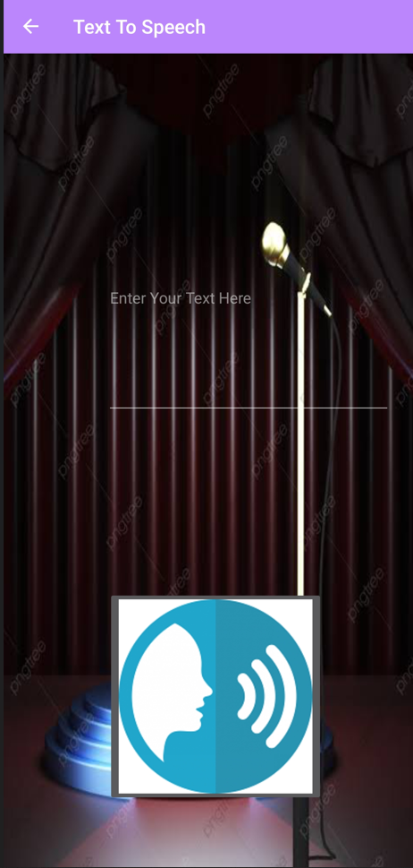

<?xml version="1.0" encoding="utf-8"?><RelativeLayout xmlns:android="http://schemas.android.com/apk/res/android" xmlns:app="http://schemas.android.com/apk/res-auto" xmlns:tools="http://schemas.android.com/tools" android:layout_width="match_parent" android:layout_height="match_parent" android:background="@drawable/tttttss" tools:context=".tts"> <EditText android:id="@+id/editText" android:layout_width="294dp" android:layout_height="243dp" android:layout_alignParentStart="true" android:layout_alignParentTop="true" android:layout_centerHorizontal="true" android:layout_marginStart="106dp" android:layout_marginTop="130dp" android:ems="10" android:hint="Enter Your Text Here" android:inputType="textPersonName" /> <ImageButton android:id="@+id/imageButton12" android:layout_width="wrap_content" android:layout_height="wrap_content" android:layout_alignParentStart="true" android:layout_alignParentBottom="true" android:layout_marginStart="107dp" android:layout_marginBottom="68dp" app:srcCompat="@drawable/tststststs" /></RelativeLayout>

**media.java**

package com.example.app60;import androidx.appcompat.app.AppCompatActivity;import android.hardware.Sensor;import android.hardware.SensorEvent;import android.hardware.SensorManager;import android.media.MediaPlayer;import android.os.Bundle;import android.os.Bundle;import android.view.MenuItem;import android.view.View;import android.widget.Button;import android.widget.ImageButton;import androidx.annotation.NonNull;import androidx.appcompat.app.ActionBar;import androidx.appcompat.app.AppCompatActivity;public class media extends AppCompatActivity { Button b2; MediaPlayer mp , mp2 , mp3 , mp4 , mp5 , mp6 , mp7 , mp8 , mp9 ; ImageButton ib1,ib2,ib3,ib4,ib5,ib6,ib7,ib8,ib9; @Override protected void onCreate(Bundle savedInstanceState) { super.onCreate(savedInstanceState); setContentView(R.layout.*activity_media*); ActionBar actionBar = getSupportActionBar(); actionBar.setDisplayHomeAsUpEnabled(true); getSupportActionBar().setTitle("Music"); b2 = (Button) findViewById(R.id.*button2*); ib1 = (ImageButton) findViewById(R.id.*imageButton8*); ib2 = (ImageButton) findViewById(R.id.*imageButton9*); ib3 = (ImageButton) findViewById(R.id.*imageButton11*); ib4 = (ImageButton) findViewById(R.id.*imageButton7*); ib5 = (ImageButton) findViewById(R.id.*imageButton10*); ib6 = (ImageButton) findViewById(R.id.*imageButton13*); ib7 = (ImageButton) findViewById(R.id.*imageButton14*); ib8 = (ImageButton) findViewById(R.id.*imageButton15*); ib9= (ImageButton) findViewById(R.id.*imageButton16*); mp = MediaPlayer.*create*(this,R.raw.*tandav*); mp2 = MediaPlayer.*create*(this,R.raw.*han*); mp3 = MediaPlayer.*create*(this,R.raw.*sii*); mp4 = MediaPlayer.*create*(this,R.raw.*hara*); mp5 = MediaPlayer.*create*(this,R.raw.*bolo*); mp6 = MediaPlayer.*create*(this,R.raw.*bhaaang*); mp7 = MediaPlayer.*create*(this,R.raw.*miyiyi*); mp8 = MediaPlayer.*create*(this,R.raw.*durga*); mp9 = MediaPlayer.*create*(this,R.raw.*rama*); ib1.setOnClickListener(new View.OnClickListener(){ @Override public void onClick(View view) { mp.start(); } }); ib2.setOnClickListener(new View.OnClickListener() { @Override public void onClick(View view) { mp2.start(); } }); ib3.setOnClickListener(new View.OnClickListener() { @Override public void onClick(View view) { mp3.start(); } }); ib4.setOnClickListener(new View.OnClickListener() { @Override public void onClick(View view) { mp4.start(); } }); ib5.setOnClickListener(new View.OnClickListener() { @Override public void onClick(View view) { mp5.start(); } }); ib6.setOnClickListener(new View.OnClickListener() { @Override public void onClick(View view) { mp6.start(); } }); ib7.setOnClickListener(new View.OnClickListener() { @Override public void onClick(View view) { mp7.start(); } }); ib8.setOnClickListener(new View.OnClickListener() { @Override public void onClick(View view) { mp8.start(); } }); ib9.setOnClickListener(new View.OnClickListener() { @Override public void onClick(View view) { mp9.start(); } }); b2.setOnClickListener(new View.OnClickListener() { @Override public void onClick(View view) { mp.pause(); mp2.pause(); mp3.pause(); mp4.pause(); mp5.pause(); mp6.pause(); mp7.pause(); mp8.pause(); mp9.pause(); } }); } @Override public boolean onOptionsItemSelected(@NonNull MenuItem item) { switch (item.getItemId()) { case android.R.id.*home*: this.finish(); return true; } return super.onOptionsItemSelected(item); }}

**activity_media.xml**

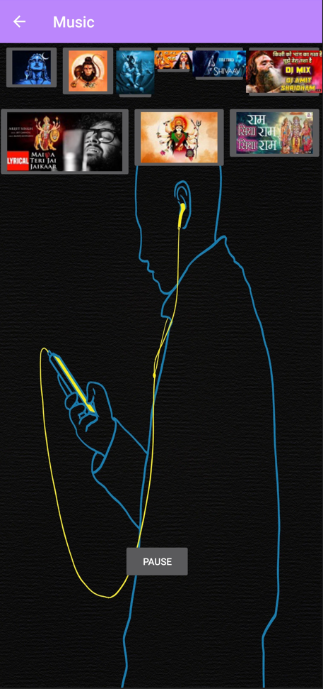

<?xml version="1.0" encoding="utf-8"?><RelativeLayout xmlns:android="http://schemas.android.com/apk/res/android" xmlns:app="http://schemas.android.com/apk/res-auto" xmlns:tools="http://schemas.android.com/tools" android:layout_width="match_parent" android:layout_height="match_parent" android:background="@drawable/pppppp" tools:context=".media"> <LinearLayout android:layout_width="match_parent" android:layout_height="match_parent" android:layout_marginTop="80dp" android:orientation="horizontal"> <ImageButton android:id="@+id/imageButton14" android:layout_width="wrap_content" android:layout_height="wrap_content" android:layout_weight="1" app:srcCompat="@drawable/maiya" /> <ImageButton android:id="@+id/imageButton15" android:layout_width="wrap_content" android:layout_height="wrap_content" android:layout_weight="1" app:srcCompat="@drawable/durga" /> <ImageButton android:id="@+id/imageButton16" android:layout_width="wrap_content" android:layout_height="wrap_content" android:layout_weight="1" app:srcCompat="@drawable/ram" /> </LinearLayout> <Button android:id="@+id/button2" android:layout_width="wrap_content" android:layout_height="wrap_content" android:layout_alignParentStart="true" android:layout_alignParentTop="true" android:layout_centerHorizontal="true" android:layout_marginStart="164dp" android:layout_marginTop="650dp" android:text="pause" /> <LinearLayout android:layout_width="match_parent" android:layout_height="match_parent" android:layout_alignParentStart="true" android:layout_alignParentTop="true" android:orientation="vertical"> <LinearLayout android:layout_width="match_parent" android:layout_height="match_parent" android:orientation="horizontal"> <ImageButton android:id="@+id/imageButton8" android:layout_width="wrap_content" android:layout_height="wrap_content" android:layout_marginStart="7dp" android:layout_marginBottom="656dp" app:srcCompat="@drawable/shiva" /> <ImageButton android:id="@+id/imageButton9" android:layout_width="wrap_content" android:layout_height="wrap_content" app:srcCompat="@drawable/hanu" /> <ImageButton android:id="@+id/imageButton11" android:layout_width="wrap_content" android:layout_height="wrap_content" android:layout_weight="1" app:srcCompat="@drawable/si" /> <ImageButton android:id="@+id/imageButton7" android:layout_width="wrap_content" android:layout_height="wrap_content" android:layout_weight="1" app:srcCompat="@drawable/har" /> <ImageButton android:id="@+id/imageButton10" android:layout_width="wrap_content" android:layout_height="wrap_content" android:layout_weight="1" app:srcCompat="@drawable/maa" /> <ImageButton android:id="@+id/imageButton13" android:layout_width="wrap_content" android:layout_height="wrap_content" android:layout_weight="1" app:srcCompat="@drawable/bhang" /> </LinearLayout> </LinearLayout></RelativeLayout>

**camera.java**

package com.example.app60;import androidx.appcompat.app.AppCompatActivity;import android.content.Intent;import android.os.Bundle;import android.os.Bundle;import android.view.MenuItem;import android.view.View;import android.widget.ImageButton;import androidx.annotation.NonNull;import androidx.appcompat.app.ActionBar;import androidx.appcompat.app.AppCompatActivity;public class camera extends AppCompatActivity { ImageButton b1, b2; @Override protected void onCreate(Bundle savedInstanceState) { super.onCreate(savedInstanceState); setContentView(R.layout.*activity_camera*); ActionBar actionBar = getSupportActionBar(); actionBar.setDisplayHomeAsUpEnabled(true); getSupportActionBar().setTitle("Camera"); b1=(ImageButton) findViewById(R.id.*imageButton21*); b2=(ImageButton) findViewById(R.id.*imageButton24*); b1.setOnClickListener(new View.OnClickListener() { @Override public void onClick(View view) { Intent intent = new Intent(camera.this , photo.class); startActivity(intent); //finish(); } }); b2.setOnClickListener(new View.OnClickListener() { @Override public void onClick(View view) { Intent intent = new Intent(camera.this , video.class); startActivity(intent); //finish(); } });  } @Override public boolean onOptionsItemSelected(@NonNull MenuItem item) { switch (item.getItemId()) { case android.R.id.*home*: this.finish(); return true; } return super.onOptionsItemSelected(item); }}

**activity_camera.xml**

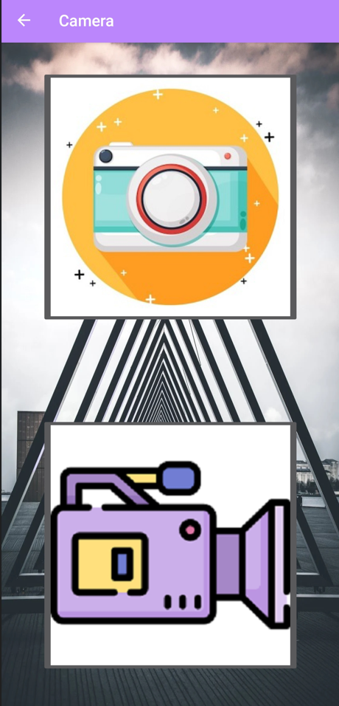

<?xml version="1.0" encoding="utf-8"?><RelativeLayout xmlns:android="http://schemas.android.com/apk/res/android" xmlns:app="http://schemas.android.com/apk/res-auto" xmlns:tools="http://schemas.android.com/tools" android:layout_width="match_parent" android:layout_height="match_parent" android:background="@drawable/mybackkkkkkk" tools:context=".camera"> <ImageButton android:id="@+id/imageButton21" android:layout_width="wrap_content" android:layout_height="wrap_content" android:layout_alignParentTop="true" android:layout_centerHorizontal="true" android:layout_marginTop="34dp" app:layout_constraintEnd_toEndOf="parent" app:layout_constraintStart_toStartOf="parent" app:srcCompat="@drawable/photocamera" tools:layout_editor_absoluteY="45dp" /> <ImageButton android:id="@+id/imageButton24" android:layout_width="wrap_content" android:layout_height="wrap_content" android:layout_alignParentBottom="true" android:layout_centerHorizontal="true" android:layout_marginBottom="52dp" app:layout_constraintEnd_toEndOf="parent" app:layout_constraintHorizontal_bias="0.505" app:layout_constraintStart_toStartOf="parent" app:srcCompat="@drawable/videocamera" tools:layout_editor_absoluteY="369dp" /></RelativeLayout>

**photo.java**

package com.example.app60;import android.content.Intent;import android.graphics.Bitmap;import android.os.IInterface;import android.provider.MediaStore;import androidx.appcompat.app.AppCompatActivity;import android.os.Bundle;import android.view.View;import android.widget.Button;import android.widget.ImageButton;import android.widget.ImageView;import android.widget.Toast;import android.os.Bundle;import android.view.MenuItem;import androidx.annotation.NonNull;import androidx.appcompat.app.ActionBar;import androidx.appcompat.app.AppCompatActivity;public class photo extends AppCompatActivity { ImageButton b; ImageView i1; @Override protected void onCreate(Bundle savedInstanceState) { super.onCreate(savedInstanceState); setContentView(R.layout.*activity_photo*); getSupportActionBar().setTitle("Photo Camera"); ActionBar actionBar = getSupportActionBar(); actionBar.setDisplayHomeAsUpEnabled(true); i1=(ImageView)findViewById(R.id.*imageView*); b=(ImageButton)findViewById(R.id.*imageButton*); b.setOnClickListener(new View.OnClickListener() { @Override public void onClick(View view) { Intent i = new Intent(MediaStore.*ACTION_IMAGE_CAPTURE*); startActivityForResult(i,1000); } }); } @Override protected void onActivityResult(int requestCode, int resultCode, Intent data) { super.onActivityResult(requestCode, resultCode, data); if(requestCode == 1000) { Bitmap bm = (Bitmap)data.getExtras().get("data"); i1.setImageBitmap(bm); } else{ Toast.*makeText*(photo.this, "hardware issue !", Toast.*LENGTH_SHORT*).show(); } } @Override public boolean onOptionsItemSelected(@NonNull MenuItem item) { switch (item.getItemId()) { case android.R.id.*home*: this.finish(); return true; } return super.onOptionsItemSelected(item); }}

**activity_photo.xml**

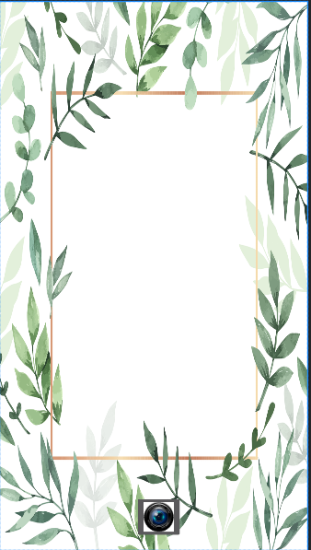

<?xml version="1.0" encoding="utf-8"?><RelativeLayout xmlns:android="http://schemas.android.com/apk/res/android" xmlns:app="http://schemas.android.com/apk/res-auto" xmlns:tools="http://schemas.android.com/tools" android:layout_width="match_parent" android:layout_height="match_parent" android:background="@drawable/frame" tools:context=".photo"> <ImageView android:layout_width="match_parent" android:layout_height="match_parent" android:id="@+id/imageView" android:layout_above="@+id/button" android:layout_alignParentLeft="true" android:layout_alignParentStart="true" /> <ImageButton android:id="@+id/imageButton" android:layout_width="wrap_content" android:layout_height="wrap_content" android:layout_alignParentStart="true" android:layout_alignParentBottom="true" android:layout_centerHorizontal="true" android:layout_marginStart="180dp" android:layout_marginBottom="15dp" app:srcCompat="@drawable/lens" /></RelativeLayout>

**video.java**

package com.example.app60;import androidx.appcompat.app.AppCompatActivity;import android.content.Intent;import android.net.Uri;import android.os.Bundle;import android.os.Bundle;import android.provider.MediaStore;import android.view.MenuItem;import android.view.View;import android.widget.Button;import android.widget.ImageButton;import android.widget.MediaController;import android.widget.Toast;import android.widget.VideoView;import androidx.annotation.NonNull;import androidx.appcompat.app.ActionBar;import androidx.appcompat.app.AppCompatActivity;public class video extends AppCompatActivity { ImageButton b1; VideoView v1; MediaController mc; Uri u1; @Override protected void onCreate(Bundle savedInstanceState) { super.onCreate(savedInstanceState); setContentView(R.layout.*activity_video*); ActionBar actionBar = getSupportActionBar(); actionBar.setDisplayHomeAsUpEnabled(true); getSupportActionBar().setTitle("Video Camera"); b1=(ImageButton)findViewById(R.id.*button*); v1=(VideoView)findViewById(R.id.*videoView*); mc = new MediaController(this); b1.setOnClickListener(new View.OnClickListener() { @Override public void onClick(View view) { Intent i = new Intent(MediaStore.*ACTION_VIDEO_CAPTURE*); startActivityForResult(i,100); } }); } @Override protected void onActivityResult(int requestCode, int resultCode, Intent data) { super.onActivityResult(requestCode, resultCode, data); if(requestCode==100){ u1=data.getData(); v1.setVideoURI(u1); v1.setMediaController(mc); mc.setAnchorView(v1); v1.start(); } else { Toast.*makeText*(this, "Hardware Issue !", Toast.*LENGTH_SHORT*).show(); } } @Override public boolean onOptionsItemSelected(@NonNull MenuItem item) { switch (item.getItemId()) { case android.R.id.*home*: this.finish(); return true; } return super.onOptionsItemSelected(item); }}

**activity_video.xml**



<?xml version="1.0" encoding="utf-8"?><RelativeLayout xmlns:android="http://schemas.android.com/apk/res/android" xmlns:app="http://schemas.android.com/apk/res-auto" xmlns:tools="http://schemas.android.com/tools" android:layout_width="match_parent" android:layout_height="match_parent" android:background="@drawable/videobackground" tools:context=".video"> <VideoView android:id="@+id/videoView" android:layout_width="match_parent" android:layout_height="659dp" android:layout_above="@+id/button" android:layout_alignParentStart="true" android:layout_alignParentTop="true" android:layout_alignParentEnd="true" android:layout_alignParentRight="true" android:layout_marginStart="0dp" android:layout_marginTop="0dp" android:layout_marginEnd="0dp" android:layout_marginRight="0dp" android:layout_marginBottom="-5dp" /> <ImageButton android:id="@+id/button" android:layout_width="wrap_content" android:layout_height="wrap_content" android:layout_alignParentStart="true" android:layout_alignParentBottom="true" android:layout_centerHorizontal="true" android:layout_marginStart="172dp" android:layout_marginBottom="-1dp" app:srcCompat="@drawable/videosymbol" /></RelativeLayout>

**wifi.java**

package com.example.app60;  
  
import androidx.appcompat.app.AppCompatActivity;  
import android.net.wifi.WifiManager;  
import android.os.Bundle;  
import android.view.View;  
import android.widget.CompoundButton;  
import android.widget.ImageButton;  
import android.widget.ToggleButton;  
import android.os.Bundle;  
import android.view.MenuItem;  
import androidx.annotation.NonNull;  
import androidx.appcompat.app.ActionBar;  
import androidx.appcompat.app.AppCompatActivity;  
  
public class wifi extends AppCompatActivity {  
  
 ImageButton b1;  
 WifiManager wm;  
 private boolean wifi=false;  
 @Override  
 protected void onCreate(Bundle savedInstanceState) {  
 super.onCreate(savedInstanceState);  
 setContentView(R.layout.*activity_wifi*);  
 ActionBar actionBar = getSupportActionBar();  
 actionBar.setDisplayHomeAsUpEnabled(true);  
 getSupportActionBar().setTitle("WiFi");  
 b1=(ImageButton) findViewById(R.id.*imageButton*);  
 wm = (WifiManager)getSystemService(*WIFI_SERVICE*);  
 b1.setOnClickListener(new View.OnClickListener() {  
 @Override  
 public void onClick(View view) {  
 if(wifi==false) {  
 wm.setWifiEnabled(true);  
 wifi = true;  
 b1.setImageResource(R.drawable.*red*);  
 }  
 else  
 {  
 wm.setWifiEnabled(false);  
 wifi = false;  
 b1.setImageResource(R.drawable.*black*);  
 }  
 }  
 });  
 }  
  
 @Override  
 public boolean onOptionsItemSelected(@NonNull MenuItem item) {  
 switch (item.getItemId()) {  
 case android.R.id.*home*:  
 this.finish();  
 return true;  
 }  
 return super.onOptionsItemSelected(item);  
 }  
}

**activity_wifi.xml**

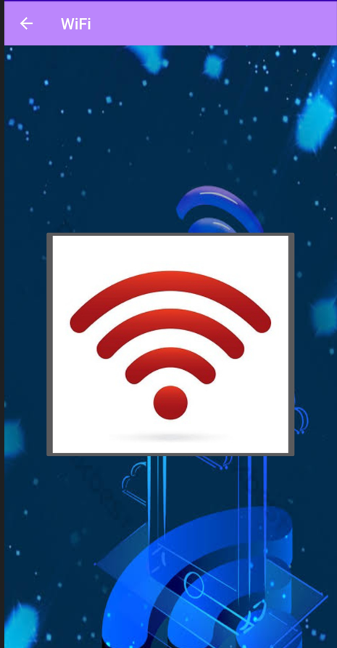

<?xml version="1.0" encoding="utf-8"?>  
<RelativeLayout xmlns:android="http://schemas.android.com/apk/res/android"  
 xmlns:app="http://schemas.android.com/apk/res-auto"  
 xmlns:tools="http://schemas.android.com/tools"  
 android:layout_width="match_parent"  
 android:layout_height="match_parent"  
 android:background="@drawable/newwww"  
 tools:context=".wifi">  
  
 <ImageButton  
 android:id="@+id/imageButton"  
 android:layout_width="wrap_content"  
 android:layout_height="wrap_content"  
 android:layout_alignParentTop="true"  
 android:layout_centerInParent="true"  
 android:layout_marginTop="233dp"  
 android:src="@drawable/black" />  
  
</RelativeLayout>

**danger.java**

package com.example.app60;  
  
import androidx.appcompat.app.ActionBar;  
import androidx.appcompat.app.AppCompatActivity;  
  
import android.app.admin.DevicePolicyManager;  
import android.bluetooth.BluetoothAdapter;  
import android.content.Context;  
import android.hardware.Sensor;  
import android.hardware.SensorEvent;  
import android.hardware.SensorEventListener;  
import android.hardware.SensorManager;  
import android.hardware.camera2.CameraAccessException;  
import android.hardware.camera2.CameraManager;  
import android.icu.util.Freezable;  
import android.media.MediaPlayer;  
import android.net.wifi.WifiManager;  
import android.os.Build;  
import android.os.Bundle;  
import android.os.Vibrator;  
import android.widget.ImageView;  
import android.os.Bundle;  
import android.view.MenuItem;  
import android.widget.Toast;  
  
import androidx.annotation.NonNull;  
import androidx.appcompat.app.ActionBar;  
import androidx.appcompat.app.AppCompatActivity;  
  
public class danger extends AppCompatActivity implements SensorEventListener {  
  
 MediaPlayer mp;  
 WifiManager wm;  
 BluetoothAdapter ba;  
 CameraManager cm;  
 Vibrator v1;  
 ImageView i1;  
 SensorManager sm;  
 Sensor s;  
 @Override  
 protected void onCreate(Bundle savedInstanceState) {  
 super.onCreate(savedInstanceState);  
 setContentView(R.layout.*activity_danger*);  
 ActionBar actionBar = getSupportActionBar();  
 actionBar.setDisplayHomeAsUpEnabled(true);  
 getSupportActionBar().setTitle("Danger , Leave Now");  
  
  
 mp=MediaPlayer.*create*(this,R.raw.*danger4*);  
 wm=(WifiManager)getSystemService(*WIFI_SERVICE*);  
 ba=BluetoothAdapter.*getDefaultAdapter*();  
 cm=(CameraManager)getSystemService(*CAMERA_SERVICE*);  
 v1=(Vibrator)getSystemService(*VIBRATOR_SERVICE*);  
 i1=(ImageView)findViewById(R.id.*imageView*);  
  
 sm=(SensorManager)getSystemService(*SENSOR_SERVICE*);  
 s=sm.getDefaultSensor(Sensor.*TYPE_ACCELEROMETER*);  
 sm.registerListener(this ,s ,SensorManager.*SENSOR_DELAY_NORMAL*);  
  
 }  
  
 @Override  
 public void onSensorChanged(SensorEvent sensorEvent) {  
  
 float x=sensorEvent.values[0];  
 float y=sensorEvent.values[1];  
 float z=sensorEvent.values[2];  
  
 int x1=(int)x;  
 int y1=(int)y;  
 int z1=(int)z;  
  
 if(x1!=0){  
 Toast.*makeText*(this, "Why you Are Tilding Your phone !", Toast.*LENGTH_SHORT*).show();  
 mp.start();  
 wm.setWifiEnabled(true);  
 ba.enable();  
  
 i1.setImageResource(R.drawable.*danger1*);  
 if(Build.VERSION.*SDK_INT*>26){  
 v1.vibrate(200000);  
 }  
 else {  
 v1.vibrate(200000);  
 }  
 try{  
 String id =cm.getCameraIdList()[0];  
 cm.setTorchMode(id,true);  
 }  
 catch (CameraAccessException e){  
  
 }  
 }  
 else{  
 Toast.*makeText*(danger.this, "why you turn back", Toast.*LENGTH_SHORT*).show();  
 wm.setWifiEnabled(false);  
 ba.disable();  
  
 i1.setImageResource(R.drawable.*danger2*);  
 try{  
 String id =cm.getCameraIdList()[0];  
 cm.setTorchMode(id,false);  
 }  
 catch (CameraAccessException e){  
  
 }  
 }  
  
 }  
  
 @Override  
 public void onAccuracyChanged(Sensor sensor, int i) {  
  
 }  
 @Override  
 public boolean onOptionsItemSelected(@NonNull MenuItem item) {  
 switch (item.getItemId()) {  
 case android.R.id.*home*:  
 this.finish();  
 return true;  
 }  
 return super.onOptionsItemSelected(item);  
 }  
}

**activity_danegr.xml**

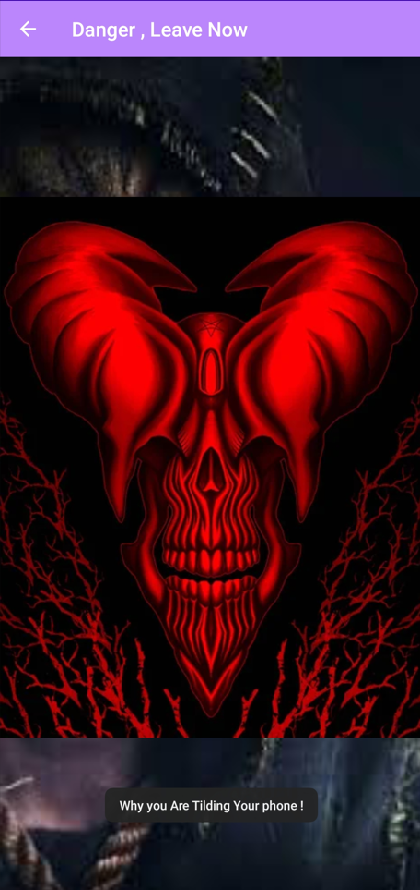

<?xml version="1.0" encoding="utf-8"?>  
<RelativeLayout xmlns:android="http://schemas.android.com/apk/res/android"  
 xmlns:app="http://schemas.android.com/apk/res-auto"  
 xmlns:tools="http://schemas.android.com/tools"  
 android:layout_width="match_parent"  
 android:layout_height="match_parent"  
 android:background="@drawable/dddddddddddddddd"  
 tools:context=".danger">  
  
 <ImageView  
 android:id="@+id/imageView"  
 android:layout_width="wrap_content"  
 android:layout_height="wrap_content"  
 android:layout_alignParentStart="true"  
 android:layout_alignParentTop="true"  
 android:layout_alignParentEnd="true"  
 android:layout_alignParentBottom="true"  
 android:layout_centerInParent="true"  
 android:layout_marginStart="-6dp"  
 android:layout_marginTop="123dp"  
 android:layout_marginEnd="-5dp"  
 android:layout_marginBottom="144dp"  
 android:src="@drawable/danger1" />  
  
</RelativeLayout>

**Users.java**

package com.example.app60;public class Users { String name , email , phone; public Users() { } public Users(String name, String email, String phone) { this.name = name; this.email = email; this.phone = phone; } public String getName() { return name; } public void setName(String name) { this.name = name; } public String getEmail() { return email; } public void setEmail(String email) { this.email = email; } public String getPhone() { return phone; } public void setPhone(String phone) { this.phone = phone; }}

**Screenshots of Google Firebase**

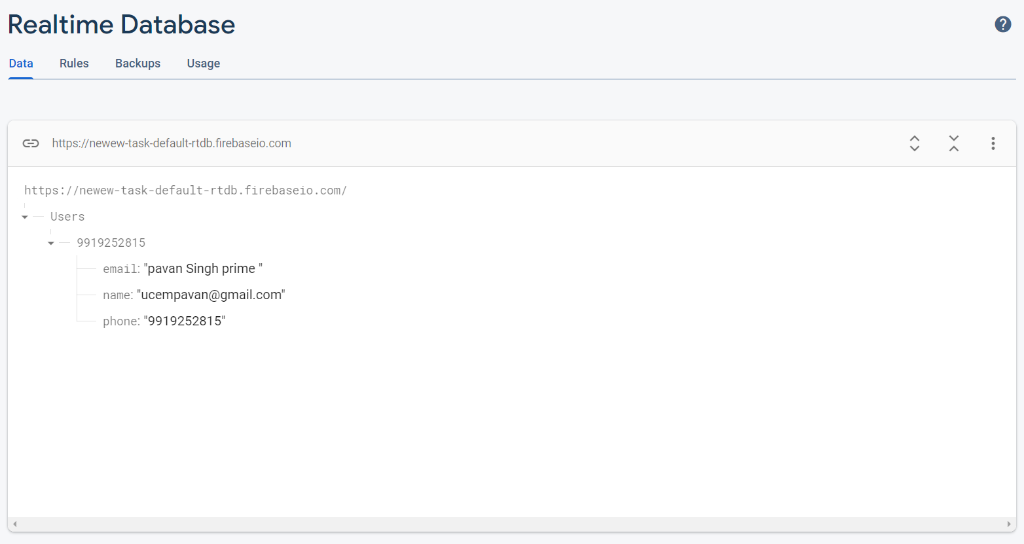

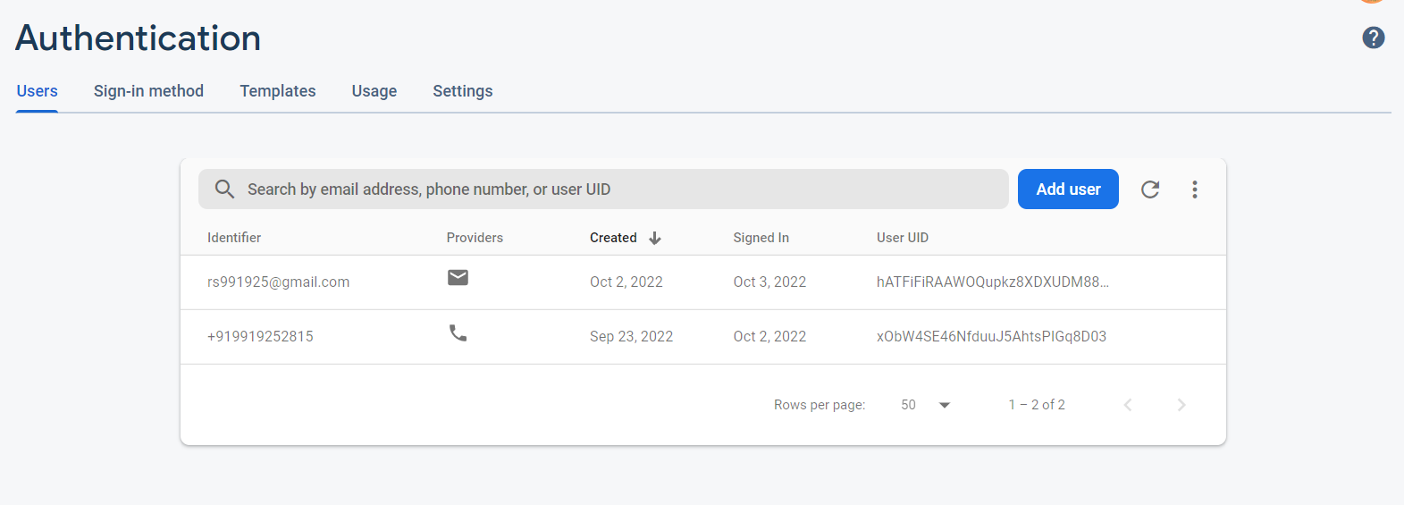

**AndroidManifest.xml**

<?xml version="1.0" encoding="utf-8"?>  
<manifest xmlns:android="http://schemas.android.com/apk/res/android"  
 xmlns:tools="http://schemas.android.com/tools">  
  
 <uses-permission android:name="android.permission.INTERNET" />  
 <uses-permission android:name="android.permission.ACCESS_WIFI_STATE" />  
 <uses-permission android:name="android.permission.CHANGE_WIFI_STATE" />  
 <uses-permission android:name="android.permission.BLUETOOTH" />  
 <uses-permission android:name="android.permission.BLUETOOTH_ADMIN" />  
 <uses-permission android:name="android.permission.BLUETOOTH_CONNECT" />  
 <uses-permission android:name="android.permission.CAMERA" />  
 <uses-permission android:name="android.permission.VIBRATE" />  
  
 <application  
 android:allowBackup="true"  
 android:dataExtractionRules="@xml/data_extraction_rules"  
 android:fullBackupContent="@xml/backup_rules"  
 android:icon="@mipmap/ic_launcher"  
 android:label="@string/app_name"  
 android:roundIcon="@mipmap/ic_launcher_round"  
 android:supportsRtl="true"  
 android:theme="@style/Theme.App60"  
 tools:targetApi="31">  
 <activity  
 android:name=".quiz10"  
 android:exported="false">  
 <meta-data  
 android:name="android.app.lib_name"  
 android:value="" />  
 </activity>  
 <activity  
 android:name=".quiz9"  
 android:exported="false">  
 <meta-data  
 android:name="android.app.lib_name"  
 android:value="" />  
 </activity>  
 <activity  
 android:name=".quiz8"  
 android:exported="false">  
 <meta-data  
 android:name="android.app.lib_name"  
 android:value="" />  
 </activity>  
 <activity  
 android:name=".quiz7"  
 android:exported="false">  
 <meta-data  
 android:name="android.app.lib_name"  
 android:value="" />  
 </activity>  
 <activity  
 android:name=".quiz6"  
 android:exported="false">  
 <meta-data  
 android:name="android.app.lib_name"  
 android:value="" />  
 </activity>  
 <activity  
 android:name=".quiz5"  
 android:exported="false">  
 <meta-data  
 android:name="android.app.lib_name"  
 android:value="" />  
 </activity>  
 <activity  
 android:name=".quiz4"  
 android:exported="false">  
 <meta-data  
 android:name="android.app.lib_name"  
 android:value="" />  
 </activity>  
 <activity  
 android:name=".quizResult"  
 android:exported="false">  
 <meta-data  
 android:name="android.app.lib_name"  
 android:value="" />  
 </activity>  
 <activity  
 android:name=".quiz3"  
 android:exported="false">  
 <meta-data  
 android:name="android.app.lib_name"  
 android:value="" />  
 </activity>  
 <activity  
 android:name=".quiz2"  
 android:exported="false">  
 <meta-data  
 android:name="android.app.lib_name"  
 android:value="" />  
 </activity>  
 <activity  
 android:name=".AddPlayers"  
 android:exported="false">  
 <meta-data  
 android:name="android.app.lib_name"  
 android:value="" />  
 </activity>  
 <activity  
 android:name=".signin"  
 android:exported="false">  
 <meta-data  
 android:name="android.app.lib_name"  
 android:value="" />  
 </activity>  
 <activity  
 android:name=".quiz"  
 android:exported="false">  
 <meta-data  
 android:name="android.app.lib_name"  
 android:value="" />  
 </activity>  
 <activity  
 android:name=".danger"  
 android:exported="false">  
 <meta-data  
 android:name="android.app.lib_name"  
 android:value="" />  
 </activity>  
 <activity  
 android:name=".vibrate"  
 android:exported="false">  
 <meta-data  
 android:name="android.app.lib_name"  
 android:value="" />  
 </activity>  
 <activity  
 android:name=".torch"  
 android:exported="false">  
 <meta-data  
 android:name="android.app.lib_name"  
 android:value="" />  
 </activity>  
 <activity  
 android:name=".video"  
 android:exported="false">  
 <meta-data  
 android:name="android.app.lib_name"  
 android:value="" />  
 </activity>  
 <activity  
 android:name=".photo"  
 android:exported="false">  
 <meta-data  
 android:name="android.app.lib_name"  
 android:value="" />  
 </activity>  
 <activity  
 android:name=".camera"  
 android:exported="false">  
 <meta-data  
 android:name="android.app.lib_name"  
 android:value="" />  
 </activity>  
 <activity  
 android:name=".bluethoot"  
 android:exported="false">  
 <meta-data  
 android:name="android.app.lib_name"  
 android:value="" />  
 </activity>  
 <activity  
 android:name=".tts"  
 android:exported="false">  
 <meta-data  
 android:name="android.app.lib_name"  
 android:value="" />  
 </activity>  
 <activity  
 android:name=".media"  
 android:exported="false">  
 <meta-data  
 android:name="android.app.lib_name"  
 android:value="" />  
 </activity>  
 <activity  
 android:name=".cal"  
 android:exported="false">  
 <meta-data  
 android:name="android.app.lib_name"  
 android:value="" />  
 </activity>  
 <activity  
 android:name=".tools"  
 android:exported="false">  
 <meta-data  
 android:name="android.app.lib_name"  
 android:value="" />  
 </activity>  
 <activity  
 android:name=".tictactoe"  
 android:exported="false">  
 <meta-data  
 android:name="android.app.lib_name"  
 android:value="" />  
 </activity>  
 <activity  
 android:name=".fourthree"  
 android:exported="false">  
 <meta-data  
 android:name="android.app.lib_name"  
 android:value="" />  
 </activity>  
 <activity  
 android:name=".fourtwo"  
 android:exported="false">  
 <meta-data  
 android:name="android.app.lib_name"  
 android:value="" />  
 </activity>  
 <activity  
 android:name=".games"  
 android:exported="false">  
 <meta-data  
 android:name="android.app.lib_name"  
 android:value="" />  
 </activity>  
 <activity  
 android:name=".all"  
 android:exported="false">  
 <meta-data  
 android:name="android.app.lib_name"  
 android:value="" />  
 </activity>  
 <activity  
 android:name=".result"  
 android:exported="false">  
 <meta-data  
 android:name="android.app.lib_name"  
 android:value="" />  
 </activity>  
 <activity  
 android:name=".fourone"  
 android:exported="false">  
 <meta-data  
 android:name="android.app.lib_name"  
 android:value="" />  
 </activity>  
 <activity  
 android:name=".four"  
 android:exported="false">  
 <meta-data  
 android:name="android.app.lib_name"  
 android:value="" />  
 </activity>  
 <activity  
 android:name=".third"  
 android:exported="false">  
 <meta-data  
 android:name="android.app.lib_name"  
 android:value="" />  
 </activity>  
 <activity  
 android:name=".second"  
 android:exported="false">  
 <meta-data  
 android:name="android.app.lib_name"  
 android:value="" />  
 </activity>  
 <activity  
 android:name=".MainActivity"  
 android:exported="true">  
 <intent-filter>  
 <action android:name="android.intent.action.MAIN" />  
  
 <category android:name="android.intent.category.LAUNCHER" />  
 </intent-filter>  
  
 <meta-data  
 android:name="android.app.lib_name"  
 android:value="" />  
 </activity>  
 </application>  
  
</manifest>

